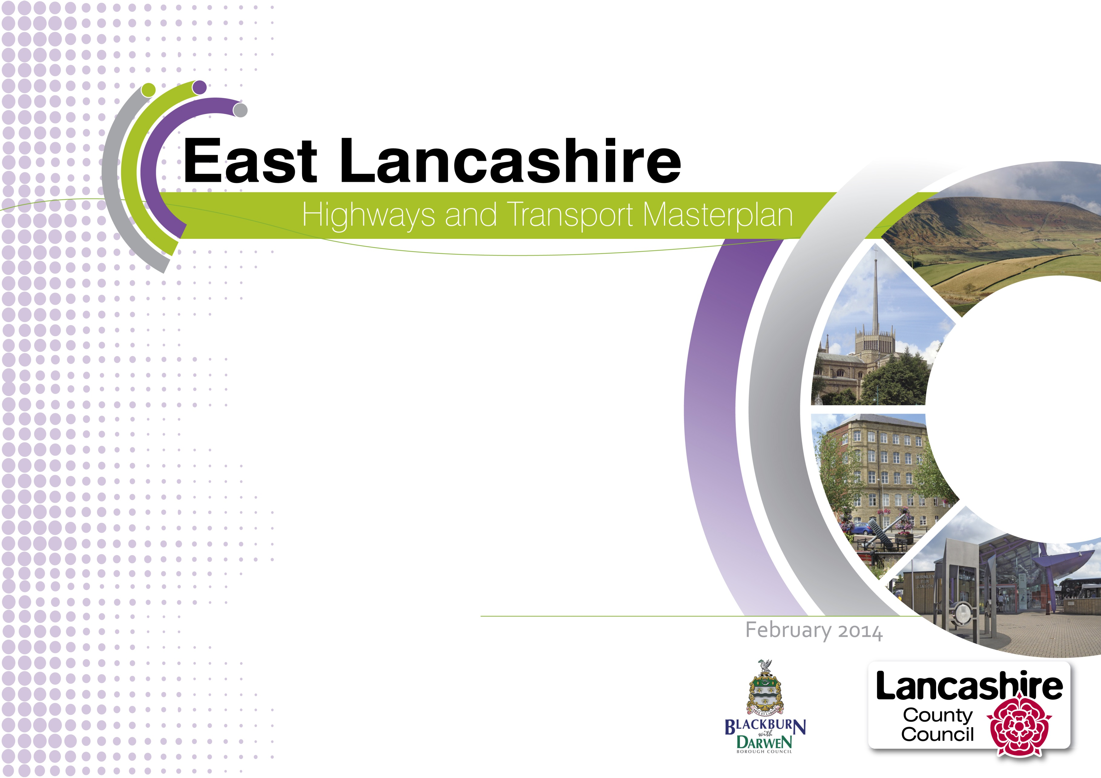

Foreword

East Lancashire can be truly proud of the fact that it was one of the power houses of the industrial revolution. 100 years ago, the area was known throughout the world for its manufacturing and engineering excellence. But global trade patterns changed and East Lancashire suffered the consequences. Large numbers of jobs were lost and the area declined.

In the last few years, though, East Lancashire's fortunes have started to turn round. World class manufacturing companies are doing business around the world. Advanced manufacturing, advanced flexible materials, aerospace, digital and creative industries have all become drivers of the resurgent and diverse East Lancashire economy which is so important to Lancashire as a whole.

Transport has always supported East Lancashire's economy. From the opening of the Leeds – Liverpool canal, through the arrival of the railways and on into the motor age, the area has benefitted from modern transport infrastructure. That continues to this day, with an investment of over £130m in improvements already planned for East Lancashire, as set out in this masterplan.

But East Lancashire isn't standing still. Development plans will provide for thousands of jobs to be created in manufacturing. Those jobs will be supported by an expanding retail and service sector, an increasing further and higher education offer and significant new housing development.

Indeed, this opportunity for growth is recognised and supported by the Lancashire Enterprise Partnership's active investment in the area, which builds on key initiatives already being delivered, such as the Lancashire Enterprise Zone to help reclaim Lancashire's role as one of the key centres for advanced manufacturing nationally.

East Lancashire's transport will need to evolve to support this economic growth. This evolution will provide a significant challenge for the area's highways and transport networks. Today the car has become the dominant means of transport and our communities suffer as a result. For many people, public transport has become the last option, rather than being the first choice for everyone, not just those without a car. And cyclists and pedestrians are too often at the mercy of old highways designed around the car. These are the challenges that this masterplan meets.

First and foremost, this masterplan is about people. The quality of our lives is intimately bound up with our ability to take part in, and derive benefit from, the wide sweep of activities we take for granted in society such as health and education, job opportunities and shopping and leisure.

This masterplan is designed to help the region move forward with confidence by supporting the development of East Lancashire’s highways and transport networks through the identification and removal of barriers to travel which are limiting people's opportunities to access that broad range of activities to the detriment of both themselves and their communities.

We believe we need to act now to put in place a programme of investment and of further work to make sure that we take every opportunity we can to support East Lancashire's development. This is not something that we can leave to chance; this is something we need to plan carefully to create a real momentum for change.

The delivery of the vision presented in this masterplan will take 10 years or more. It will need public and private money. It will need the backing of partners including the Lancashire Enterprise Partnership through their Growth Deal negotiations, neighbouring authorities, the rail industry and government agencies, as well as the private sector. Choosing which options to pursue will need care and will need a conversation that involves everyone, for this will affects us all, residents or visitors, young and old alike.

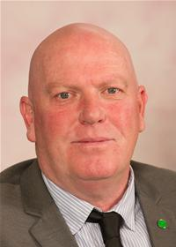

Councillor Maureen Bateson County Councillor John Fillis
Executive Member Regeneration Cabinet Member for Highways and Transport
Blackburn with Darwen Borough Council Lancashire County Council

Foreword 1
Executive Summary 1
Introduction – East_Lancashire's Masterplan 7
How consultation shaped the masterplan 8
East Lancashire Now 9
East Lancashire Now – People and Places 12
People 12
Places 14
East Lancashire Now – Transport and Travel 15
Travel patterns - Longer distances 15
Travel patterns in East Lancashire 16
Looking to the Future – Our priorities 22
Economic Growth 22
Health and Wellbeing 23
Sustainability 24
Looking to the Future– Funding 26
Government funding 26
Strategic partners 26
Developer contributions 27
Looking to the Future– What are the challenges? 29
Our Vision 30
Taking Our Vision Forward – What we're doing now 31
Current Schemes: 32
Transport for Lancashire schemes 34
Other schemes 34
Taking Our Vision Further 36
Taking Our Vision Further –Connecting East Lancashire 37
Rail connections 37
What we will do next: 38
Motorway Gateways 39
What we will do next: 40
Taking Our Vision Further –Travel in East Lancashire 42
Key corridors 42
The M65/A56 Corridor 42
What we will do next: 42
Blackburn Corridors 43
What we will do next: 43
The A59 Corridor 44
What we will do next: 44
Public transport 44
What we will do next: 45
Taking Our Vision Further –Local Travel 47
Cycling 47
What we will do next: 47
Local links 48
What we will do next: 50
Next Steps 51
Securing Developer Contributions 51
Milestones 52
Funding 54
Appendix 1 – Scheme Delivery Timescales and Funding 57
Local Transport Authority Schemes 57
Highways Agency 58
Transport for Lancashire 58
Other Schemes 58
Appendix 2 – A56 Colne to Foulridge Bypass proposal 60
Appendix 3 Blackburn with Darwen 61
Appendix 4 District Maps 62
Burnley 62
Hyndburn 63
Pendle 64
Ribble Valley 65
Rossendale 66
Appendix 5 Glossary 67

Figure 1 LTP Masterplan Areas 6
Figure 2 The study area 9
Figure 3 People 13
Figure 4 Places 14
Figure 5 Longer distance journeys: 15
Figure 6 Major Commuting Movements 17
Figure 7 The Current Network 18
Figure 8: Our current sustainable transport network 19
Figure 9: Traffic problems today 21
Figure 11: Current schemes and proposals 31
Figure12: Connecting East Lancashire 41
Figure 13: Travel in East Lancashire 46

Executive Summary

This document presents the Highways and Transport Masterplan for East Lancashire.

Both Lancashire County Council and Blackburn with Darwen Council, as highways and transport authorities, have a Local Transport Plan (LTP3) that sets out transport priorities until 2021. Both strategies establish a commitment to support Lancashire's economy and to tackle deep-seated inequalities in its people's life chances, revitalising our communities and providing safe, high-quality neighbourhoods.

As part of this, in partnership with the unitary authorities of Blackburn with Darwen and Blackpool, the County Council is producing a set of Highways and Transport Masterplans that will cover the entire county, reflecting the county's economic areas:

- Central Lancashire, covering Preston, South Ribble and Chorley
- East Lancashire, produced jointly with Blackburn with Darwen Council and covering Blackburn with Darwen, Burnley, Hyndburn, Pendle, Rossendale and Ribble Valley
- West Lancashire
- Fylde Coast, produced in cooperation with Blackpool Council and covering Blackpool, Fylde and Wyre and
- Lancaster.

Once completed, these masterplans will set out a cohesive highways and transport strategy for the whole county, linking economic development, spatial planning and public health priorities to the wider policy objectives of the County Council, Blackburn with Darwen Council and Blackpool Council

Future funding allocations from central government will be devolved to the Lancashire Enterprise Partnership (LEP), which covers the local authority areas of Lancashire, Blackburn with Darwen and Blackpool. It is therefore vital

that there is a coherent highways and transport strategy for the whole county, rooted in approved and adopted strategies and plans.

The first of these masterplans has now been completed. The Central Lancashire Highways and Transport Masterplan was approved by the County Council in March 2013 and work is already underway to deliver the transport improvements set out within it.

By their nature, the masterplans need clear and reliable evidence. However, in East Lancashire, that evidence is still emerging. Whilst the economic and public health evidence is robust, not all Local Plans are at the same stage of development across the area. This means that there is no comprehensive set of adopted spatial policies and plans to inform our proposals.

How consultation shaped the masterplan

The consultation on the draft masterplan drew responses from a wide range of organisations and individuals. Our partners, both local and national, the business community and many private individuals took the opportunity to influence the shape of East Lancashire's highways and transport networks.

Across all groups of respondents, there was support for the masterplan and for its vision. There was a general consensus that improved connectivity, both externally and internally, is essential for the future economic growth of East Lancashire.

By far the two biggest areas of discussion, however, were the A56 Colne to Foulridge bypass and the potential rail link to Rossendale. Whilst our partners and East Lancashire's businesses are very supportive of a bypass, public opinion was divided as to the merits, or not, of a bypass. There was, however, total consensus as to the merit of a commuter railway link into Rossendale. In both

cases, we believe that we need to do more work before we can set out a detailed appraisal of viable options for these corridors.

We have taken on board many of the views and ideas we have received. The masterplan we now have is a stronger
document for these responses. As study work comes to fruition, there will be many more opportunities in the coming years to debate and discuss their findings and to make sure that the actions that result from the work presented here are as effective as we can collectively make them.

The masterplan presented here therefore sets out our vision for travel and transport in East Lancashire and how we will work towards that vision. The masterplan will develop as further evidence becomes available, with further consultation at each stage combined with opportunities to comment.

East Lancashire Now

East Lancashire is an area of dramatic contrasts, with moors and farmland surrounding historic towns that were once at the forefront of the industrial revolution. However, since its industrial heyday in the 19th and 20th centuries, the area saw significant economic decline that left a legacy of social and economic challenges.

Manufacturing is still very important for the economy though. East Lancashire has a growing group of higher value industries, with aerospace, advanced manufacturing, advanced flexible materials, digital and creative industries all featuring strongly in the area's economy. These high value industries mean that East Lancashire will play a key role in the success of the Lancashire Advanced Engineering and Manufacturing Enterprise Zone which was launched in April 2012, and in the Arc of Innovation planned by the LEP.

Whilst East Lancashire's population is predicted to increase as elsewhere in the county, the area has a very distinct population profile. In particular, East Lancashire has a
higher proportion of children and young people, providing a window of opportunity to create a large, skilled workforce which can strengthen Lancashire’s economy. There is significant variation in age, ethnicity, wealth, car
ownership and travel patterns across the five districts and unitary authority area of Blackburn with Darwen.

In transport terms, there is a strong belief locally that East Lancashire is poorly connected, with both road and rail networks making it difficult for people and goods to move around.

Whilst road links to the west and south are reasonable, connections to the east are less so, not least because the M65 motorway finishes abruptly just to the west of Colne. Rail links, on the other hand, are either poor or missing:

- Journey times to Manchester, Leeds and Preston are lengthy and for some require a change of train.
- Rolling stock is generally of poor quality now and will fall further behind compared to adjacent networks as they are electrified.
- Fast, frequent and reliable access by train to Manchester Airport is of critical importance, yet there are currently no through services from East Lancashire.
- Rossendale has no mainline rail service of any sort.
- Poor patronage figures for stations on the Colne branch show just how poorly Pendle is served by rail.

Looking to the future

A key driver for East Lancashire’s economic development is the Lancashire Enterprise Partnership (LEP), of which both Lancashire and Blackburn with Darwen councils are members. The Partnership's Lancashire Growth Plan for 2013/14 has been approved and sets out how strong and sustainable economic growth can be achieved in the county.

The partnership is the driving force behind the newly created Lancashire Advanced Engineering and Manufacturing Enterprise Zone that covers the two BAE
Systems sites at Samlesbury and Warton. The partnership has 6 further strategic development sites along the M65 corridor.

There are other more local economic and development plans which form part of the spatial background to the development of our highways and public transport networks.

Also, in April 2013, both Blackburn with Darwen Council and the County Council took responsibility for some work that was previously carried out by the NHS. The county council and the NHS will now work together to tackle some of the key issues that affect people's health and wellbeing, helping people to stay healthy and prevent illness.

Funding

The cost of delivering the package of measures identified in the masterplan, and those that will come out of the work we propose to do, cannot be borne entirely by public sector funding. We have shown that, in areas where we can come to rely on the development industry to contribute funding to new infrastructure, we can increase investor confidence and our ability to attract other sources of funding, and in turn improve the prospects of delivery, and delivering to earlier timescales.

Moving forward, investment in major new infrastructure will, increasingly, need to demonstrate an economic justification. In practice, this means a clear strategy towards bringing forward integrated development proposals for new development and economic growth alongside the infrastructure to support it. In order to deliver our proposals, it is vital that local authorities take every opportunity to coordinate their development planning strategies with future infrastructure investment, and pursue and pool together contributions from the development industry.

New procedures have been put in place for collecting and investing developer contributions. Whilst the Community Infrastructure Levy (CIL) is yet to feature in East Lancashire, it is already proving to be a key mechanism in other parts of Lancashire to delivering major new infrastructure to stimulate and support major house building and business development.

Although market conditions are very different between the Central and East Lancashire, there are areas in East Lancashire that are, or would have the very real prospect to
be attractive areas for developers to build, new residents to live and businesses to locate to and bring jobs.

A number of these areas coincide with transport schemes supported by this masterplan, for example, along the A56 corridor north of Colne to Earby or at Huncoat. In these areas, the prospect for infrastructure delivery will be greatly enhanced in support of new opportunities for development and economic growth and local authorities are encouraged to coordinate future development activity to maximise these opportunities.

The speed and certainty with which we will be able to implement new infrastructure will be directly linked to developer contributions. For this reason it is important that local development frameworks are revisited to bring forward housing sites in locations that have the ability to generate CIL contributions.

Our Vision
The East Lancashire Highways and Transport Masterplan must deliver good, reliable connections for people, goods and services whilst offering choice, facilitating travel on foot, by cycle, bus and rail as well as by car and goods vehicle.

Therefore, the 5 principles that have guided the development of this masterplan are that we will:

- Support the economic development of East Lancashire and of the county as a whole.

- Work to address deprivation
- Promote community resilience
- Increase healthy behaviour
- Reduce our carbon footprint

From these principles, a number of priorities have emerged that we will work towards. We want:

- Sustainable travel to become the choice wherever possible, even in rural areas.
- Our strategic employment sites flourish and be well connected nationally and internationally.
- Local developments and business to be supported and have the strategic and local connections that they need to succeed.
- People from all communities to be able to access the employment and education opportunities that are available both in East Lancashire and further afield.
- Active travel to be encouraged and supported, making walking and cycling safe and easy choices for local journeys.
- Public realm improvements that support both new development and existing communities and enhance the appearance and safety of sustainable travel routes.
- Visitors to find the area attractive and easy to travel around without a car.

Taking our vision forward - What we're doing now

We and our partners already have schemes and proposals in place to tackle some of these problems including:

- Todmorden West Curve
- Blackburn Station Upgrade
- Manchester Road Station Upgrade, Burnley
- Pennine Reach
- Rawtenstall Bus Station
- Nelson to Rawtenstall Bus Corridor Study
- Freckleton Street Link Road
- Haslingden Road Corridor Improvements, Blackburn
- North Valley Corridor Improvements, Colne

Highways Agency 'Pinch Point' schemes:
- M65 Junction 5 improvements
- M65 Junction 4 upgrade

And through Transport for Lancashire (TfL):

- Clitheroe to Manchester Rail Corridor Improvements
- Centenary Way Viaduct Major Maintenance Scheme

Other schemes:

- A56 Colne-Foulridge Bypass (TfL development pool)
- Whinney Hill Link Road

Taking our Vision Further

The work done so far in the masterplanning process has shown us that, despite the improvements we are already making, there will still be issues to resolve on East Lancashire's highways and transport networks.

These issues fall into a number of themes which provide the basis for the further work that we are presenting in this masterplan. The themes are grouped into 3 strands:

- Connecting East Lancashire
- Travel in East Lancashire and
- Local Travel

Connecting East Lancashire looks at how East Lancashire connects to other areas, particularly to the rest of the county and neighbouring growth areas. We need to make sure that its people, economy and housing markets are more fully integrated to areas of opportunity.

Key to this connectivity will be the rail network. This will need to provide the better connections and standards of service that will support East Lancashire's people and businesses in the future.

The main motorway gateways provided by the M65 and the M66 will also need to be able to cope with the demands placed on them.

What we will do next:

- To look at possible solutions to these issues in depth, we are going to commission a Rail Connectivity Study.
- We will build on the work done so far and produce an A56/M66 Haslingden/Rawtenstall to Manchester Gateway Study.
- To find out what else we can do to make sure that the M65 gateway works well, we will produce a Samlesbury / Cuerden / Whitebirk Growth Triangle Study.

Travel in East Lancashire is about the links between East Lancashire's towns and the major employment and housing locations. Economically, these are the connections that make sure that most people and businesses can link into the wider highways and transport networks.

Congestion on key corridors has significant impacts on travel of all kinds, but particularly on travel to work, on businesses and on public transport. We therefore need to ensure that the key corridors can cope with the traffic that wants to use them.

As well as improving public transport reliability, we also need to do what we can to enhance public transport connectivity within East Lancashire, to make bus travel an attractive and viable option where possible, particularly for journeys to employment and education.

What we will do next:

- A Burnley/Pendle Growth Corridor Study will look at what needs to be done to make sure that our roads can support the economic growth planned for Burnley and Pendle.
- The Blackburn Key Corridors have been identified and business cases for funding will be developed.
- The Ribble Valley Growth Corridor Study will include the A59 between Samlesbury and North Yorkshire boundary and also the A671/A6068 route between Whalley and M65 Junction 8.

- The East Lancashire Accessibility Study will focus on travel between the main towns and employment areas, but will also include travel to education and for leisure.

Local Travel takes up the challenge of making sure that everyone, regardless of their background or where they live, can get to the services and opportunities that they need, from education and employment to leisure and health.

Making our cycling and walking networks attractive is key to this. Part of this is making sure that we look after the highways and transport assets we have already – the roads and footways, the lights and signs and all the other things that help our networks function.

But the best road, bus and cycle networks serve no purpose if people can't or don't want to use them. We need to make it easy to change between methods of travel so that whether people are travelling short or long distances, we can reduce dependence on private cars as much as possible for everyone. Making sure that travel to work is cheap and easy also helps the economy.

What we will do next:

- The East Lancashire Strategic Cycle Network will provide 'good' links between towns, employment, education and housing.
- Although we know in general terms what we need to do, much of the work of identifying where we need to improve Local Links will come out of work in other areas of this masterplan and from the day to day contacts we have with our partners and our communities.

The 3 strands are closely linked to each other. Easy local travel, by walking and cycling, needs to feed into the bus and rail networks for longer journeys. The bus and rail networks themselves need to connect properly both for journeys in East Lancashire and to the wider area. No matter how far from East Lancashire people and goods are going, the connections to strategic road and rail networks

must work to make national and international travel as easy as possible.

Running through all 3 strands is the need for transport to support transformational economic growth across East Lancashire. From the largest to the smallest investment that results from this masterplan, from strategic rail improvement schemes down to local footpaths, East Lancashire's transport networks must be made fit for use in the 21st century.

Next Steps

This masterplan represents the beginning of a 10 year programme of infrastructure delivery to serve East Lancashire well into the future.

There is much to do and it will need the commitment and efforts of a variety of providers to see it through – Councils and Transport Authorities, Lancashire’s Local Enterprise Partnership, Highways Agency, Network Rail - and the support of private business and house builders as well.

Over the next 2 years to 2015 we will need to:

- Progress with the studies and other evidence gathering, working with our partners to ensure that we can make the case for the programme.
- Once we have that evidence, consult on and then programme the resulting actions.
- For currently funded schemes, finalise designs, begin to assemble land, and start works.
- For schemes less far advanced, carry out the detailed study work needed to progress to public consultation.
- Begin the preparation of major scheme business cases where appropriate.
- For proposals made in this masterplan, consult and work with communities, stakeholders and infrastructure providers to reach agreement on scheme specifics and secure funding for those proposals.

Delivery and funding of the masterplan will rely on a number of infrastructure providers and a variety of funding

sources, and we will be working closely with these partners to make sure there is the guarantee of their support and assistance, with funding to follow.

Crucial to all this will be the support of residents and businesses. Too often attempts to deliver growth and new development have failed without the buy in and full support of the communities affected. We have the opportunity to make significant and long-term improvements, backed by substantial investment, to East Lancashire’s highways and transport system.

Introduction - Lancashire's Highways and Transport Masterplans

Both Lancashire County Council and Blackburn with Darwen Council, as highways and transport authorities, have a Local Transport Plan (LTP3) that sets out transport priorities until 2021. Both strategies establish a commitment to support Lancashire's economy and to tackle deep-seated inequalities in its people's life chances, revitalising our communities and providing safe, high-quality neighbourhoods. Under the plans, both authorities will:

- Improve access into areas of economic growth and regeneration
- Provide better access to education and employment
- Improve people's quality of life and wellbeing
- Improve the safety of our streets
- Provide safe, reliable, convenient and affordable transport alternatives to the car
- Maintain our assets and
- Reduce carbon emissions and their effects

As part of this, in partnership with the unitary authorities of Blackburn with Darwen and Blackpool, the County Council is producing a set of Highways and Transport Masterplans that will cover the entire county.

Once completed, these masterplans will set out a cohesive highways and transport strategy for the whole county, linking economic development, spatial planning and public health priorities to the wider policy objectives of the County Council, Blackburn with Darwen Council and Blackpool Council. Each masterplan will:

- Outline current issues affecting our highways and transport networks
- Look at the impact of plans and policies in future years, including the Lancashire Enterprise Partnership's Plan for Growth and approved Local Development Framework Core Strategies

- Put forward the measures we consider are needed to support future growth and development and improve our communities
- Outline funding mechanisms and delivery programmes and associated risks.

Future funding allocations from central government will be devolved to the Lancashire Enterprise Partnership (LEP), which covers the local authority areas of Lancashire, Blackburn with Darwen and Blackpool. It is therefore vital that there is a coherent highways and transport strategy for the whole county, rooted in approved and adopted strategies and plans. More detail on future funding is provided later in this masterplan.

Rather than produce a masterplan for each district, five masterplans will reflect the travel areas identified in the County Council's Local Transport Plan:

- Central Lancashire, covering Preston, South Ribble and Chorley
- East Lancashire, produced in cooperation with Blackburn with Darwen Council and covering Blackburn with Darwen, Burnley, Hyndburn, Pendle, Rossendale and Ribble Valley
- West Lancashire
- Fylde Coast, produced in cooperation with Blackpool Council and covering Blackpool, Fylde and Wyre and
- Lancaster.

Whilst the majority of districts fall within one area, Ribble Valley is more complex. In travel terms, those ties are principally to central and east Lancashire and it is therefore included in 2 masterplan areas.

All five masterplans will integrate to ensure that the whole of Lancashire sees economic and housing growth that will maximise its potential by identifying the highways and transport improvements that will be needed both to maximise economic growth across Lancashire and meet the local visions identified in each area.

All the masterplans require similar evidence, which must be up-to-date and accurate. Local Plans, the planning policies that set out how an area will develop, must be able to provide details of future land use and there must be a sound economic strategy in place. Existing travel and transport must be understood and there must be evidence as to the impact of future development on the highways and transport networks. The health and social needs of the population must also be known.

However, even where all this evidence is not in place, the development of the masterplans allows us to establish and build consensus on the principles and priorities that will drive our highways and transport activities. These masterplans therefore provide an important opportunity to inform and shape emerging development strategies and ensure the proper alignment of investment decisions affecting both future development and infrastructure.

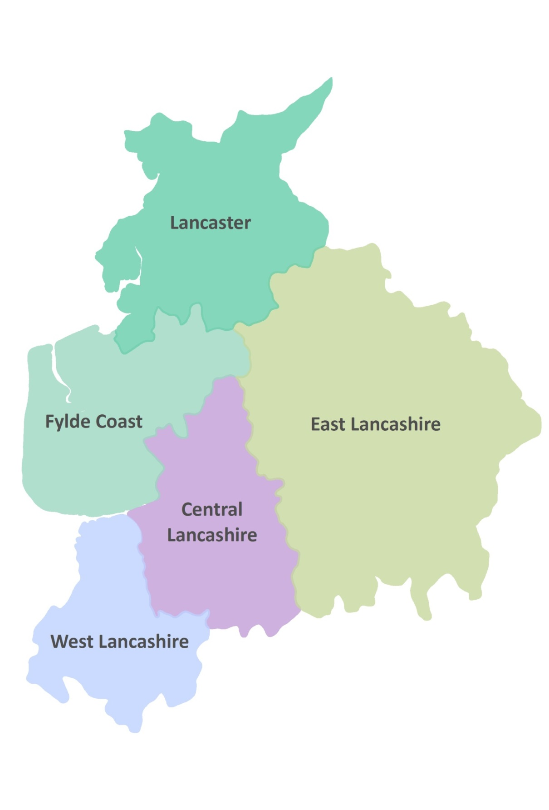
Figure 1 LTP Masterplan Areas

Introduction – East_Lancashire's Masterplan

This document presents the Highways and Transport Masterplan for East Lancashire. Recognising Blackburn with Darwen Council's and Lancashire County Council's transport priorities, it sets out how we will develop our future highways and transport strategy for Blackburn with Darwen, Burnley, Hyndburn, Pendle, Ribble Valley and Rossendale to 2023 and beyond.

The fundamental purpose of transport is to enable economic and social activity. It allows people to get to work, to access services and to see friends and visit places. It also allows businesses, suppliers and customers to come together. However, transport also impacts on people, on places, and on our environment. Traffic congestion brings delay and disrupts communities; road accidents cause injury and suffering; vehicle emissions affect local people's health and contribute to global environmental problems and so on.

Balancing the positive and negative impacts of transport is vital in providing sustainable highways and transport networks for the future. However, we can only do this if we consider the consequences that changing these networks will have not just on the users, but on the people, environment and economy of East Lancashire, both now and in the future.

The need for robust evidence has been highlighted but in East Lancashire, whilst some evidence is in place, some evidence is still emerging.

Economic and public health evidence is robust. The Lancashire Enterprise Partnership has adopted the Lancashire Growth Plan 2013/14 that sets out where they will promote strategic economic growth and the individual authorities also have established development priorities. There is also a wealth of information about health in the area.

However, not all Local Plans are at the same stage of development across the area, which means that there is no set of definitive adopted spatial policies and plans.

Blackburn with Darwen not only have a Core Strategy but have also published more detailed site allocations and, as highways authority, have identified infrastructure required to deliver the planned economic growth. Hyndburn and Rossendale have recently adopted Core Strategies. Burnley and Pendle adopted their Local Plans in 2006 but are now replacing them and have new emerging Local Plans, whilst Ribble Valley has publicised its Core Strategy.

Whilst we do have evidence of current conditions on the highways and transport networks in East Lancashire, our information about the actual journeys that people make is now old and we are waiting for the release of data from the 2011 Census. We also have transport studies planned and in progress in the area which will provide us with much better evidence as to how transport can best support East Lancashire's economy and people.

Without total confidence in our information on the current situation, and with adopted Core Strategies in only 3 districts, the masterplan sets our vision for travel and transport in East Lancashire and how we will work towards that vision.

This masterplan therefore:

- Describes East Lancashire's people and places as they are now
- Outlines what we know of current transport patterns and identifies issues with the current highways and transport networks that support East Lancashire
- Sets out the current plans and policies that will impact on the area in the future.
- Uses the evidence to establish what challenges our transport networks face

- States our vision for what our highways and transport networks should be able to do by 2026
Shows what work is already underway to achieve that vision and
- Lastly, sets out how we will to take the masterplan forward.

How consultation shaped the masterplan

The consultation on the draft East Lancashire Highways and Transport Masterplan drew responses from a wide range of organisations and individuals. Our partners, both local and national, the business community and many private individuals took the opportunity to influence the shape of East Lancashire's highways and transport networks. The results of the consultation

The future work presented in this masterplan will ultimately affect us all, so having support from our stakeholders is very important to us. We are very grateful for all the comments that have been made on our proposals and now feel that we are better informed and have a stronger basis on which to develop our studies and thinking, as well as influence our partners.

Across all groups of respondents, there was support for the masterplan and for its vision. There was a general consensus that improved connectivity, both externally and internally, is essential for the future economic growth of East Lancashire. This masterplan recognises the importance of connectivity from the most strategic down to the most local.

A number of stakeholders across different groups expressed concern at the lack of sustainable transport measures in the masterplan. We feel that we have struck the correct balance between facilitating traffic on our highways network whilst providing better alternatives for those who choose to use them. Improving rail connectivity, public transport, cycling and walking are all integral to this masterplan, but these improvements need to happen before leaving the car behind becomes the natural thing to do.

Other comments have offered more detailed ideas for new junction arrangements and changes to road space, and improvements to public transport. These include ideas for

new transport infrastructure but also for improving the existing network. Whilst these may not appear in this
'high-level' plan, these suggestions will inform more detailed work to come, and there will be many more opportunities to comment on and influence the studies as we go forward.

By far the two biggest areas of discussion, however, were the A56 Colne to Foulridge bypass and the potential rail link to Rossendale.

Options to guide the development of the A56 Colne to Foulridge Bypass were presented in the masterplan, with the County Council expressing a preference for the 'Brown' route.

This section of the masterplan elicited more response than any other by a significant margin, but opinion is polarised as to the merits, or not, of a bypass. Almost without exception, there is total support for the 'Brown' route amongst businesses and our partners. However, amongst the public, responses are more mixed, with four distinct opinions emerging in questionnaires distributed during and after an event in Colne specific to the bypass:

- 45% were in favour of the 'Brown' option.
- 17% were in favour of some other A56 bypass option
- 11% wanted some other bypass of Colne and
- 27% were against any bypass.

However, there have also been a number of petitions specifically against the 'Blue' route and also against the building of any bypass.

This consultation response does confirm that we do have support to undertake the next stage of the work that will give us the evidence to draw up detailed design proposals for all the southern options. These options will include

what could ultimately be done along the North Valley to increase capacity in the absence of a bypass, as well as detailed consideration of all possible routes for an A56 Colne to Foulridge bypass. Once this work has been completed we will be able to consult on our final proposals.

The second area of concern was that the masterplan did not commit to reinstating commuter services on the Rawtenstall to Bury rail line. We believe that more detailed work needs to be done before such a commitment can be made.

That detailed work was originally programmed as part of the rail connectivity study. However, in the light of suggestions and comments in the consultation, we will take now take it forward as an element of the gateway study, which will now have a stronger focus on the role of the A56/M66 corridor as a whole, for all modes and for all journeys into the wider East Lancashire area.

We have taken on board many of the views and ideas we have received. The masterplan we now have is a stronger document for those responses. As study work comes to fruition, there will be many more opportunities in the coming years to debate and discuss their findings and to make sure that the actions that result from the work presented here is as effective as we can collectively make them.

East Lancashire Now

East Lancashire, which had a population of 530,500 in 2012, is an area of dramatic contrasts, with spectacular moors and farmland surrounding historic towns that were once at the forefront of the industrial revolution. However, since its industrial successes of the 19th and 20th centuries, the area has seen significant economic decline which has left a legacy of social and economic challenges, including deprivation, unemployment and a relatively poor skills base in some urban parts of the area.

Manufacturing still remains a key driver for the economy though, with employment in the sector more than double the national average. East Lancashire has a growing portfolio of higher value industries with aerospace, advanced manufacturing, advanced flexible materials, digital and creative industries all featuring strongly in the area's economy. These high value industries mean that East Lancashire will play a key role in the success of the Lancashire Advanced Engineering and Manufacturing Enterprise Zone which launched in April 2012 and in the Arc of Innovation established by the LEP, which will link world class clusters of industry, technology development and research excellence.

The area has economic links to a much wider area however, which have shaped the study area of the masterplan, as Figure 2 shows.

East Lancashire's industrial heritage has given the area a very distinctive character. Whilst the architectural legacy includes heritage townscapes, it also includes the utilitarian terraced housing that is the stereotype of East Lancashire. Much of this traditional housing is unfit for purpose and adds to the economic, health and social challenges faced by much of the area; however the housing offer of the area is now evolving to meet current and future demand.

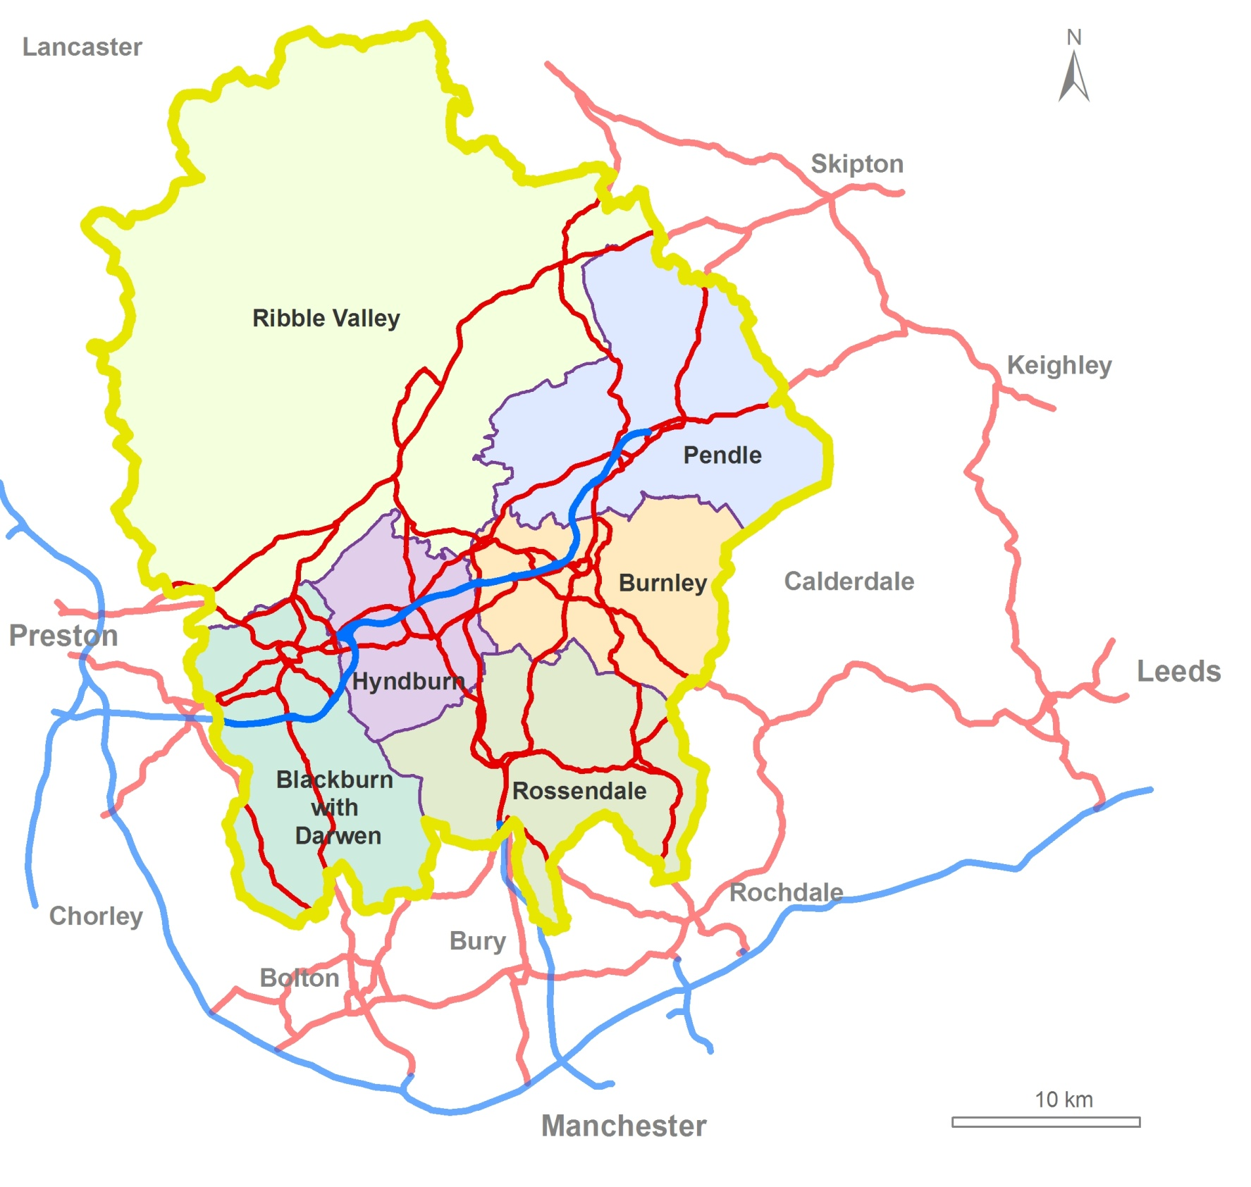
Figure 2 The study area

The six areas that make up East Lancashire each have their own character:

Blackburn with Darwen

The borough consists of a relatively compact urban area set within the countryside between the high land of the metropolitan borough boundaries of Bolton and Bury in the south and the Mellor ridge to the north. The West Pennine Moors form a natural barrier towards Chorley to the west and Rossendale to the east. Within this dramatic landscape, the borough covers an area of 13,700 hectares and has a population of 141,200 people in approximately 55,000 households,

The borough has an extremely young population, with nearly a third of residents aged 0-19 years. Coupled with a population increase over recent years, the population is forecast to grow by 10% by 2035. As a result, there will need to be a significant increase in the provision of a range of high quality housing.

Blackburn with Darwen offers high value employment, attracting people from outside the borough. Despite this, Blackburn with Darwen still faces some social and economic challenges in parts of the urban area

Blackburn is the largest town in East Lancashire and provides the focus for the western part of the area. It is a key destination for shopping and employment and is home to Blackburn College, the largest Further Education college in East Lancashire, and also to the area's principal emergency hospital. The town has seen major investment in recent years, with substantial highway improvements and on-going redevelopment including the Cathedral Quarter and the Knowledge Zone.

Sitting south of Blackburn is Darwen, the second largest settlement in the borough. Darwen town centre fulfils a market town role providing small scale retail developments and community services. The town retains a strong identity and the surrounding hills and moors present a striking backdrop.

Burnley

Although it is a largely rural district, Burnley's economic strengths are mainly in manufacturing, distribution, hotels and retail, public administration, education and health. Advanced manufacturing is a key sector, with Burnley a nationally significant hub for the aerospace industry. Automotive and construction are also important manufacturing sectors.

The town of Burnley has similarities to Blackburn. It provides a focus for the most easterly districts of the county. It is a key destination for shopping and employment and is home to Burnley College, UCLan and the new University Technical College and also to the area's second hospital. Also like Blackburn, the district has seen significant investment, with the LEP committing substantial Growing Places funding to Burnley for the Weaver's Triangle and the Burnley Bridge business park. Burnley has been awarded the most enterprising town in Britain award 2013.

Burnley is the third most populous borough in East Lancashire. Burnley's population has declined in the past due to migration out of the district. By 2035 however, it is estimated Burnley's population will show a 3% increase.

Whilst the borough has well off areas that are highly desirable residential locations, the town of Burnley itself has some areas with high levels of deprivation as a result of the declining influence of the textile industry. This has resulted in significant social and economic challenges in some parts of the district, including low skill levels, worklessness, poor quality housing and health inequalities.

Hyndburn

Geographically, Hyndburn is the smallest district in Lancashire covering just 73 square kilometres; it is, however, one of the most densely populated. The principal town is Accrington, which has a particularly rich architectural heritage.

Hyndburn has a small economy which has experienced limited growth over recent years. The area's economic base is rooted in textiles, engineering, chemicals and extractive industries. Manufacturing is one of the area’s key strengths with 23% of employees working in the sector.

There are large differences in income levels between the more affluent wards in the rural areas and the least affluent wards within urban centres. In common with some other districts in East Lancashire, Hyndburn has significant issues in some parts of the district including the quality and price of housing, the poor health of many residents, low levels of job creation and areas of severe economic deprivation.

The population is set to grow by only 7% by 2035, which is below the Lancashire average. As a result, the projected growth of household numbers in the authority is below national and county averages.

Pendle

Pendle has the second largest district population in East Lancashire. It has a mix of high quality rural areas, a large part of which are in an Area of Outstanding Natural Beauty (AONB), and dense urban areas centred around the M65 motorway in the towns of Brierfield, Nelson and Colne. Barnoldswick and Earby, in the largely rural north of Pendle, are home to a number of prominent businesses.

Pendle has a diverse economy. Manufacturing is a key activity with Pendle having the highest relative share of employee jobs in the manufacturing sector in Great Britain. The aerospace industry is a major strength, supporting high value employment and also the wider economy through supply chains in the area, with Rolls Royce a major aerospace employer. Precision engineering, textiles and furniture are also important.

As well as high value manufacturing, Pendle has a service function and a strong visitor economy based around the Forest of Bowland AONB. It is also a major shopping destination with Boundary Mill and Colne attracting 2.6 million visitors each year from across the region and Yorkshire.

Pendle’s population is growing with an expected 11% increase by 2035. There will, therefore, be significant increase in housing provision alongside a need for new jobs.

As with many districts in East Lancashire, the industrial change the area has undergone has resulted in significant social and economic challenges in some areas, characterised by low skill levels, worklessness, poor quality housing, significant health inequalities and high concentrations of deprivation.

Ribble Valley

Geographically, Ribble Valley is the largest district in Lancashire, although the rural nature of the district means it has the lowest population and population density in the county. Over 70% of the borough is within the Forest of Bowland Area of Outstanding Natural Beauty (AONB). The administrative centre is the attractive market town of Clitheroe.

Ribble Valley has a small mixed economy, with manufacturing, agriculture and tourism the most prominent sectors. Distribution, hotels and restaurants account for a large proportion of employment and many farming businesses have diversified to offer locally produced food and drink, retail, leisure and business facilities and tourism related activities. The district is home to BAE Systems and the Lancashire Advanced Engineering and Manufacturing Zone.

The rural nature of the district and the affluence of many of its residents mean that Ribble Valley has few of the problems of the dense urban areas of East Lancashire. However, the rural setting does mean that geographical isolation is an issue for less well off residents.
The overall population of the district has seen a strong growth for a number of years. Of particular note are the higher proportions in the older age groups, especially in the 45-54 age group. By 2035 the population of Ribble Valley is expected to increase by 9%.

Rossendale

More so than in any other part of East Lancashire, the geography of Rossendale has shaped the district. The steep valleys, cut into the moors by the River Irwell and its tributaries, have resulted in linear urban areas that straddle the main roads along the valley bottoms. The local countryside is rich with wildlife and is an important asset for tourism, attracting ramblers, wildlife enthusiasts and cyclists.

Rossendale has a small economy with manufacturing the main industry and strengths in tourism, construction and service sectors. Despite the continued decline in manufacturing employment there has not been a substantial shift in the local economy toward other industries, with the area poorly represented in higher growth sectors, although the area is home to Scout Moor, the largest onshore windpower project in England.

There is a healthy business enterprise base, dominated by small businesses and good self-employment rates, but half the working population commute to jobs outside the borough, earning significantly more than those who do not.

Rossendale's population is growing with an expected 13% increase in inhabitants by 2035. This is above the 10% average increase in Lancashire and is the largest in East Lancashire.

As a result, the standard of housing and levels of deprivation greatly differ from east to west. The west is desirable for commuting due to its good connectivity, resulting in high house prices and low levels of deprivation. The east of Rossendale is less well connected. Consequently, house prices are lower and deprivation is more severe and widespread.

East Lancashire Now – People and Places

People

Whilst East Lancashire's population is predicted to increase as elsewhere in the county, the area has a very distinct population profile.

In particular, East Lancashire has a higher proportion of children and young people, providing a window of opportunity to create a large, skilled workforce which can strengthen Lancashire’s economy.

Like much of the county, East Lancashire has an ageing population. However, the proportion of those over 75 is smaller than other areas, although the number of people over 75 has increased in recent years and is projected to continue to do so.

A further distinctive feature within East Lancashire is the diversity within its population, with 17% from BME backgrounds, of which a large proportion are of South Asian heritage.

There are wide health inequalities within East Lancashire. This is driven by relatively high early death rates in some areas from cardio-vascular, cancer and respiratory diseases and also by accidents, chronic liver disease, suicides and infant deaths. Mental health issues are also more common in some areas.

These poor health outcomes are linked to the relatively high levels of socio-economic deprivation in some communities caused by the long-term decline in the textiles industry. This deprivation is the result of a combination of factors including low income levels, unemployment, low education levels and poor housing, coupled with community factors such as a lack of community cohesion and higher crime levels.

Across the East Lancashire area;

- Whilst the unemployment rate across East Lancashire as a whole is below the North West average, unemployment is an issue in some areas, particularly parts of Blackburn with Darwen, Burnley, Hyndburn and Pendle.
- Self-employment is above the North West average.
- Average gross weekly pay of residents is well below the North West average in all districts except Ribble Valley.
- Reflecting this, the number employed in managerial and professional jobs is much lower than the North West average across much of the area.
- Education levels are low across some areas, with parts of Burnley, Blackburn with Darwen, Pendle and Rossendale in particular having below average numbers qualified to NVQ level2 or above

Where people live determines where many journeys start and end, so the more people in an area, the greater the demand on the network. This is particularly true of commuting, which currently places by far the biggest strain on our transport systems as many workers try to travel in a relatively short period of a few hours in the morning and early evening.

Figure 3 shows how the population of East Lancashire is spread across the area, as recorded in the 2011 Census. The largest settlements follow the line of the M65, from Blackburn in the west to Colne in the east. The very linear nature of Rossendale is also clear from the map. Predicted population growth is varied, with very small increases in some districts, but far greater growth in others.

What are not shown on the map are the small settlements that are scattered across the rural areas. These communities have only a very limited impact on overall travel patterns because, individually, the numbers of journeys are small. However, their needs are still an essential consideration for this masterplan.

The neighbouring towns and cities that have a major influence on East Lancashire are also shown. Preston and Central Lancashire are at the heart of Lancashire's economic growth plans. However, Blackburn with Darwen and Rossendale also have strong economic and physical links to Greater Manchester, whilst Pendle and the Ribble Valley have links to Yorkshire.

.

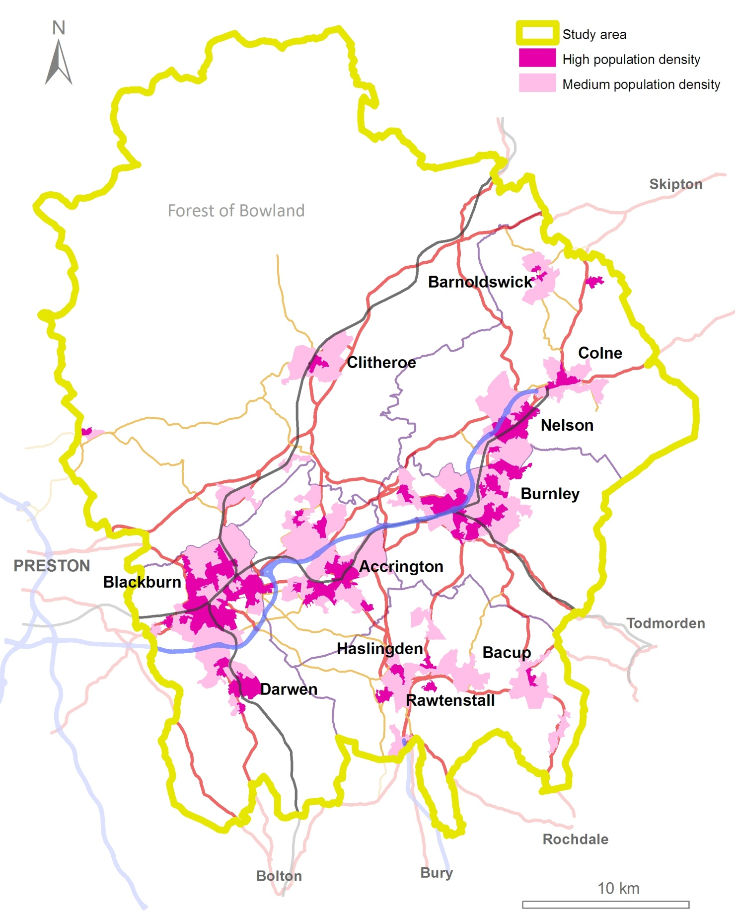
Figure 3 People

Places

The other major influence on travel patterns are the places that people want to travel to.

Whilst our town centres have traditionally been a focus for employment and shopping, out of town locations are now also major destinations for both people and goods. Both Oswaldtwistle and Colne in particular are home to major retail developments that attract visitors from a much wider area.

Large numbers of journeys are also made to the hospitals and education facilities in Blackburn and Burnley, as well as some to facilities in West Yorkshire.

Tourist and sporting destinations can also attract large numbers of journeys. The East Lancashire Railway and the Adrenaline Gateway, both in Rossendale are both significant tourist attractions and both Blackburn and Burnley have football venues that attract fans from across the country.

Large numbers of people also visit the countryside of East Lancashire, in particular the Forest of Bowland AONB and the West and South Pennine Moors, and whilst these journeys are in smaller numbers to smaller destinations, combined they become more significant.

Figure 4 shows the places that are visited by large numbers of people. Together, people and places shape the demand for travel in, to and from East Lancashire. The next section looks at this travel demand and how it affects the highways and transport networks.

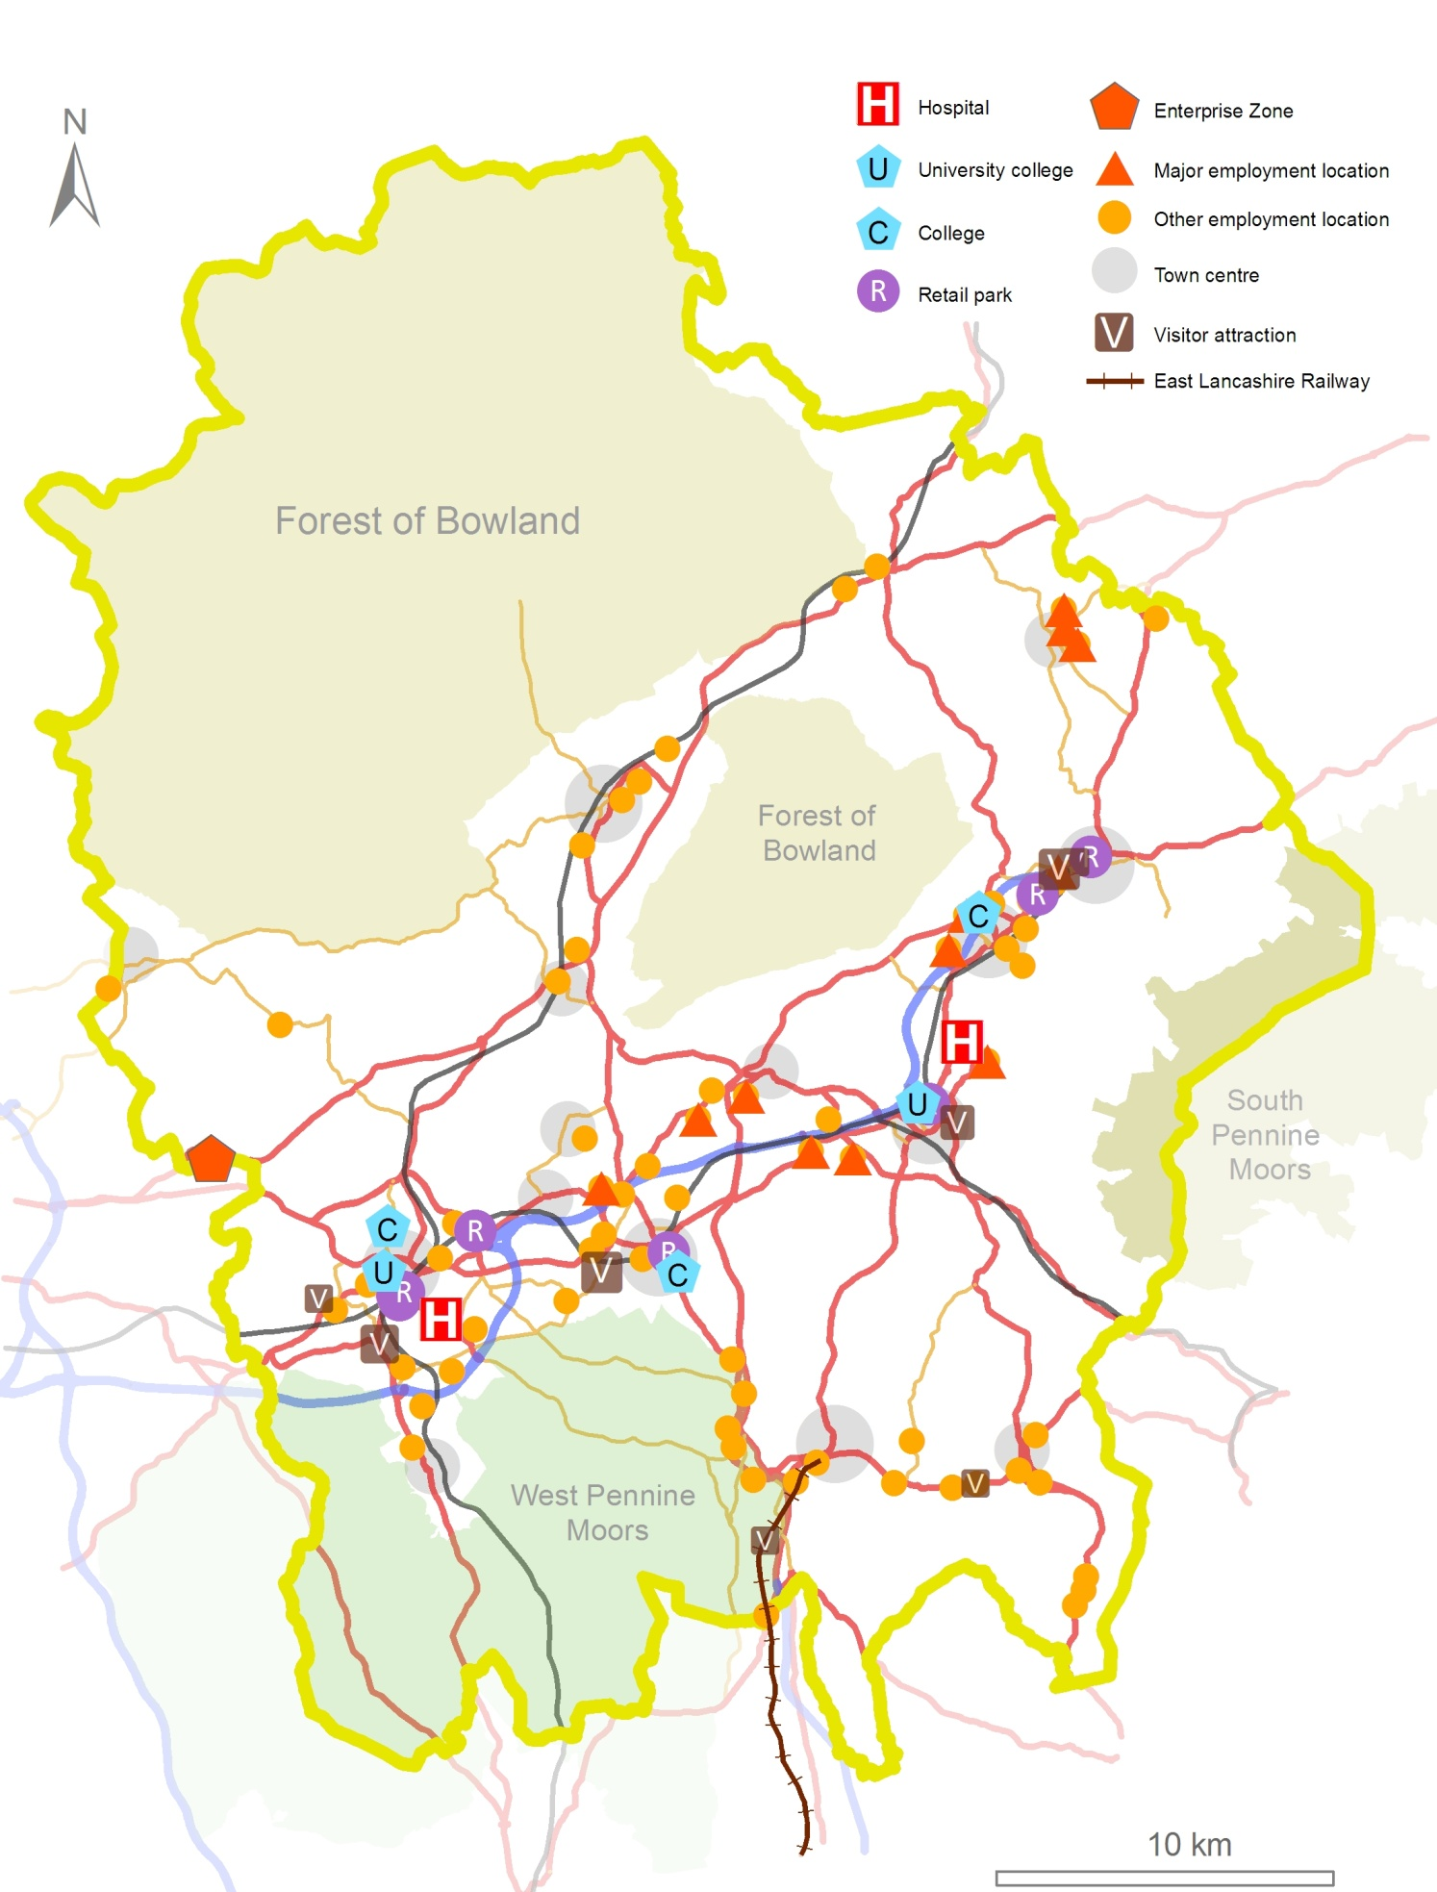

Figure 4 Places

East Lancashire Now – Transport and Travel

Travel patterns - Longer distances

Blackburn and Burnley are the major transport hubs for the East Lancashire area. Both have good connections to the strategic road network and Blackburn provides a gateway to rail services from Preston (West Coast Mainline) and Manchester. Hyndburn also has good road and rail connectivity.

Pendle, at the end of the East Lancashire line, has limited rail services, whilst Rossendale has no mainline rail connection of any sort. Pendle, Burnley and Rossendale do, however, benefit from a frequent high quality bus service to Manchester.

As well as journeys to and from East Lancashire, there are also large numbers of journeys that cross the area, as East Lancashire sits on a main corridor between the North West and Yorkshire and Humberside.

The M65 and A59 provide the principal east-west road links across the area. The M65 has junctions with the M6/M61 in the west, but at its eastern end finishes abruptly just outside Colne, leaving long distance traffic to travel through Colne on its way to and from the motorway.

Links to Manchester are provided by the A56(T) which runs from the M65 to join the M66 at Edenfield.

A cross-Pennine rail service links Preston to Leeds through Blackburn and Burnley. However, there are currently no direct rail services to Manchester other than from Clitheroe and Blackburn.

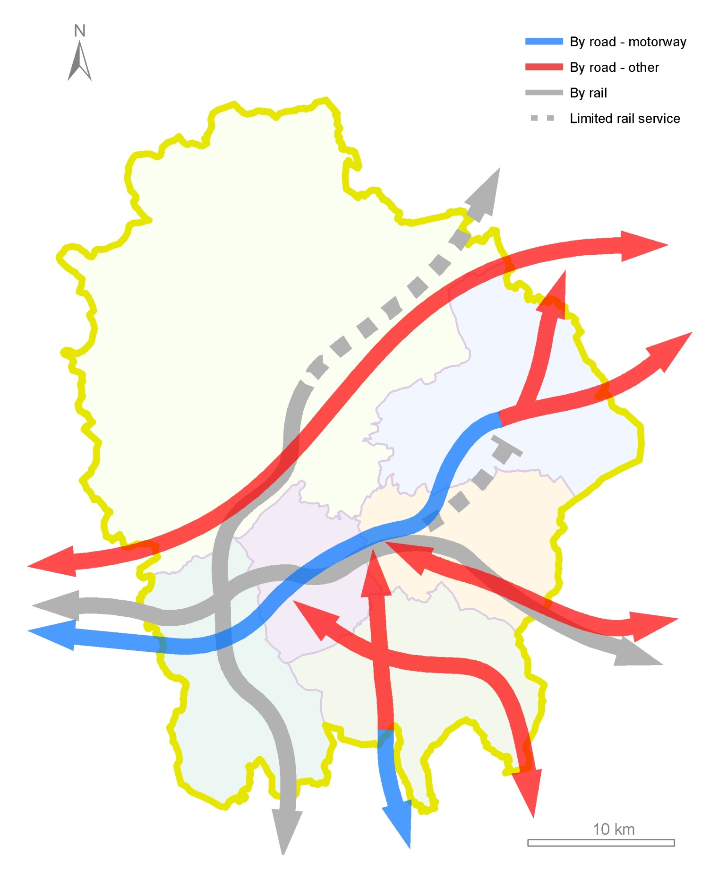

Figure 5 Longer distance journeys:

Travel patterns in East Lancashire

Information on where people live and need to travel to in East Lancashire, together with an understanding of the longer distance journeys in the area, provides a basis to understanding the main journey patterns in the area.

Journeys are made for many purposes, but the purpose that dominates the busiest times of the working week is the journey from home to work. This is also the journey type about which most information exists.

Questions about travel to work were asked in the 2011 Census. So far, none of this information, including the numbers of people commuting between different towns and small areas, has been published. When it is, it will be used in the further development of this masterplan. Figure 6 therefore shows best information we have now, although we know that this picture is based on old information and its reliability is therefore questionable.

The major commuter journeys (more than 1,500 a day) are shown in figure 6. The bonds that exist along the M65 corridor are clearly shown, with particularly strong links between Burnley and Pendle and between Accrington and Blackburn with Darwen. Rossendale has very strong connections with Greater Manchester, whilst Blackburn with Darwen and Burnley also have links to Manchester itself. There is also commuting between the districts on the M65 corridor and Central Lancashire. Ribble Valley has ties to Burnley, Blackburn with Darwen and Central Lancashire, with large numbers coming to work in the district, principally at Samlesbury.

Not shown on figure 6 are the commuter journeys that happen within local areas. Blackburn with Darwen and all five districts all have very high internal daily commuter flows, from around 6,000 in Rossendale, to around 8,000 in Hyndburn, Pendle and Ribble Valley, 9,000 in Burnley and over 13,000 in Blackburn with Darwen.

Whilst most commute times are currently under 15 minutes in most districts, recent survey data shows that the majority of people would be prepared to travel further than they do now, with most prepared to travel for at least half an hour. This will make connections to the wider jobs market all the more important, to ensure that access to these jobs is available to all East Lancashire's residents, not just those that own a car.

These commuter movements take place in the context of a highway network that has reached or is reaching capacity in a number of places but where sustainable modes are becoming a viable option for some journeys.

The public transport network is, in urban areas, comprehensive, there is a developing cycle network and pedestrian facilities are improving.

However, the reality is that the majority of commuters still chose to use cars. Across East Lancashire, around 70% of commuter journeys are made by car, even in areas of low car ownership where car sharing is more common. For some, it is a choice, often due to perceptions and lack of knowledge of alternatives. For some though, particularly in rural areas, it is a matter of necessity as there are currently only limited viable alternatives.

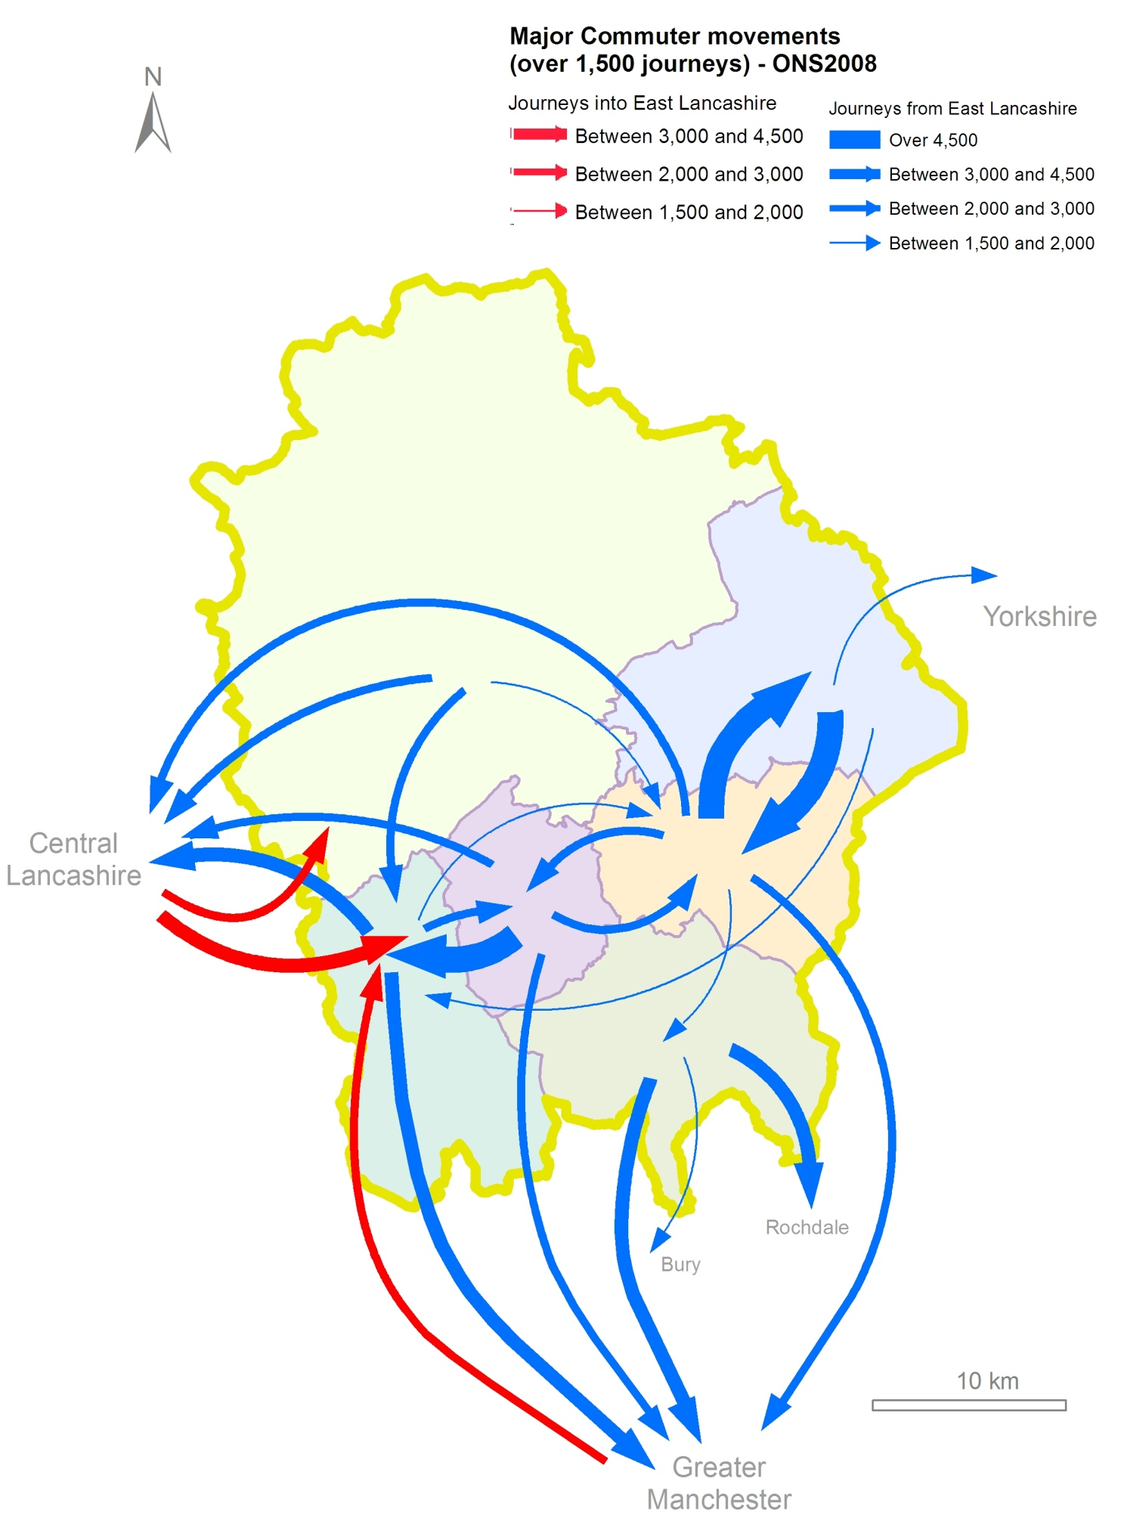

Figure 6 Major Commuting Movements

So far we have looked at where people live, where they are likely to travel to and have showed the resulting travel patterns. But what impact do these journeys have? What do we see on our highways and transport networks?

The car is the dominant travel choice for most people for most journeys. There are many reasons for this, but the most obvious impact on our roads is the amount of traffic they carry, not just in the peak hours but through the whole day.

Figure 7 shows the number of motorised vehicles that use our major roads in a typical day. As would be expected, the highest flows are on the motorway, but there are also some very high volumes of traffic on the roads that are shared by other users for other purposes than simply getting from A to B.

These high levels of traffic on the roads in our communities clearly have impacts that are felt by everyone, not just vehicle occupants.

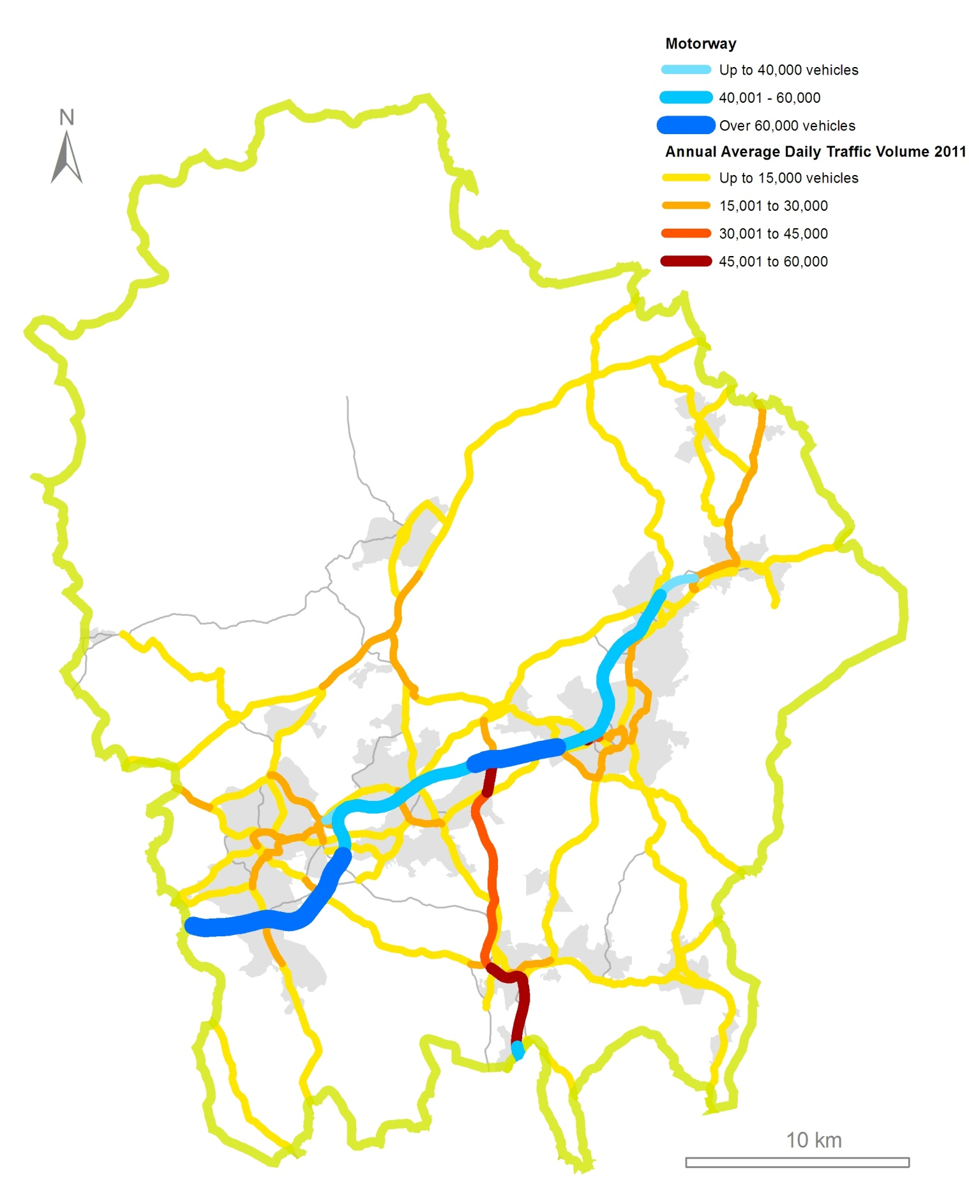
Figure 7 The Current Network

The previous map shows the volume of traffic on our major roads. This traffic of course includes buses, which suffer the same delays as other road users unless there are dedicated bus lanes etc. Bicycles may not be counted in the traffic totals, but cyclists also have to share this road space unless they have dedicated cycle provision.

Figure 8 shows the main sustainable transport provision in East Lancashire. Not surprisingly, the busiest rail station is Blackburn (with over 1.3m users), providing as it does the rail hub for the area and having the only direct service to Manchester at the moment. However, the importance and potential of Clitheroe to its catchment area is also clear and Accrington and Burnley Manchester Road are also busy stations.

The East Lancashire Railway is a heritage society operating services between Rawtenstall and Heywood. The line provides the only direct rail service between Rossendale and Manchester and, although predominantly a tourist attraction, does serve the local community as well, notably continuing to operate during severe weather.

The high frequency bus network, which shows the most heavily used services, is good in the urban areas and the links to Greater Manchester are good, particularly the X43 'Witch Way' express bus service and the 'X41' Lancashire Way. Links into the Ribble Valley are more limited, not surprising given the rural nature of the district.

Cycling provision is more varied, although the beginnings of a good cycling network are in place.

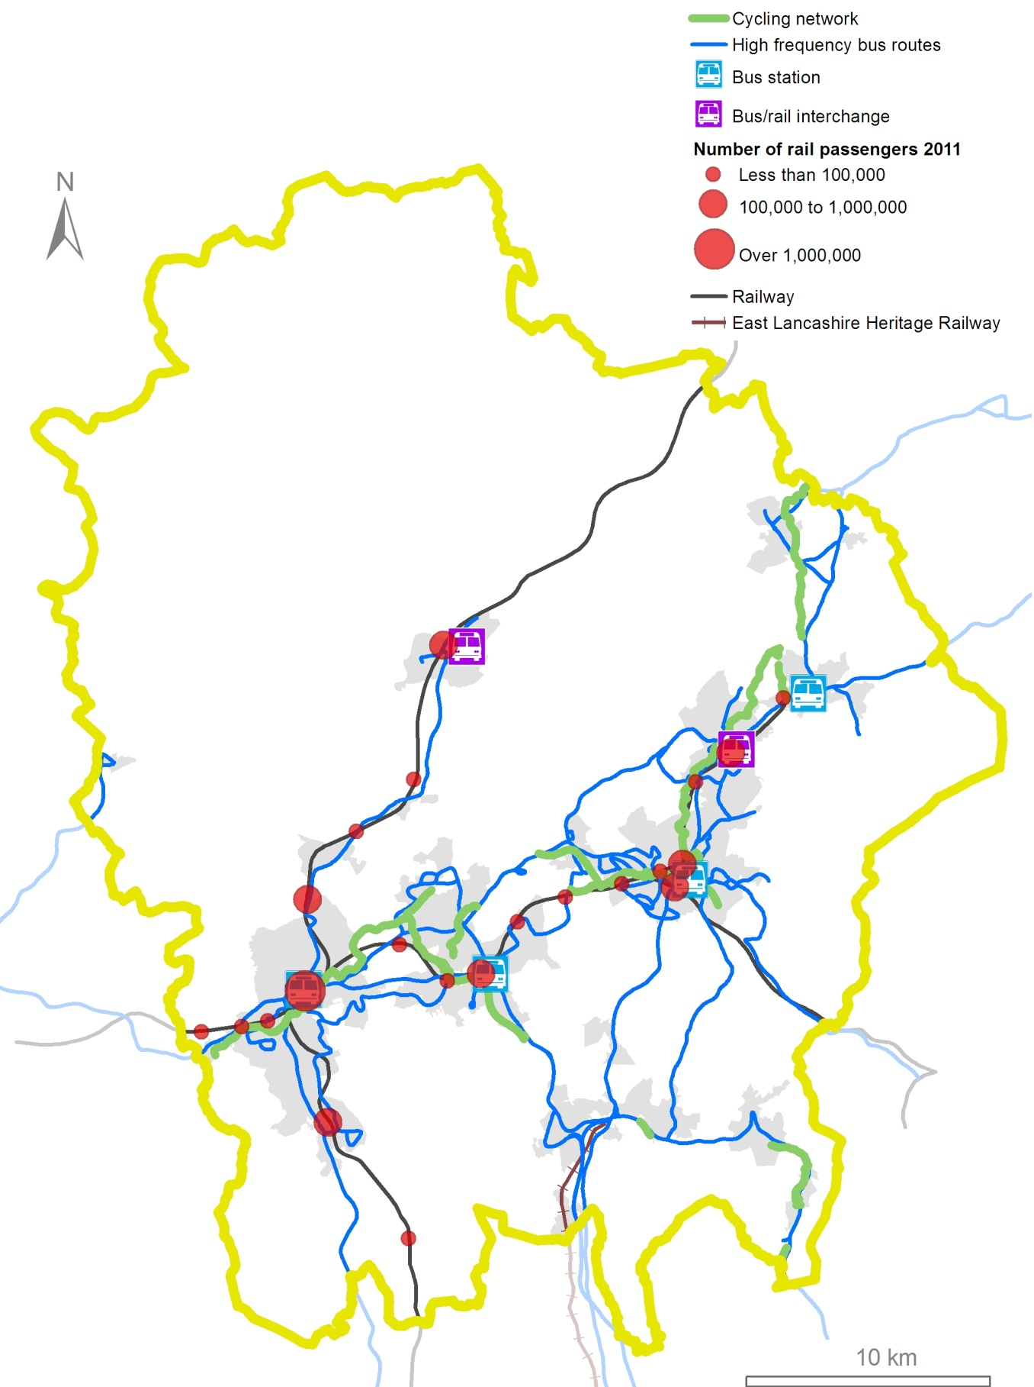
Figure 8: Our current sustainable transport network

So far we have looked at the demands on the network from where people live, where they want to travel to and how they choose to travel.
We now want to look at the impact these journeys have on the economy and on us as we travel about in our daily lives.

There is a strong perception locally that East Lancashire is poorly connected, with both road and rail networks making it difficult for people and goods to move around.
Whilst road links to the west and south are reasonable, connections to the east are ineffective, not least because the M65 motorway finishes abruptly just to the west of Colne. Rail links, on the other hand, are either far from adequate or non-existent:

- Journey times to Manchester, Leeds and Preston are lengthy and for some require a change of train.
- Rolling stock is generally of poor quality now and risks falling further behind compared to adjacent networks as they are electrified.
- Fast, frequent and reliable access by train to Manchester Airport is of critical importance, yet there are currently no through services from East Lancashire.
- Rossendale has no mainline rail service of any sort.
- Poor patronage figures for stations on the Colne branch show just how poorly Pendle is served by rail.

These issues are discussed in more detail when we look at how we can develop our options for travel in East Lancashire.

More locally, the biggest issue is congestion. Some congestion is inevitable; better economic conditions tend to produce more traffic. However, too much congestion hampers business and makes travel difficult for everyone.

The worst congestion is at peak commuting times, but these peak times are getting longer and traffic is building on less suitable routes as people change their travel patterns to try to avoid the jams.

But congestion is only part of the problem. Increasing traffic has a wide range of unwelcome side effects. Impacts on road safety (a particular problem in the urban areas of East Lancashire) and on local air quality are the most obvious. However, where roads are busy with motor traffic, they can become barriers to local movement. Busy roads can make people worry about safety or about how difficult walking and cycling will be. For instance:

- people are far less likely to want to cycle or walk any distance due to fears about safety and pollution
- communities suffer if the roads that run through them are busy and difficult to cross other than at limited places
- local centres cannot become sustainable if busy roads make the area unattractive and potential visitors therefore go elsewhere

And as well as these local impacts, there are the wider environmental and social impacts that affect our ability to meet our commitments to:

- reduce carbon emissions
- improve personal health and well-being in Lancashire
- support economic development
- increase community cohesion and
- provide affordable travel options in the future

Until more people have alternatives to the car that they are confident will meet their needs, the number of cars will continue to grow, at least as long as people can afford to run them. The cost of motoring is already a significant burden to many lower income households and this burden becomes even greater as the distance needed to be travelled increases, as happens from more rural areas. The provision of improved walking, cycling and public transport infrastructure is vital to support sustainable economic growth.

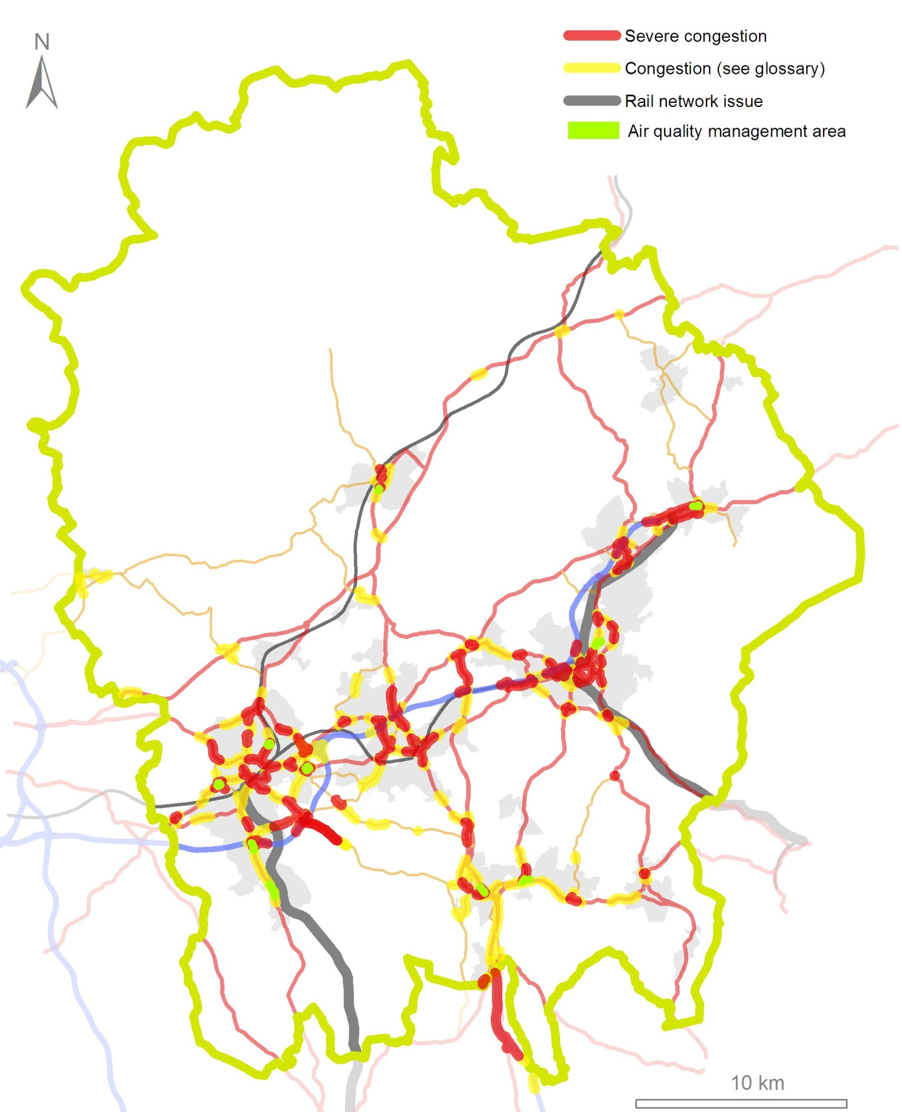
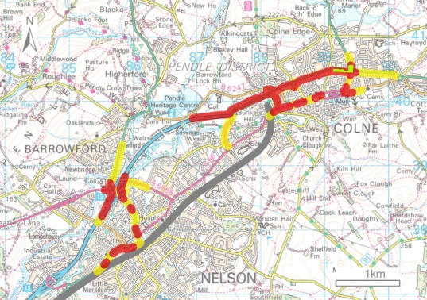
Figure 9 shows where the most urgent and significant highways problems are in East Lancashire, both the congestion (based on the latest 2012 data) and also where air quality is being affected. Congestion also presents significant issues for public transport reliability and for our communities.

The diagram also shows the rail corridors that are not performing as well as we would like.

Figure 9: Traffic problems today
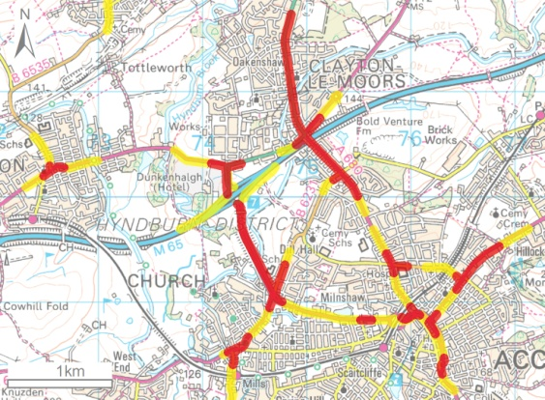
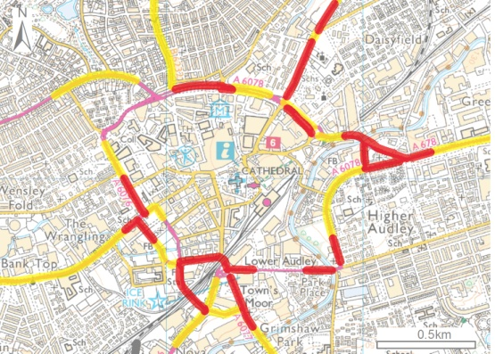
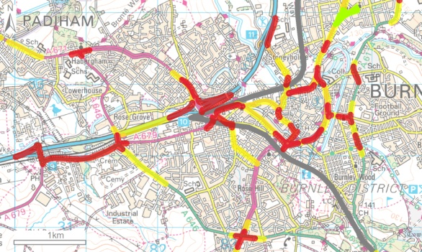
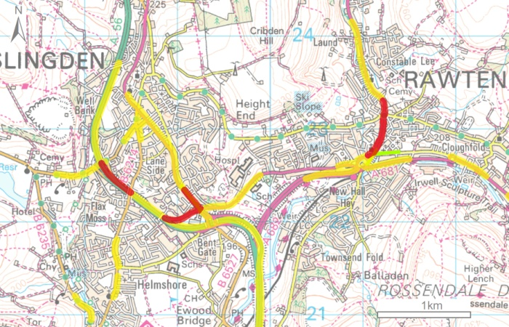

Looking to the Future – Our priorities

We have looked at what we know of our current transport problems and at the wider issues that impact on transport. We now need to look at East Lancashire in the longer term as both the people and the places of the area change over the next 10 to 15 years.

The future development of East Lancashire is being shaped by policies and strategies being put in place now. These plans allow us to understand how economic development will be promoted and how public health will be improved. Whilst there are also changes that are harder to predict, such as how our weather and climate will alter and how technology will advance, we know that we need to do all we can to make sure that what we do now is sustainable for future generations.

Economic Growth

A key driver of East Lancashire’s economic development is the Lancashire Enterprise Partnership (LEP), of which both Lancashire and Blackburn with Darwen councils are members. Other East Lancashire representation is given by the Chairman of Regenerate Pennine Lancashire and the Leader of Burnley Borough Council.

The Partnership has an approved Lancashire Growth Plan for 13/14 which sets out how strong and sustainable economic growth can be achieved in the county.

The partnership is the driving force behind the newly created Lancashire Advanced Engineering and Manufacturing Enterprise Zone that covers the two BAE Systems sites at Samlesbury and Warton. The Zone has the potential to create between 4,000 and 6,000 high value jobs in the long term. This will have a significant impact on East Lancashire because

of the already strong links to the large aerospace industry supply chain in the area.
The Growth Plan also sets out the key strategic development sites in the county:
The Michelin Site in Burnley, is next to the Heasandford Industrial Estate, 2 miles from the town centre. The entrance to the site and its northern boundary have already benefited from new developments by Aircelle (part of the French Safran group and Burnley’s largest employer) and the Lancashire Digital Technology Centre (LDTC). The remainder of the site is now undergoing transformation as ‘Innovation Drive’, an advanced manufacturing and aerospace supplier park. Development is well underway and a number of companies have already signed up to be tenants of the site.
Burnley Bridge Business Park, next to junction 9 of the M65, is a 70 acre development that is expected to provide 1,400 new and sustainable jobs for the region once full. As well as £3.8 million from the North West European Regional Development Fund (ERDF), the site has also received £2 million of funding from Lancashire's allocation from the Growing Places Fund to help tackle infrastructure and site constraints, including building a new bridge and access road across the Leeds-Liverpool canal to link the business park to the motorway.

The Weavers' Triangle, which straddles the Leeds-Liverpool canal, has the potential to transform Burnley town centre. Offices, leisure activities and education use could create approximately 1,000 private sector jobs. This will be the site of the new University Technical College (UTC) which opened in August 2013. Burnley, Visions Learning Trust UTC specialises in engineering and construction, supporting advanced manufacturing employers within the aerospace supply chain, the nuclear industry and green utilities and technologies.

The development of Burnley Knowledge Quarter will support Burnley's vision to become a centre for advanced manufacturing, digital and creative industries and of educational excellence. The Knowledge Quarter includes
Burnley Education Campus – home to the University of Central Lancashire (UCLan) and Burnley College - and will
contain the neighbouring Knowledge Park, a prestige business park with direct links to the Education Campus.

This development is part of the Arc of Innovation which will support the growth plans of Lancaster University, UCLAN and Edge Hill University, especially their innovation-focused and industry spin-out/spin-in developments. The initial focus will be on maximising synergies between centres of excellence, linking world class clusters of industry, technology development and research excellence in particular within East Lancashire at Salmesbury, Darwen, Burnley and Barnoldswick as well as Lancaster, Warton and Preston in the wider county area.

The Freckleton Street Employment Area focuses on a new commercial sector adjoining the remodelled Blackburn College Campus with its new University Centre. Located on the western and south western sides of the town centre, the site is linked to the delivery of the Freckleton St link road and could create upwards of 675 jobs. Allied to the development of the College it introduces high value, knowledge based industries into a town centre that is at the heart of East Lancashire's public transport networks.

Whitebirk Sixty Five in Hyndburn, a strategic employment site next to junction 6 of the M65, is a 36 hectare development capable of significant job creation.

Other priorities for the LEP include the Local Growth Accelerator Strategy for East Lancashire. This will be focused on delivering economic change but will also support the delivery of innovative ways of tackling deprivation and economic inactivity, in particular enabling
residents from deprived communities to access new jobs or enterprise opportunities.

Sector Delivery Plans will be put in place to unlock opportunities of national significance in emerging and established growth sectors. Plans will focus on the rural economy of Lancashire, which has strong growth characteristics, and on Lancashire’s visitor economy, which already attracts more visitors than the Lake District, but has a value and profile that can be significantly improved.

Whilst the LEP provides the strategic vision for Lancashire's growth, how land is used is a vital factor in how an area's economy and people develop. Housing and development must support economic growth but must also ensure that public health considerations are taken into account and that future plans are sustainable.

The key document that sets out how land use and development will be managed by a planning authority is the Core Strategy. This is the main component of a Local Plan and provides the spatial background to the development of our highways and public transport networks.

Blackburn with Darwen not only have a Core Strategy but have also published more detailed site allocations and, as highways authority, have identified infrastructure required to deliver the planned economic growth. Hyndburn and Rossendale have recently adopted Core Strategies. Burnley and Pendle adopted their Local Plans in 2006 but are now replacing them and have new emerging Local Plans, whilst Ribble Valley has publicised its Core Strategy.

Blackburn with Darwen Council expects a net increase of over 9,300 homes. The preferred location of these developments will be in the inner urban areas of Blackburn and Darwen, or accessible locations elsewhere within the urban area.

Pendle’s population is increasing, with a need for around 4,500 new homes over the next 15 years which will significantly alter the housing offer in the borough.
Elsewhere, the growth is forecast to be on a smaller scale with between 3000 to 3700 new homes built in Rossendale and Hyndburn. In Hyndburn 75% of these will be delivered in Accrington and surrounding townships; in Rossendale 50% will be delivered in Bacup or Haslingden and the remainder in Rawtenstall and the smaller settlements.

Ribble Valley expects to see the development of around 1,900 new homes, with over 1,000 of these on the Standen site at Clitheroe.

As well as the strategic sites identified by the LEP, there are a number of other sites that have been identified by the planning authorities for future local development.

Blackburn's Cathedral Quarter centres on the key landmarks of the cathedral and the railway station. The area will become an important gateway and meeting point in the town centre, providing a hotel, offices, Clergy Court, mini bus interchange, restaurants, shops and a new public square.

Also in Blackburn, a major transformation of the Freckleton Street area is planned which will see it become a major new mixed use quarter. The Furthergate and Pennine Gateway area, which forms a gateway into the town, is also expected to see redevelopment.

The M65 corridor is the home to a concentration of developments. The LEP has identified sites at junctions 6 and 9, but there are also local plans for a large mixed development at Clayton which could offer significant local employment as well as housing.

At Huncoat, the former power station and colliery also lie in the M65 corridor. This site again has the potential for a large mixed development, with up to 96 hectares of employment land and a further 35 acres given over to housing.

The Pendle Gateway consists of a series of employment opportunities along the M65 corridor concentrated round

Junctions 12 and 13. At Junction 12, Brierfield Mill is proposed for a mixture of employment, leisure and residential uses. The 7 hectare site has over 35,000sq m of existing accommodation and the potential to create 1000 jobs. There are also proposals to expand the existing Lomeshaye Industrial Estate which adjoins J12 to provide 85,000sq m of new floorspace with over 2,100 jobs and there is a further 30,000 sq m of new mixed residential/employment space at the Riverside Business Park off Junction 13. This will be complemented by mixed developments at Reedyford Mill and Riverside Mill in Nelson

At the end of the M65 in Colne, there are plans for a significant employment development which will be complementary to the Boundary Mill store.

West Craven, centred on Barnoldswick, is also a key location with Rolls Royce, a key global manufacturer in the aerospace industry, at its heart. An extension to West Craven Employment Zone in Earby will help to support the LEP’s focus on maximising the economic value and benefits of the emerging Arc of Innovation.

To the south of the area, the Rawtenstall Development Zone, situated in the town centre, includes both the New Hey Business Park and the Valley Centre, the latter being intended for retail and office use.

Health and Wellbeing

In April 2013, Lancashire County Council and Blackburn with Darwen Council took responsibility for much of the public health work that was previously carried out by the NHS.

The two authorities will now work with the NHS to tackle some of the key issues that affect people's health and wellbeing, helping people to stay healthy and prevent illness. The changes will make sure that public health experts have a greater input to many of the different council services that impact on people's health including education, housing, transport and the local environment.

We already know there are health and social issues of real significance in East Lancashire and that our transport networks could help to address. Among the work that the
two councils will take responsibility for are a number of strands that have a bearing on the masterplan:

- tackling obesity;
- increasing levels of physical activity;
- public mental health;
- cancer and long-term conditions prevention through behavioural and lifestyle campaigns;
- accidental injury prevention;
- community safety promotion, violence prevention and response(public health aspects);
- tackling social exclusion through local initiatives (public health aspects);
- public health services for children and young people aged 5-19.

Public Health Profiles for 2013, produced by Public Health England, show that there is significant work to do in some areas. Indicators that have a bearing on how we shape future transport strategy include a number that are categorised as 'significantly worse than the national average' in different areas of East Lancashire:

- Obese children (Burnley)
- Physically active adults (Blackburn with Darwen, Hyndburn, Pendle)
- Life expectancy – male (Blackburn with Darwen, Burnley, Hyndburn, Pendle, Rossendale)
- Life expectancy – female (Blackburn with Darwen, Burnley, Hyndburn, Pendle, Rossendale)
- Road injuries and deaths (Burnley, Ribble valley)

Based on these issues, both councils have public health strategies which set out immediate priorities. For Blackburn, priority actions include:

- Keep children and young people safe
- Improve the quantity and quality of physical activity for children and young people
- Improve the quality of the physical environment

- Make healthy choices easier
- Improve older people’s access to transport
- Promote older people’s independence and choice

For Lancashire, the priorities are more general:

- To work to narrow the gap in health and wellbeing and its determinants
- To help older people with health problems to maintain their independence
- 'Healthy Weight' through environmental measures

These priorities have clear links to travel and transport. Reducing road injuries and deaths and improving access to transport are clear and specific transport issues. Active travel is key to tackling obesity and encouraging healthy choices for all ages. But our streets and public spaces are also deeply influenced by transport. A lower life expectancy is closely related to deprivation; addressing deprivation requires addressing the social determinants of deprivation and that includes access to employment and to education among other factors.

Sustainability

From the National Planning Policy Framework to the Local Sustainable Transport Fund, sustainability has become a key factor in all plans and policies. For a highways and transport masterplan, it presents several key challenges to what we want to achieve.

- Lancashire's transport infrastructure assets are the most valuable publicly owned asset managed by the two Councils, with a combined estimated gross replacement cost of about £10 billion.

Without this infrastructure, Lancashire would not be able to function as a place to live, work or visit. Given the importance that Lancashire's transport infrastructure plays in our everyday lives and in our economic future, it is vital that we maintain and manage this asset as sustainably as possible, maximising benefits and opportunities and reducing negative impacts as far as

possible to provide best value for the people of Lancashire.

- Highways Authorities have had a duty to manage roads to ensure that flooding does not represent a nuisance to road users. However, under The Flood and Water Management Act 2010 (FWMA) both the County Council and Blackburn with Darwen Council have now also been designated as a Lead Local Flood Authority (LLFA). The FWMA places a range of new powers, duties and responsibilities on the LLFA and its partner Flood Risk Management Authorities (RMAs), including the production of a Local Flood Risk Management Strategy.

As LLFAs, we are therefore working with our RMA partners to develop options for water management in rural areas, with a view to balancing the needs of agricultural productivity, flood risk management and sustainable drainage practices. We will therefore make sure that proposals put forward under this masterplan fit with our Local Strategies and that issues of flooding and drainage that could affect a proposal are taken into account in the development of schemes and business cases.

- The roll out of superfast broadband across the county will have a fundamental impact on how many of us do business on a day to day basis. It will allow many people to reduce the amount they have to travel – we can shop from home, download films and games and, of course, work from home. For businesses, it will offer far greater access to customers and digital media, also with less need to travel.

We need to maximise the benefits of reduced car traffic for our highways and transport networks while also taking account of the negative impacts, such as greater delivery traffic. We also need to ensure that those who cannot or do not adopt superfast broadband are not forgotten.

- There are many areas of East Lancashire that are remote from employment and services. Many of these are in the

rural areas of the county, but it would be wrong to assume that all our towns and villages have good connections, particularly to the east of the area. These areas have come to rely on the car, making it very difficult for those without their own transport. However, increasing car use is unlikely to be sustainable in the future. Providing alternatives both for residents and for visitors will therefore be vital for economic development.

- There is now little argument that we need lifestyles that generate a smaller carbon footprint. 'Low carbon' transport has the potential to allow individuals to make a genuine difference to the world around them. However, the evidence of travel choices made at the moment shows that what is on offer now is not what people are prepared to switch to. This suggests that we need to do more to provide low carbon options that more people want to use.

- East Lancashire has some of the most stunning scenery in the county. With the Forest of Bowland in the north, the iconic Pendle Hill in the centre and the Pennine Moors in the south, the area's geography provides both constraints on development but also a wonderful natural heritage to be enjoyed and protected.

As well as future development, Figure 10 also shows how the environment of East Lancashire impacts on development :

- the areas of outstanding natural beauty
- the green belt, put in place to prevent the merging of neighbouring towns and to direct investment to the older parts of the urban areas.
- the high quality agricultural land.
- the areas at risk of flooding and
- the areas of nature conservation value.

Figure 10: Future plans and priorities

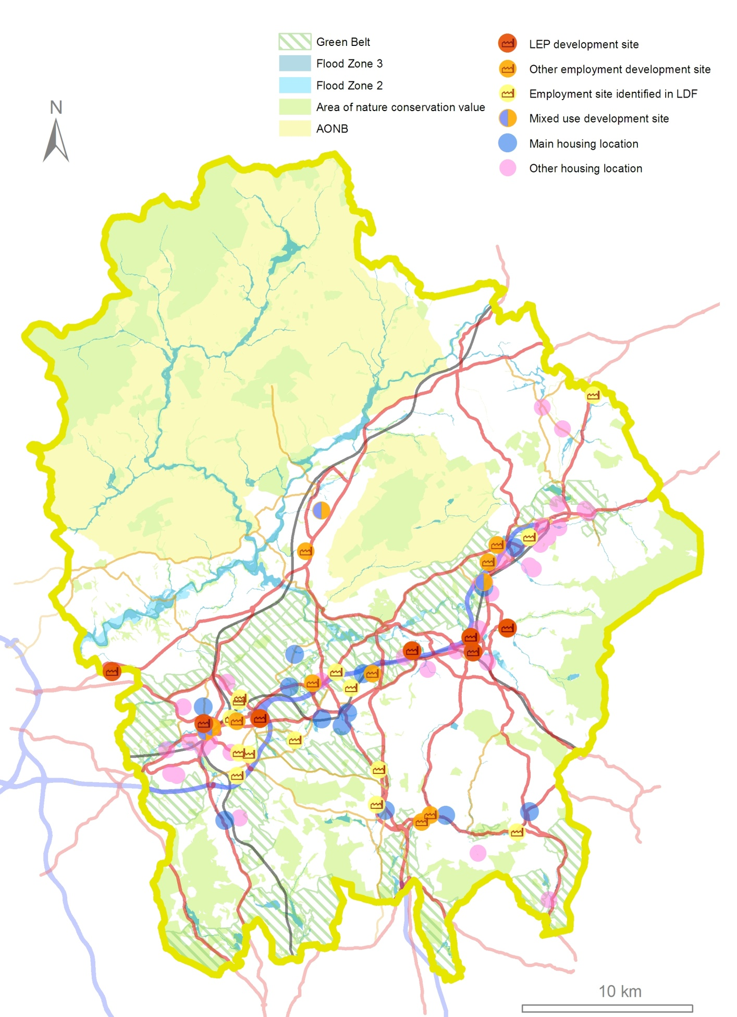
Looking to the Future– Funding

There is already a substantial public sector funding investment in infrastructure identified in East Lancashire, with almost £130m set out in this masterplan to 2021/22. Year on year, this is broadly similar to the public sector contribution towards delivery of the Central Lancashire Highways and Transport Masterplan to 2024/25. Additional schemes are likely to emerge from the study work we intend to carry out over the next two years.

This funding in part results from the way funding for transport infrastructure is changing. These changes are already happening, as the Preston, South Ribble and Lancashire City Deal shows. The City Deal's £334m Infrastructure Delivery Programme includes four major highway schemes and local community infrastructure, such as schools and health facilities. The Delivery Programme is funded through pooling local and national resources, including funds from the DfT (including the Local Major Scheme Programme), from local government and from private sector investment through the Community Infrastructure Levy (CIL).

We now need to be ready to take advantage of these changes, set out below, for the benefit of the rest of Lancashire.

Government funding

The changes to the way transport infrastructure is funded will come into effect from 2015/16. From that time, Transport for Lancashire (TfL) will be responsible for a multi-million budget devolved from the Department for Transport. TfL has decided which local major transport schemes to prioritise for funding, review and approve individual major scheme business cases, and ensure effective delivery of the programme.

Through the Preston, South Ribble and Lancashire City Deal, TfL has secured a ten year local major transport
scheme allocation from the Department for Transport, something only achieved by four other local transport bodies nationally (Greater Manchester, West Yorkshire and York, the Sheffield City region and South Yorkshire and the West of England). This will facilitate delivery of agreed priority schemes such as the Clitheroe to Manchester Rail Corridor capacity improvements alongside City Deal infrastructure improvements in Central Lancashire.

As TfL is a committee of the Lancashire Enterprise Partnership (LEP), this has created for the first time the opportunity to integrate key economic and transport priorities and plans. TfL is therefore able to make robust and binding decisions that transcend complex local economic relationships, transport patterns and local government administrative boundaries.

In June 2013, the Chief Secretary to the Treasury confirmed the establishment of the Single Local Growth Fund (SLGF). The SLGF will amount to over £2bn in 2015/16 and will include a significant amount of local transport funding. In addition to funding for local major transport schemes, from 2015/16 the SLGF will include over 40% of the Integrated Transport Block (IT Block) funding currently received directly from the Department for Transport by local transport authorities. The Government has committed to maintain the SLGF at a total of at least £2bn each year in the next Parliament.

IT Block funding is capital funding used by local transport authorities for small transport improvement schemes costing less than £5 million. Schemes include – small road projects, road safety schemes, bus priority schemes, walking and cycling schemes and transport information schemes. The reduction in the amount of IT Block from 2015/16 will mean that the County Council and Blackburn with Darwen Borough Council will have less direct guaranteed funding for local transport schemes going forward.

The SLGF will be a single pot with no internal ring fencing. Access to the fund will be through a 'Growth Deal'. This will be a process of negotiation, with areas making their case to the Government in much the same way as for City Deals, leading to bespoke decisions on the amount and flexibilities that each area will receive, subject to robust governance arrangements. Positive negotiations with the Government regarding the Preston, South Ribble and Lancashire City Deal indicate the overarching governance arrangements of the LEP are considered fit for purpose.

The amount of funding unlocked through a Growth Deal will depend on the strength of the Strategic Economic Plan prepared by the LEP, which will cover the period 2015/16 to 2020/21, and which must be submitted to the Government by March 2014. Local Enterprise Partnerships with the strongest Strategic Economic Plans that can demonstrate their ability to deliver growth will gain the greatest share of the SLGF.

Strategic partners

Our strategic partners are also seeing changes that will impact on what we can achieve through this masterplan.

The rail industry is complex, with operation of the infrastructure separate to the operation of passenger and freight train services.

Network Rail is the private sector owner and operator of the national rail network, including track, signalling, bridges and tunnels. It operates in 5 year 'Control Periods' (CP), for which delivery plans are produced. CP5 will start in April 2014, with CP6 in April 2019.

However, the Government's High Level Output Specification (HLOS) and Statement of Funds Available (SoFA) determine what is delivered in these control periods. These set out what the Government wants achieved by the rail industry
during that control period and the amount of money available.

The HLOS and SoFA for CP5 have been published. In order to achieve infrastructure improvements in Lancashire in the next CP, we therefore need to be in a position to influence the development of the HLOS that will determine activity in CP6.

Network Rail recognises the importance of working closely with local authorities, as agreeing priorities will be key to ensuring valuable investment opportunities are not missed.

It is currently undertaking its Long Term Planning Process, which is designed to understand future rail travel markets and produce an output in the form of Route Studies which match the market with local requirements and aspirations to provide a series of options for funders.

The study of relevance for East Lancashire will be the North of England Route Study. Market studies have recently been published on Network Rail’s website and work on the Route Study will begin in the second quarter of 2014. The East Lancashire Highways and Transport Masterplan will be used to inform this route study.

Current market study recommendations are that conditional outputs for East Lancashire should:
- improve the service offering between Clitheroe, Blackburn and Greater Manchester
- improve the service offering between Blackpool, Preston and Leeds and
- improve journey times on rail routes in East Lancashire.
Additional work to improve the railway in East Lancashire is being conducted through the ‘Red Rose Alliance’, a joint working programme between Northern Rail and Network Rail that intends to improve performance, journey times and infrastructure reliability on the ‘Roses Line’.

Many rail services in the county carry people making relatively short journeys and are a key part of an area’s local public transport network. They have seen substantial growth in demand in recent years, a trend that is expected to continue.

At the moment the franchise contracts underlying most train services in England are specified, funded and managed centrally by the DfT based in London. The Government is currently looking at whether decisions relating to local rail services should be made closer to the communities they serve, a process called 'Rail Devolution'.
Rail devolution recognises that local decision makers may be best placed to recognise trends in usage and demand and to identify how transport networks can adapt to new housing and/or employment patterns and to therefore determine how the transport network can develop in a way that contributes to achieving the wider economic objectives of an area. They are also able to compare the benefits of expenditure on different types of transport provision and make decisions on priorities for expenditure on investment and subsidies, recognising the interests of different groups of users.

Away from the rail industry, the Highways Agency (HA) is an Executive Agency of the DfT and is responsible for operating, maintaining and improving the strategic road network in England, which includes major trunk roads and most motorways.

The HA has an integral role in assisting growth in East Lancashire by ensuring that the strategic corridors of the M66 / A56 (T) and M65 operate effectively and efficiently and integrate fully with the local highway network.

This role is addressed by the Route Based Strategies (RBS) currently being taken forward, including one covering HA roads in Lancashire, which have an initial 5 year and ultimately 15 year horizon. The strategy initially will identify performance issues on routes and also future challenges, taking account of local growth challenges and priorities. This stage is expected to be complete by April 2014.

The HA, working with the DfT, will then use this evidence to identify and prioritise possible solutions to inform investment plans for the next full government spending review in 2015 and beyond.

The masterplan will need to be in accord with the RBS but will focus on the connections with the local network so that the strategic and local road networks are considered holistically. The HA is happy to share RBS work with us to avoid duplication and wasted resource.

Since the horizons for both the RBS and the masterplan are similar, the possibility of enhanced value for money through sharing information / expertise / contracts / modelling / knowledge and delivery of future schemes will be explored as well as aligning our strategies to provide added value for all parties.

Developer contributions

When a development is proposed, the developer may be expected to contribute to local infrastructure in several ways.

'Section 278' agreements are made between a developer and a Highway Authority to enable works to be carried out on the public highway to facilitate development.

'Section 106' agreements can be put in place to make it possible to approve a planning proposal that might not otherwise be acceptable in planning terms. For example, a section 106 agreement might require a developer to fund improving the access road to a site, to ensure that access will be safe once the development is completed. They are specific to the site that is proposed for development.

Since April 2010, local authorities have been able to charge a 'Community Infrastructure Levy' (CIL) on any new development above a certain size. Where introduced, CIL is a general levy on qualifying development, designed to raise funds for infrastructure needed to support the development proposals. We are now in a transitional period where both CIL and section 106 agreements can apply.

In introducing CIL, local planning authorities need to prepare a 'charging schedule'. The schedule sets out what, if anything, the charge will be per dwelling for residential development, or per square metre for all other
development. In setting the charges, planning authorities need to balance the level of charge with the potential impact on the economic viability of development.

Across Lancashire, this need for balance between developer contributions and development viability is a key issue. There is a need to secure developer funding from private sector investment and to do so housing allocations of an appropriate nature and scope to generate CIL need to be made. Areas that could be suitable for such development include our smaller towns such as Huncoat, Fence, Barnoldswick and Earby, where infrastructure improvements are already planned, although the potential for development exists in other areas.

Looking to the Future– What are the challenges?

As the previous pages show, East Lancashire faces considerable challenges in its future development. However, it also has many advantages working in its favour.

These positive and negative influences are summarised here to show the strengths and opportunities in the area and also the potential weaknesses and threats. Appreciating these provides us with the understanding of what will influence and shape our highways and transport network in the future.

STRENGTHS

- The LEP working in partnership with the County Council, Blackburn with Darwen Council and the borough councils to support and enable development ensuring collaborative County wide approach to fostering growth.
- Strong partnership working across the public sector and a commitment to prioritise economic growth.
- Significant, international, high tech and knowledge based business presence (BAE Systems, Rolls Royce, Aircelle and high value SME's)
- Strong Advanced Manufacturing base – key priority within the LEP Growth Plan
- LEP public/private collaboration delivering the Lancashire Enterprise Zone (Warton & Samlesbury sites – Advanced Engineering and Manufacturing)
- Strong built heritage and outstanding natural landscapes
- Culturally diverse population
- Expansion of the education facilities in Blackburn and Burnley
- Resistance to downturn showed by Cities Outlook 2013
- Skilled workforce prepared to travel across area.
- Committed programmes for new transport investment
- Outstanding leisure and recreational opportunities
- Strong and demonstrable track record in successfully bidding for and delivering major transport schemes

OPPORTUNITIES

- The Strategic Economic Plan and Growth Deal
- Pennine Lancashire Investment Plan signed by all authorities
- Core Strategy and emerging individual Site Allocation Local Plans for the districts across the area show advancing plans for accommodating new development
- Comprehensive development plans include strategic sites as a focus for investment
- Rising educational standards
- Commitment by the LEP to tackle deprivation and address the skills gap
- Lancashire’s Assisted Area status allocation for 2014-2020 expected to be along the M65 corridor
- Devolved funding for local major transport schemes
- Proximity to Preston, Manchester and Leeds giving a strong geographic position to link to economic growth areas.
- Quality of Place attributes: town centres, historic environments, the Leeds-Liverpool Canal, countryside
- A growing visitor economy
- High proportion of young people provides the opportunity to create a large skilled workforce which can strengthen Lancashire’s economy
- Todmorden curve providing new direct rail links to Manchester
- Substantial committed public transport investment
- Superfast broadband
- Successful City Deal by LEP
- Proximity to HS2 bringing the opportunity to link into any benefits generated

WEAKNESSES

- Travel horizons are perceived to be more limited than they are.
- Low confidence and aspiration in some communities
- Poor educational attainment and lack of higher level skills in parts of the community
- High levels of worklessness in some areas.
- Poor rail connectivity (non-existent in places)
- Lack of 'low carbon' transport alternatives.
- Poor life expectancy and ill health in some areas
- Limited housing choice and quality

THREATS

- Current transport network unable to cope by 2026
- Growing car ownership and use, with limited alternatives.
- Perception of East Lancashire as a cul-de-sac
- Decline of public transport for non car owners
- Sluggish economic climate
- Financial threats and uncertainty - Comprehensive Spending Review
- Uncertainty amongst private investors
- Reluctance to change travel behaviour
- Poor external image and perceptions of some parts of East Lancashire
- Congestion on major routes outside the area, particularly in Greater Manchester
- Potential for widening divide in standard of public transport, especially rail in adjoining City Regions

Our Vision

Transport is an enabler. In most cases, it doesn't 'do' anything itself but it does allow society to function. Developing our options for East Lancashire's highways and transport networks therefore involves asking a fundamental question; what do we expect these networks to do?'

We have shown that there are travel and transport problems now. Connections in and out of East Lancashire, for both people and freight, need to be better, with improved journey times and reliability both east and west, to Central Lancashire and Yorkshire, and south to Greater Manchester.

The employment and housing development considered previously, both strategic and more local, presents a major opportunity to regenerate and improve East Lancashire. Our networks will need to be able not just to cope with this development in the future but to positively enable these aspirations to the benefit of the area as a whole.

The demographics of the area have been discussed. We therefore know that we need to ensure that employment and education opportunities can be accessed both locally and further afield. We also know that these travel opportunities must be sustainable and cost effective. The residents of our rural areas must also be considered as deprivation by distance is a real threat in these areas.

Lastly, the visitor economy is of increasing importance in the area. From retail outlets to adrenaline sports, the area offers numerous tourist destinations. It also has magnificent countryside that will need to be accessed in such a way as to enable the rural economy to flourish without destroying the countryside that it depends on.

And on top of these needs is the need to be sustainable, to “meets the needs of the present without compromising the ability of future generations to meet their own needs”. We

need to balance the social, environmental and economic consequences of our decisions by maximising benefits and opportunities whilst reducing negative impacts as far as possible to provide the best outcome for the people of East Lancashire. Our sustainability commitments are to:

- Improve personal health and well-being;
- Increase community cohesion;
- Provide affordable travel options and
- Reduce carbon emissions.

The East Lancashire Highways and Transport Masterplan must therefore deliver good, reliable connections for people, goods and services whilst offering choice, facilitating travel on foot, by cycle, bus and rail as well as by car and goods vehicle. Alternatives to the car help to reduce pollution, cut energy consumption, contribute to healthier lifestyles and community cohesion and can offer cost-effective alternatives for those who have no access to a car by reason of age or income.

Therefore, the 5 principles that have guided the development of this masterplan are that we will:

- Support the economic development of East Lancashire and of the county as a whole.
- Work to address deprivation
- Promote community resilience
- Increase healthy behaviour
- Reduce our carbon footprint

We will work with partners to align our priorities and objectives to help overcome some of the problems encountered in East Lancashire, such as deprivation, unemployment and poor health, as well as specific transport issues such as rural isolation, pollution, congestion and busy roads that make places unattractive to live. We will also have an eye to the future and innovations that may change how

and why we travel, such as electric vehicles or superfast broadband.

From these principles, a number of priorities have emerged that we will work towards. We want:

- Sustainable travel to become the choice wherever possible, even in rural areas.
- Our strategic employment sites flourish and be well connected nationally and internationally.
- Local developments and business to be supported and have the strategic and local connections that they need to succeed.
- People from all communities to be able to access the employment and education opportunities that are available both in East Lancashire and further afield.
- Active travel to be encouraged and supported, making walking and cycling safe and easy choices for local journeys.
- Public realm improvements that support both new development and existing communities and enhance the appearance and safety of sustainable travel routes.
- Visitors to find the area attractive and easy to travel around without a car.

Taking Our Vision Forward – What we're doing now

Whilst we may not have all the information we need to finalise this masterplan, we do know a lot now and we and our partners already have schemes in place to tackle many of the problems, as figure 11 shows.

The area's Local Transport Plans have already been mentioned. They set out a broad strategy for how transport and the way we travel in Lancashire will change moving forward to 2021. The Local Transport Plan's objectives for both authorities are set out in the introduction of this masterplan. The current Local Transport Plan Implementation Plans set out schemes that will be implemented in the next three years to 2015/16.

The LEP, through Transport for Lancashire (TfL), have approved the Local Major Transport Scheme Investment Programme for Lancashire. Six schemes are in the investment programme and will be funded subject to detailed scheme development and appraisal demonstrating that they represent high value for money.

A further six schemes were in the development programme, however two schemes for junction improvements on the M65 (junctions 4 and 5) are now to be taken forward by the Highways Agency as part of the national Local Pinch Point Fund.

Lastly, we are already carrying out studies to support both the masterplan and TfL. These studies are starting to help us understand how to adapt the highways and transport networks to the pressures facing them.

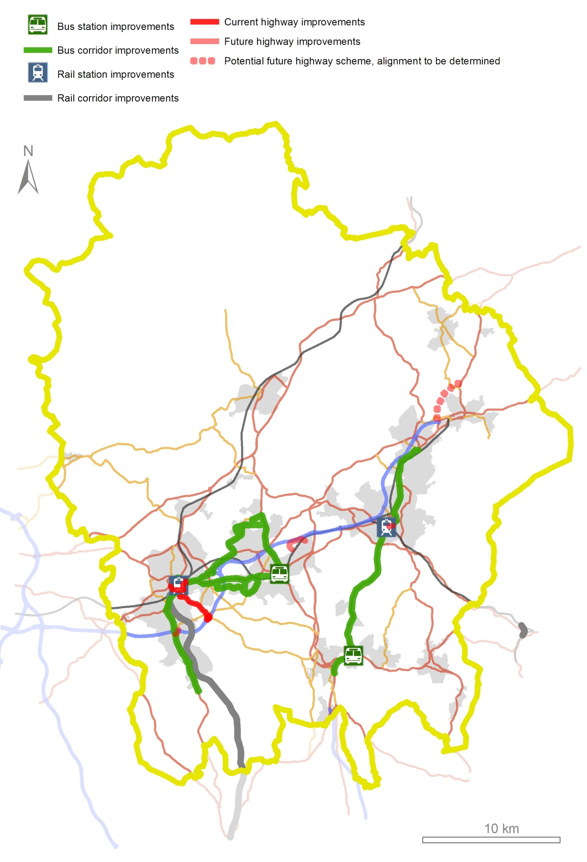
Figure 11: Current schemes and proposals

Current Schemes:

Todmorden West Curve

Burnley Borough Council recently made a successful bid to the Regional Growth Fund to secure the funding needed for the re-instatement of the Todmorden West Curve. The re-instatement of this 500 metre length of track will allow a direct service from Burnley to Manchester.

The new train service will provide an hourly service between Manchester and Blackburn via Todmorden, Burnley and Accrington 7 days a week. The service is currently planned to start in December 2014.Initially journey times between Burnley and Manchester will average about 55 minutes but a further timetable change in Dec 2016 will see this reduced to nearer 45 minutes.

Blackburn Railway Station Upgrade

Blackburn station has recently undergone major refurbishment of a number of the platform areas, through a £2m package of investment in 2011 from the National Stations Improvement Programme (NSIP), Access for All & Blackburn with Darwen Council, transforming platform 4 to provide a new canopy, heated waiting room and lift access. Further NSIP investment will now deliver a major refurbishment of the entrance area and concourse – an estimated investment of £600k.

The proposals will bring the entrance into the current era, improving the overall appearance, helping the station to feel brighter and more welcoming, whilst respecting the listed status of the station. Improvements include:

- the existing entrance doors replaced with sliding doors
- the front windows exposed, bringing in natural light
- the roof structure will be made good where necessary
- mirrored cladding used at high level within the existing apex of the roof and
- the solid barrier to the ramp replaced with a visually ‘lighter’ handrail.

By making the station far lighter and brighter, the customer’s experience of using the station will be improved which should encouraging greater use of the station.

Works are expected to be completed early in 2014.

Manchester Road Railway Station Upgrade, Burnley

Manchester Road railway station is undergoing a major redevelopment ahead of the introduction of a direct train service to Manchester from December 2014. The re-instated Todmorden West Curve will make this possible. The scheme comprises
:
- A new railway station building which will Introduce manned ticket facilities;
- New platform waiting shelters to both platform 1 & 2;
- Improved entrance for pedestrian use of Manchester Road;
- New cycle parking provision; and
- New car parking to provide 50 spaces and 4 new DDA parking spaces.

There are associated improvements to pedestrian and cycle links between the station and town centre, with the provision
of a signalled pedestrian/cycle crossing on Trafalgar Street and the addition of pedestrian facilities to the Manchester Road/Finsley Gate/Queen's Lancashire Way traffic signal junction. These improvements will enhance access to Burnley town centre and the Education and Enterprise Zone at Princess Way.

Pennine Reach

Pennine Reach will provide a new rapid bus service designed to improve public transport in Blackburn with Darwen and Hyndburn, giving improved access to key

strategic employment sites (including Whitebirk65), education, health, shopping and leisure facilities.

It will operate between Accrington and Blackburn via Clayton-le-Moors, Great Harwood, and Rishton and between Accrington, Blackburn and Darwen. The scheme includes a fleet of high quality, easy access buses, dedicated bus priority, better passenger facilities, innovative ticketing solutions and real time bus information. Services will link with the strategic rail network and local shuttle services

The scheme also includes new bus stations in Blackburn, on the old markets site, and in Accrington town centre, providing interchange facilities with the recently refurbished railway station. An interchange in Great Harwood will also be delivered.

The Department for Transport is to provide £31.9 million (80% of the total cost) and work has already started and is due to be completed by 2016.

Rawtenstall Bus Station

The bus station in Rawtenstall is dated, peripheral and no longer fit for purpose. In 2013, Rossendale Council held a design competition for architects to come up with proposals for the former Valley Centre Site and adjacent including the police station, one stop shop and former town hall. The proposals had to include a new bus station within the site, working with design parameters provided by the County Council, including stand numbers and other technical features that they needed to incorporate.

The competition closed at the end of August with the winning architect being announced this autumn. Rossendale Borough Council will be working with the architect to deliver the scheme, and the County Council has committed £3.5 million to meet the cost of the new 8-stand bus station.

Nelson to Rawtenstall Bus Corridor Study

We are currently looking at what small-scale infrastructure and system improvements will provide the greatest benefit along the Nelson to Rawtenstall bus corridor, particularly for the Nelson-Manchester (X43) bus service. This is the first stage in improving journey times and reliability to enhance public transport between the town centres and extend opportunities for people to access employment, education and training in Manchester.

A second stage of the study will develop an integrated solution for all travel modes centred on the local network within Rawtenstall. This will include a review of the New Hall Hey roundabout Park and Ride site as well as looking at how enhancements for buses could also improve the gyratory for other users, particularly pedestrians.

Freckleton Street Link Road

The Freckleton Street to Montague Street Link Road will complete an important section of the Blackburn Town Centre Orbital Route and forms part of the wider masterplan for Blackburn town centre with the intention of helping to shape the physical environment of the area. Phase 1 of this development was completed with the opening of the Wainwright Bridge in June 2008. The link road between Freckleton Street and Montague Street is Phase 2.

The key objectives of the scheme are:
- Complete a key section of the Blackburn Orbital route
- Enable the future delivery of the Freckleton Street Masterplan
- Provide a direct link to Wainwright Bridge thereby improving efficiency and reducing journey time / congestion
- Transform area and provide new opportunities for redevelopment, investment and employment
- Enhance public transport provision and facilities
- Enhance cycling and pedestrian provision and facilities

- Improve road and pedestrian safety
- Improve connectivity between the Freckleton Street area and the town centre
- Improve public transport efficiency
- Improve local air quality
- Reduce noise levels

Work on this £11m scheme has commenced and will be completed by March 2015

Haslingden Road Corridor Improvements, Blackburn

The scheme will widen Haslingden Road and upgrade mini roundabouts to signalised junctions, facilitating future regeneration and reducing congestion. Safety for cyclists and pedestrians will also be improved.

Significant development in the Haslingden Road corridor has placed additional pressure on the surrounding highways network. Haslingden Road, Walker Park, Roman Road and Shadsworth industrial estates provide a range of employment, business, health and leisure opportunities and there are also plans for 2,243 new homes locally. The improved access could see the creation of up to 1,900 extra jobs.
North Valley Corridor Improvements, Colne

A Route Managements Strategy along the North Valley Road corridor is being developed to improve traffic flow, reduce accidents and improve pedestrian and cycle facilities. Improvements that could come forward include;

• Modernisation of the Pelican crossings on Vivary Way, North Valley Road and Byron Road and the pedestrian facilities at the Hanover Street signals.
- Potential reconfiguration of existing junctions.
• The removal unnecessary/unfit street furniture and signs and the provision of new signing where needed.
• Further fine tuning and optimisation of the traffic signal control systems, including assessing the feasibility of continuous journey time monitoring to subsequently improve traffic signal optimisation.

Highways Agency 'Pinch Point' schemes

The 'Pinch Point' programme forms part of the UK Government’s growth initiative, outlined during the Chancellor’s Autumn Statement in November 2011. The HA was initially allocated over £200m to deliver focused improvements to the Strategic Road Network, during the period 2012/13 – 2014/15. Following the Autumn Statement 2012 the HA received an additional £100m for the programme.

The programme is designed to deliver smaller scale improvements to the strategic road network that will help to stimulate growth in the local economy and relieve congestion and/or improve safety.

M65 Junction 5 Improvements

Heavy congestion is a problem on the junction exit slip roads and the roundabout. This impacts on the surrounding network resulting in queuing on local roads. Safety issues have also been recognised on the roundabout and on the interface with local roads.

Works will be carried out to address these problems by the installation of traffic signals to all arms of the roundabout together with junction layout improvements to facilitate improved traffic flow.

The works should help to reduce daily congestion, reduce journey times, improve safety and boost the economy

The estimated cost is £1.43 million and work is expected to be carried out between May and December 2014.

M65 Junction 4 Upgrade

This scheme involves the full signalisation of the M65 junction 4 at Earcroft, which will ensure that traffic can exit the M65 without excessive queuing. The scheme includes associated access improvements into the Chapels area of Blackburn with Darwen, supporting the Council's Housing

proposals in East Darwen, the build-out of remaining land south of M65 Junction 4 and at Lower Darwen Paper Mill.

Although this scheme was prioritised by TfL the investment will now be taken forward by the Highway Agency using Local Pinch Point funding.

Transport for Lancashire schemes

The TfL Major Schemes Programme includes 3 schemes in East Lancashire that, once the scheme appraisal has demonstrated value for money, will be funded from 2015/16.

- Clitheroe to Manchester Rail Corridor Improvements

To improve connectivity between the Ribble Valley, Blackburn and Manchester, improvements are planned to the standard and frequency of rail services between Blackburn and Manchester. This will involve the selective double tracking of the railway line between Bolton and Blackburn.

The Blackburn to Manchester route is the busiest serving Manchester without a core two trains per hour service. However, demand between Blackburn and Manchester is similar in magnitude to the combined Manchester demand

for Bradford and Halifax. By extending the length of double track railway line, service frequencies will be increased to a half-hourly service throughout the day, with an increased frequency at peak hours. Reliability will also be improved.

There will also be improvements to passenger waiting facilities and information provision at selected stations north of Blackburn and south of Darwen.

- Centenary Way Viaduct Major Maintenance Scheme, Burnley

The Centenary Viaduct is a seven span continuous bridge carrying the A682 through the centre of Burnley. It is a critical part of Burnley town centre's road network

and without it, effective movement through Burnley would be impossible. Work is now needed to its structure to ensure its continued operation.

Because of its poor condition, abnormal loads are currently banned from the viaduct. This is a significant problem at a time when Burnley is developing rapidly and has major infrastructure projects underway. The scheme will rectify the numerous defects that have been identified in the structure and allow it to reopen to all traffic.

Other schemes

The Major Schemes programme also includes a development pool for schemes which are acknowledged to be a TfL priority, but which are not yet in the investment programme. In East Lancashire there is one such scheme.

A56 Colne to Foulridge Bypass

The A6068, as it passes through the North Valley area of Colne, carries traffic of around 25,000 vehicles per day including over 1,300 heavy goods vehicles. Not surprisingly, this causes severe problems, with congestion and delays throughout much of the day. In the peak hours, the congestion is among the worst in Lancashire. The standing traffic affects local air quality, resulting in a declared AQMA, and the road effectively severs the North Valley housing areas from all amenities in Colne.

There is also the question of where economic growth is to be accommodated within Pendle and this will also have an impact on future traffic in the area

The 'A56 Village Bypasses' is a long standing proposal which would see a bypass built from the end of the M65 to the A56 north of Kelbrook/Earby. The route has been protected for a number of years. This scheme has not attracted funding and would also preclude any future re-opening of the Colne to Skipton Railway line.

The M65 to Yorkshire Corridor study was commissioned by Lancashire County Council to investigate whether a bypass was still the most appropriate solution, both to Colne's
current congestion and to accommodating potential development proposals that could put more traffic on the network. If a bypass was needed, the second question was whether the original scheme was still the route to take forward.

On the evidence available, the study concluded that a bypass was likely to be needed and that the most cost effective route would be a shortened version of the currently protected scheme. This would run from a new junction between Junctions13 and 14 on the M65 to a point on the A56 just north of Foulridge. Importantly, it would not stop the reopening of the railway at some time in the future.

This 'Brown' route was one of 2 southern options that did not preclude railway reopening, the other being the 'Blue' option to the west of the 'Brown'. A 'Red' option based on the original scheme was a third southern variant based on the currently protected line. Two northern options, 'Pink' and 'Purple' were also considered and a 'Green' option ran from Foulridge to the east to meet the A6068.

The results of the study were published as part of the consultation on this masterplan with a view to finding out what our partners and East Lancashire's residents and businesses thought of the possible changes to the bypass scheme.

This consultation response does confirm that we do have support to undertake the next stage of the work that will give us the evidence to draw up detailed design proposals for all the southern options. These options will include what could ultimately be done along the North Valley to increase capacity in the absence of a bypass, as well as detailed consideration of all possible routes for an A56 Colne to Foulridge bypass. Once this work has been completed we will be able to consult on our final proposals.

The further work required will include detailed traffic data collection which will be used to model the traffic implications of development and of changes to the highway network. The traffic study will not only look at the immediate area

that changes in and around Colne could affect, but will also consider the impacts across a much wider area.

These impacts will include potential traffic changes to other parallel routes such as the A682, as well as other, more local, roads. It will also consider traffic changes to longer distance routes such as the A59 as well as to roads in neighbouring highway authority areas.

Alongside the traffic work, there will be a detailed environmental appraisal which will include consideration of the impact of each proposal on the natural environment, on the built environment and on our heritage, as well as on human health.

These work streams will be iterative with the actual scheme design process and our partners and the public will be involved at all appropriate stages. We will work throughout with other local authorities potentially affected by our proposals, including Pendle Borough Council, North Yorkshire County Council, Craven District Council and Bradford Metropolitan District Council.

Before any further decisions are taken on the most appropriate solution both to Colne's congestion problems and to supporting future development, there will be a full public consultation at which the detailed work will be presented alongside the viable options that have emerged.

The timetable for this work is set out in Appendix 1 and consultation reports on both the masterplan and on the A56 Colne to Foulridge Bypass Options have been published alongside this masterplan.

There is one other scheme that, like the A56 Colne-Foulridge Bypass, has had its route protected for a number of years. However, funding for this scheme will come from the development that it will make possible.
The proposed Whinney Hill link road is a single carriageway road approximately 3km in length that will run to the north of Huncoat village near Accrington. It will pass through an area of agricultural land and rough grassland, crossing the former Huncoat Colliery and power station sites.

Traffic congestion has resulted in poor air quality in the Huncoat area, with a large number of HGVs currently forced to use the village roads. With the development of new housing on the former colliery site at Huncoat, development of Huncoat as a major employment site, and employment sites at junction 7, congestion is forecasted to get worse.

The road would divert traffic from roads across a wide area, in particular out of the built up areas of Accrington, Church, Clayton-le-Moors and Huncoat. At a strategic level, the road would also provide the main access point for housing development on the former Huncoat Colliery and for major employment development at the former Huncoat power station site.

The County Council will continue to work with the LEP, Hyndburn Borough Council and developers to develop a funding package to deliver this link road.

Taking Our Vision Further

The work done so far in the masterplanning process has shown us that, despite the work that we are already doing, there will still be unresolved issues on East Lancashire's highways and transport networks.

These issues fall into a number of themes:

- Rail connectivity limited by the speed, frequency and rolling stock quality of trains in East Lancashire
- Major motorway gateways with limited capacity
- Key corridors not able to support highway and public transport demand.
- Bus and rail stations not necessarily fit for modern uses
- Public transport provision for employment and in the rural area
- Limited cycling networks
- Limited interchange between public transport and cycling
- Neighbourhoods and the links between them need to be good enough standard to make travel easy for everyone.

These themes provide the basis for the further work that we are presenting in this masterplan. They are grouped into 3 strands:

Connecting East Lancashire looks at how East Lancashire connects to other areas, particularly to the rest of the county and neighbouring growth areas, to make sure that its people, economy and housing markets are more fully integrated to areas of opportunity.

Key to this connectivity will be the rail network. This will need to provide the enhanced connectivity and service standards that will support East Lancashire's people and businesses in the future.

The main motorway gateways provided by the M65 and the M66 will also need to be able to cope with the demands placed on them.

Travel in East Lancashire is about the links between East Lancashire's towns and the major employment and housing locations. Economically, these are the connections that ensure that most people and businesses can link into the wider highways and transport networks.

Congestion on key corridors has significant impacts on travel of all kinds, but particularly on commuting, on businesses and on public transport. We therefore need to ensure that the key corridors can cope with the traffic that wants to use them.

As well as improving public transport reliability, we also need to do what we can to enhance public transport connectivity within East Lancashire to make bus travel an attractive and viable option where possible, particularly for journeys to employment and education.

Local Travel takes up the challenge of ensuring that everyone, regardless of their background or where they live, can get to the services and opportunities that they need, from education and employment, to leisure and health.

Making our cycling and walking networks attractive is key to this. Part of this is making sure that we look after the highways and transport assets we have already – the roads and footways, the lights and signs and all the other things that help our networks function.

But the best road, rail, bus and cycle networks serve no purpose if people can't, don't want to or don't know how to access them. We need to make it easy for people to understand their local travel opportunities and have the ability to change between modes of travel, so that whether travelling short or long distances, we can reduce reliance on the private car as much as possible for everyone. There is also a strong economic argument for making sure that travel to work is cheap and easy.

These strands are not independent of each other. Easy local travel, by walking and cycling, needs to feed into the bus and rail networks for longer journeys. The bus and rail networks themselves need to interlink properly both for journeys in East Lancashire and to the wider area. And no matter how far from East Lancashire people and goods are going, the connections to strategic road and rail networks must work to facilitate national and international travel.

Running through all 3 strands is the need for transport to support transformational economic growth across East Lancashire. From the largest to the smallest investment that results from this masterplan, from strategic rail interventions down to local footpaths, East Lancashire's transport networks must be made fit for 21st century purpose.

Taking Our Vision Further –Connecting East Lancashire

How we connect East Lancashire to the rest of the county and to opportunities further afield. The issues:

- Rail connectivity limited by the speed, frequency and rolling stock quality of trains in East Lancashire
- Major motorway gateways with limited capacity

Rail connections

Major investment in the rail stations and links that serve East Lancashire are already planned that will address 2 of the issues highlighted in this masterplan.

- The reinstatement of the Todmorden West Curve will allow a new train service, from December 2014, that will provide an hourly service between Manchester Victoria and Blackburn via Rochdale,Todmorden, Burnley and Accrington 7 days a week.

- The selective double tracking of the railway line between Bolton and Blackburn will allow the operation of a more reliable half hourly service between Blackburn and Manchester. This will greatly improve connectivity between the Ribble Valley, Blackburn and Manchester.

This will complement work already carried out on the Blackburn to Hellifield line, which included major investment along most of the line to improve capacity. Whilst the speed limit remains low, at just 45mph, higher speeds are now possible which, if implemented, would reduce journey times for Clitheroe to Manchester passengers. In addition, the platforms at all Ribble Valley stations were lengthened to enable all platforms to take 3 /4 coach trains.

However, there are still fundamental problems with the network that need to be addressed, as the rail network has the potential to contribute far more to a transformational change in East Lancashire's economic fortunes.

- The East Lancashire line links Preston, Blackburn, Accrington and Burnley with Bradford and Leeds via Hebden Bridge. It is a twin track railway (with the exception of the Colne branch) currently used by 2 services:

  - The Blackpool North to York inter-regional service uses old but higher quality class 158 diesel units which are capable of operating at 90mph. This service only calls at Blackburn, Accrington and Burnley Manchester Road in East Lancashire although some peak services make additional stops. The service operates at hourly intervals for most of the day.

  - The Blackpool South to Colne all stations service. This is generally operated by lower quality Pacer diesel units with trains calling at all stations. On weekdays it operates at hourly intervals although on Sunday that reduces to 2 hourly.

Journey times on both routes are slow, typically around 70 minutes for the journey from Burnley to Leeds via Bradford and a similar time for the journey between Colne and Preston.

- Colne is relatively isolated. The branch from Gannow Junction at Rose Grove to Colne is single track, and this, combined with the single line branch between Kirkham and Blackpool South, reduces timetable reliability and flexibility for the Blackpool South to Colne service. The performance of this service continues to be an issue.

- Links to Greater Manchester are set to become increasingly more important, particularly to the airport, which is the North of England's primary international hub, and to other areas of growth. Even with the reinstatement of the Todmorden West Curve, the Colne branch will have no direct service to Manchester. However, whilst Pendle will have no direct rail access to Manchester, Rossendale has no direct access to the mainline rail network at all, with only a heritage rail service running from Rawtenstall to Bury and Heywood.

- From Clitheroe, the line to Hellifield is only used by regular freight workings and limited passenger services - the DalesRail (Blackpool North to Carlisle summer timetable only) and Ribble Valley Rambler (Blackpool North to Hellifield winter timetable only) services and charter services such as the Fellsman. Whilst there are ambitions to see the line used by services linking the Settle to Carlisle rail line to Manchester Airport, in the near future the line will continue to serve bespoke leisure and recreational markets.

A significant advantage in working to improve rail connectivity is that both of the rail corridors serving East Lancashire are covered by Community Rail Partnerships (CRP).

The East Lancashire CRP covers the route from Preston to Colne and Burnley Manchester Road. The line has been formally designated by the DfT as a community rail line and service. The designation covers all stations between Lostock Hall (near Preston) and Colne as well as Burnley Manchester Road.

The Clitheroe Line CRP covers the service between Manchester Victoria and Clitheroe and has also been formally designated as a community rail service. This designation covers the entire service and the stations from Hall i'th Wood to Clitheroe inclusive, including Blackburn.

Designation covers lines, services and stations and is a formal process which results in an agreed 'Route Prospectus' for the line which is ultimately signed off at Ministerial level. Parliament considers designation to be a permanent arrangement although it recognises that changing circumstances may require a review of the route prospectus. Designation allows CRPs and the railway industry greater freedom to implement innovative solutions that stand outside normal industry processes.

What we will do next:

To examine possible solutions to these issues in depth, we are going to commission a Rail Connectivity Study. This will focus in particular on the importance of enhanced connectivity between East Lancashire and the growth areas of Preston and Central Lancashire, Manchester (including Manchester Airport) and Leeds. It will also consider how the benefits of HS2 can best be realised in the area.

The benefits of this enhanced connectivity stretch beyond those reflected in the relatively narrow remit of traditional cost to benefit analysis and include wider issues of social impact and the visitor economy which also have an economic value.

Where the evidence shows that rail investment will deliver transformational economic benefit, the study will look at how the existing network and the services that run on it, including the rolling stock, can be improved and whether the potential exists to expand the network.

- Sections of the North’s railway network are currently being electrified in a major programme through to 2018 forming part of the first main line electrification schemes in the region for over 20 years.

The electrification programme will bring many benefits in terms of improved journey times and better quality and more reliable trains. But it will also create a new set of boundaries between the electrified and non-electrified network. Expanding the national electrified network is a long-held ambition for Network Rail and

East Lancashire is keen to benefit from a modern efficient railway.

The Rail North 'Long Term Rail Strategy' proposes that parts of the East Lancashire line should be part of the core strategic electric network across the north of England. If this did happen, then infill electrification schemes could see the Bolton to Blackburn, Blackburn to Clitheroe and Gannow Junction to Colne lines electrified.

Experience has shown that the very act of investing in railway electrification gives passengers greater confidence that the line is valued by the railway operators and therefore has a secure future. The sparks effect is well proven, occurring when passenger numbers significantly increase when a line is electrified.

- There is a long standing aspiration, which has considerable local support, to reopen the railway line between Colne and Skipton. Passenger services on the line withdrawn in January 1970 and the track was subsequently lifted. However, the track bed remains more or less intact and could potentially be reinstated.

Colne is served by one train an hour which runs on the East Lancashire Line to Preston and Blackpool South. Skipton, on the other hand, is on the Airedale Line and is served by frequent electric trains that reach Leeds in around 40 minutes. The missing link could potentially give a faster connection between East Lancashire and Leeds.

The Lancashire and Cumbria Route Utilisation Strategy (2008) recognised this stretch of railway and stated “in a scenario of high mode-shift from road to rail, additional sources of investment funds could become available, in which case the route between Colne and Skipton could be a candidate for addition to the network. As long as doing so is affordable, the alignment should be protected for future railway use."

A group of local stakeholders (Skipton-East Lancashire Rail Action Partnership) has raised the profile of this

potential reopening and has recently commissioned consultants to develop an initial business case.

Once the Rail Connectivity study has reported, we will need to work closely with the Department for Transport, Network Rail and the train operating companies to influence future rail expenditure. Outputs from the Rail Connectivity Study and other work in the masterplan will be used to inform the North of England Route Study, discussed previously, which forms the next phase of the Long Term Planning Process. The Route Studies will provide evidence for input into future franchise specifications, the Initial Industry Plan for Control Period 6 and other network enhancement mechanisms.

Motorway Gateways

East Lancashire is served by 2 motorways that together represent the strategic gateways to the area for both people and freight. The M65 provides links westward to the M6 and M61, whilst the M66 runs south to link with the M60 and M62. The M66 is connected to the M65 by the A56 which joins the motorway at junction 8.

The Highways Agency (HA) is generally responsible for motorways and indeed has responsibility for the M66 and for that part of the M65 from the M6 to Junction 10 at Burnley, from where the County Council takes responsibility for the motorway up to its terminus at Colne. The HA is also responsible for the A56 between M65 junction 8 and the point where it becomes the M66. Other than the terminal junction where the M66 becomes the A56, the M66 is in Greater Manchester.

This mix of ownership and of local authority interest will mean that work to improve East Lancashire's gateways will very much be a joint effort and will affect highways beyond East Lancashire's boundaries.

This is particularly true where capacity constraint outside Lancashire's gateways could impact on the county's ability to grow and therefore affect the economic viability of the wider area. We will work with our partners, especially the HA, to identify where major junctions on the wider motorway network (the M6 and the M61/M60/M62) need relief to unlock the potential for growth in the wider area.

However, it is important to remember that the motorways are also in close proximity to many communities, so whilst there is pressure to support economic growth and the increasing numbers of trips that such growth brings, there is also a real need to improve air quality and reduce traffic noise for those living adjacent to those routes.
The M66 Gateway

The M66 provides the main gateway to East Lancashire from Greater Manchester and is particularly important to Rossendale, providing as it does the major corridor for commuters to get to Manchester and for visitors to arrive.

The M66 itself currently suffers from severe congestion during the peak hours, with the congestion spreading to ever more of the day. This impacts on travel to Greater Manchester, making journeys, especially commuting, slow and difficult.

As well asmaking the journey difficult for cars and lorries, it also has a significant impact on the X43 (Witch Way) and X40/41 (Lancashire Way) bus services that use the motorway.

The X43 Witch Way, which runs from Nelson via Burnley, Rawtenstall and Prestwich to Manchester, is one of the highest quality services in the country, with purpose built luxury buses; it is very popular with commuters. The X40/41 Lancashire Way is an express service that runs from Blackburn via Accrington, Baxenden, Haslingden, Helmshore and Prestwich and on into Manchester.

These services are already vital, as Rossendale currently has no station on the national rail network and is remote from it, so the bus provides the only public transport link to Manchester. But the need to link to the increasing economic opportunities that Greater Manchester offers will make public transport even more important in the future.

Since reliability, punctuality and good journey times are all critical to a successful bus service, congestion issues on the routes need resolving. We have already put in place the Nelson to Rawtenstall Bus Corridor Study to improve journey times and reliability for the X43 between Nelson and Rawtenstall, so we now need to look at how we can work with our partners to resolve the remaining congestion issues, principally on the M66.

There are also aspirations to develop a commuter rail link between Rawtenstall and Manchester using the railway line

currently leased and operated by the East Lancashire Railway.

Rossendale Borough Council would like to see the line re-opened to commuter journeys towards the end of the life of Rossendale's Core Strategy in 2026. Most studies to date have concluded that challenging issues would need resolving to enable both regular main line and heritage services to operate on the same infrastructure and that such an initiative could be very poor value for money.

What we will do next:

We will build on the work done so far and produce an A56/M66 Rawtenstall to Manchester Gateway Study. This will look at the broader A56/M66 corridor and consider how links to Greater Manchester and to the wider motorway network can be facilitated.

The study will consider how congestion can be reduced and bus reliability improved. Most importantly, it will not restrict itself to the roads that Lancashire is responsible for, but will extend to roads in Greater Manchester.

However, the study will also look at how a rail link could provide benefits to Rossendale and to the wider East Lancashire area and will also consider what form such a link could take, as there are a number of potential solutions to rail provision in that corridor.

The study will allow us to work closely with the HA in developing management strategies for the corridor. It will also complement the Rail Connectivity Study that is considering how East Lancashire's current network can be enhanced and/or extended.

.

The M65 Gateway

As we have demonstrated, the M65 plays an essential role in the economy of East Lancashire, connecting people and businesses internally as well as providing the primary means of access to Central Lancashire and the M6, particularly for freight.

From the strategic development site at Cuerden at one end of the M65 to the West Craven Employment Zone at the other, the M65 provides a key link for the Arc of Innovation. Many future employment opportunities and priorities will continue to be along this corridor, including at Guide (Junction 5), Whitebirk (Junction 6), Clayton-le-Moors (Junction 7), Burnley Bridge (Junction 9), and Pendle Gateway (Junction 12/13).

Unlike many motorways, the M65 is not 3 lanes throughout its length, with reduced capacity on some sections, particularly between the M61 and Whitebirk. Volumes on the M65 have consistently grown by about 4% per annum since its opening in 1997 and evidence now suggests that the current level of demand at peak times is causing congestion, with some junctions along the motorway at or near capacity and congestion on surrounding roads that link to the motorway.

Work to upgrade junction 4 and junction 5 is now being taken forward by the Highways Agency. Work is also planned on Haslingden Road in Blackburn, where corridor improvements will see the road widened, mini roundabouts upgraded and improvements to signalised junctions all of which will be funded through a combination of local authority funding and national Local Pinch Point funding.

However, capacity issues mean that the A6119/A677 route to the north of Blackburn, between the A59 at Samlesbury and Whitebirk, currently provides a second crucial link to the Enterprise Zone and the M6, both for Blackburn and for the wider East Lancashire area.

As traffic continues to grow, however, the section of the M65 between the M61 and Whitebirk is likely to become a bottleneck, with congestion forcing more traffic onto

alternative routes and making the M65 even less suitable as a major gateway to East Lancashire.

What we will do next:

To find out what else we can do to ensure that the M65 gateway operates effectively, we will produce a Samlesbury / Cuerden / Whitebirk Growth Triangle Study that will include the main routes between these 3 key economic growth locations.

The Growth Triangle study will focus on those junctions on the M65 and on the A6119/A677 that may need to be improved and on other highway works that may be needed to ensure the capacity, reliability and safety of the network in the area.

The study will also look at whether increased capacity on the M65 between the M61 and Whitebirk is needed. Working with the HA, that capacity could be provided by widening the 2 lane sections to 3 lanes, which would be made easier by the fact that the structures were built to ultimately take 3 lanes. The extra capacity could also be provided by the introduction of 'Smart Motorway' technology.

Smart motorways use a range of innovative technology to actively control the flow and speed of traffic and to provide driver information on overhead signs. Smart motorways vary the speed limits in response to conditions on the road, as well as using the hard shoulder as an extra lane to make journey times more reliable, improve traffic flow and reduce congestion.

Other technology improvements could potentially enable joint management of trunk road/ local highway routes in advance of future Smart Motorways and on those sections of motorway routes that would not benefit from Smart motorway technology.

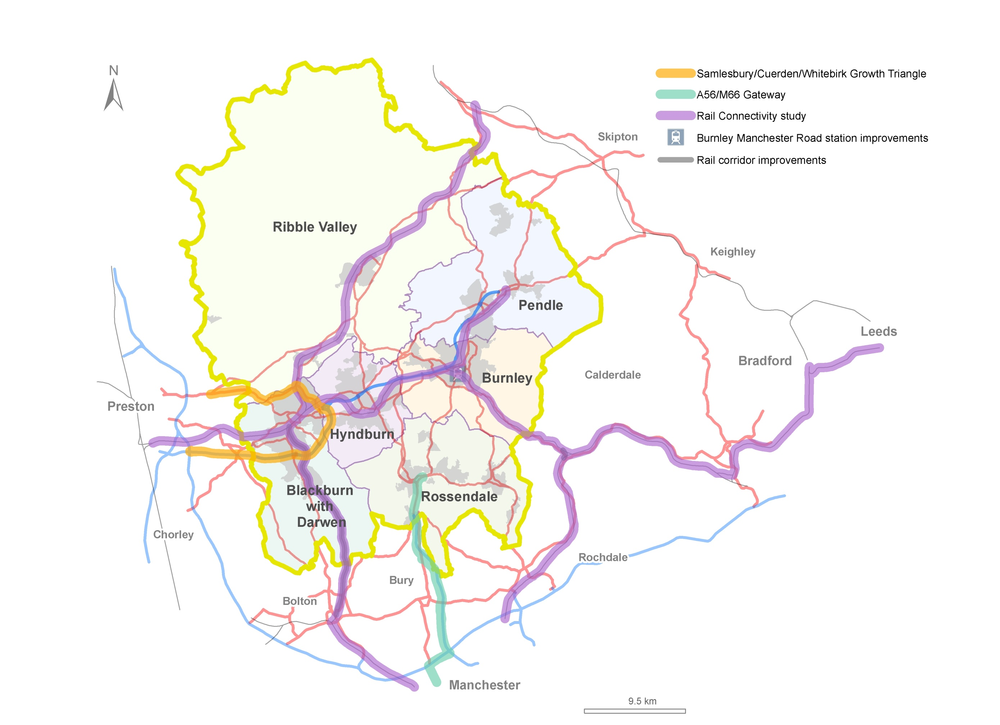
Figure12: Connecting East Lancashire

Taking Our Vision Further –Travel in East Lancashire
The links between East Lancashire's towns and the major employment and housing locations. The issues:

- Key corridors not able to support highway and public transport demand.
- Bus and rail stations not necessarily fit for modern uses
- Public transport provision for employment and in the rural area

Key corridors

The A56 and A59 provide the main links to the motorways for much of East Lancashire. These two roads, together with the major routes that connect them to each other and to the M65, are East Lancashire's key highway corridors. They provide the main arteries for all types of road transport, from the largest HGVs, through buses down to bicycles and pedestrians.

However, not all key corridors are inter-urban. Blackburn has significant congestion issues around the town centre. These could not only inhibit the economic development of the town, but have implications for the wider area, given Blackburn's location on the M65 Gateway and the town's role as a key gateway to East Lancashire and a significant destination not just for jobs, but for education, shopping and leisure.

Keeping these key corridors functioning as well as possible is vital to East Lancashire's aspirations. Over the years, improvements have been made where needed and maintenance has always been a high priority.

However, the situation in East Lancashire is changing as economic development takes place and it is therefore appropriate to revisit these corridors to see what may need to be done to support growth in the light of works that are already planned.

The M65/A56 Corridor

The strategic importance of the M65 and its role as the gateway to East Lancashire has been discussed. However, a strategic link is of no use if local traffic can't link to it easily. Since the Samlesbury / Cuerden / Whitebirk Growth Triangle Study will look at issues from Whitebirk to the M61, the M65/A56 corridor is defined here as the broad corridor that runs from Whitebirk to the West Craven Development Zone.

The M65 itself has few problems until it reaches its terminus at Colne, where its current abrupt finish causes congestion and leaves traffic struggling to get down local roads to reach destinations further north and east. The question of how best to tackle this issue will be resolved by further work to be carried out under the A56 Colne to Foulridge Bypass study.

At junctions, however, congestion can be an issue on the surrounding roads. At Junction 10 (Gannow Top) we have installed traffic signals at the northern roundabout to improve the flow of traffic, but the southern roundabout and other junctions in the corridor also have problems now and problems will increase in the future.

There are also problems on roads that link existing and future development sites to the motorway. For some sites, such as Huncoat, dedicated infrastructure is already planned, which will be funded by developers, whilst at Burnley Bridge, that infrastructure is being put in place now. However, we need to be sure that we do all we can to make access to development sites from the motorway as easy as possible.

Not all highway problems are congestion however, as the high volumes of traffic, particularly HGVs, can lead to other problems. Work is currently included in the TfL Major Schemes Programme to repair the Centenary Viaduct that
carries the A682 through the centre of Burnley. This is a critical part of Burnley town centre's road network and

without it, effective movement through Burnley would be impossible.

The problems at the end of the motorway have already been discussed. This study will build on work being undertaken in the short term to improve the traffic signals on the A6068 between the M65 and the A56 and will look at whether further improvements can be made to ease congestion prior to any decision on the A56 Colne to Foulridge Bypass being taken.

What we will do next:

The Burnley/Pendle Growth Corridor Study will look at what needs to be done to ensure that our highways can support the economic growth planned for Burnley and Pendle.

Starting at Junction 7, the corridor runs along the M65 and then continues along the A6068 Vivary Way/North Valley Road to the junction with the A56 Skipton Road. It then follows the A56 to Earby.

As well as looking at how the motorway's junctions function now and in the future, the study will look at the connections to and from the principal employment sites, existing and future, which lie within the broader M65/A56 corridor.

Blackburn Corridors

Blackburn with Darwen Council (BwDC) expects a net increase of over 9,300 homes across 291 potential sites. The preferred location of these developments will be in the inner urban areas of Blackburn and Darwen, or accessible locations elsewhere within the urban area. There are also 35.2 hectares of net site area for employment development over 38 sites.

It has therefore been important to understand the transport impacts of planned development in terms of potential future impacts on the highway network and constraints on travel which may without action, make development in a particular location unsustainable.

Analysis undertaken by consultants Capita Symonds on behalf of BwDC has highlighted that the existing highway network already experiences congestion in the AM period at some key junctions within the local highway network.

Development sites have been assessed against a number of accessibility criteria to determine which sites are located favourably for sustainable development. The likely impact of the development on the local highway network has been undertaken by assessing link capacities and by using a strategic traffic model of the area.

The results identified junctions on the highway network operating within, approaching and over capacity in 2012 and each future year scenario, with and without additional Local Plan developments.

In the future year scenarios, the extent of the network experiencing congestion increases, demonstrating that the existing highway network would struggle to accommodate the proposed levels of Local Plan development without increases in congestion or peak spreading, resulting in the congested period being experienced for a greater duration.

The potential network problems are sufficiently severe to make mitigation imperative if development is to go ahead successfully. Whilst some measures will be accommodated within existing programmes or by working with developers, there remain two major strategic strands of work.

- The first of these strands is the completion of the Blackburn Town Centre Orbital Route. Once complete, the orbital route will allow traffic to move freely across the town without impacting on the heart of the town centre and, in particular, on the Knowledge Zone. Removing through traffic and reducing other motorised traffic as far as possible will ensure that Blackburn town centre has a vibrant and lively character that will be attractive to residents, visitors and external investors alike.

The completion of the route would see improvements to the highway between Copy Nook and the Towns Moor retail park, a new bridge over the Leeds and Liverpool Canal in Audley, improvements to the Towns Moor Gyratory and the widening of Montague Street. The likely scheme cost is in the region of £10m.

The second of the strands considers how traffic from the motorway can reach Blackburn's planned developments, in much the same way as the M65/A56 corridor study will set out for the rest of the M65 corridor.

Two schemes are proposed, As well as making the most of work to be done by the Highways Agency at Junctions 4 and 5, the new infrastructure will ensure access to the M65 from proposed new development and will make travel into Blackburn easier.

- The Darwen East Distributor Route will be a new link road on the eastern side of Darwen which will unlock land to enable the future development of new housing and improve access to local employment opportunities planned

through the Council’s emerging Local Development Framework. The scheme also provides a local traffic
alternative to the already busy A666 and enables better access to M65 Junction 4.

The likely scheme cost is around £3m.

- The Fishmoor Link Road will be a new link road which will facilitate future development of housing and employment in the Fishmoor area of Blackburn with Darwen. It also relieves one of the borough’s busiest and congested junctions at the Blackamoor Road and Roman Road junction, which is an Air Quality Management Area.

In addition, the scheme will also improve access to local businesses at Walker Park and Roman Road industrial estates from M65 Junctions 4 and 5.

The likely scheme cost is around £3m.

There is, however, a third strand to the key corridors which will seek to promote sustainable and affordable transport modes to ensure that the future regeneration of Blackburn is sustainable.

A programme of workplace and community travel planning, supporting access to employment by BwDC with the potential to roll out similar initiatives across the East Lancashire area at some time in the future. These would complement the Local Links programme outlined later in this masterplan.

What we will do next:

Unlike the other key corridors, work is much more advanced on Blackburn's Key Corridors. Work will therefore focus on the production of a business case to underpin future funding.

.

The A59 Corridor

The A59 is a former trunk road that runs generally in a north-easterly direction from the M6 at Junction 31 near Samlesbury through the Ribble Valley to Whalley and Clitheroe, before crossing into North Yorkshire, where it is joined by the A56 to the west of Skipton.

In Lancashire, the A59 has been improved considerably over the last 40 years, and for much of its length is a high standard single carriageway road with the effects of long inclines relieved by climbing lanes. Apart from Copster Green and Gisburn, all communities along the route have bypasses.

Although the A59 does not carry a significant volume of through traffic, it retains an important role in linking the scattered communities of the Ribble Valley, including Clitheroe, to the motorway network. The Enterprise Zone site at Samlesbury lies at the far south-western end of the route.

What we will do next:

The Ribble Valley Growth Corridor Study will include the A59 between Samlesbury and North Yorkshire boundary and also the A671/A6068 and A680/A6185 routes between Whalley and M65 J7 and J8. The study will look at how these important roads can be made to function as effectively as possible for cars, freight and for other users.

The study will identify where junctions may need to be improved or where other highway works may be needed to ensure that capacity, reliability and safety issues do not hinder economic growth.

Public transport

The highways and transport networks that serve East Lancashire grew out of the industrial development of the 19th and 20th centuries. As the economy of the area has changed, those networks haven't always kept up with the changes.

Historically, the labour market was always very local, with the majority of people working within a short distance of their home. Whilst most commute times are currently under 15 minutes in most districts, recent survey data shows that the majority of people would be prepared to travel further than they do now, with most prepared to travel for at least half an hour. This makes it even more important that connections within East Lancashire allow these longer journeys and take full advantage of strategic improvements.

However, encouraging more car use is not an option. Not only is this expensive for individuals, but it is not environmentally sustainable. We therefore need to make sure that public transport services can support increased commuting and that public transport infrastructure is fit for purpose.

We are already taking some steps to improve our public transport in East Lancashire:

- The major redevelopment of Burnley Manchester Road rail station
- New bus stations are planned for Blackburn, Accrington and Rawtenstall
- Pennine Reach will provide a new rapid bus service in Blackburn with Darwen and Hyndburn, giving improved access to key strategic employment sites (including Whitebirk65), education, health, shopping and leisure facilities.
- Small-scale infrastructure and system improvements are being planned for the Nelson to Rawtenstall bus corridor to improve journey times and reliability, particularly for the Nelson-Manchester (X43) bus service.

In the remote and/or rural areas of East Lancashire, such as the Ribble Valley, the problems are rather different. These areas are very dependent on the car, which not only leads to local problems on the highways network, but makes life very difficult for those who, for whatever reason, do not have their own transport.

Typical reported problems include:

- Accessing employment, particularly jobs that aren't '9 to 5'
- Accessing education and lifelong learning in the evening
- Medical appointments that don't coincide with limited bus services
- Access to key centres in the evening or at weekends

Whilst a sparser population makes providing commercial bus services challenging, car dependence is unlikely to be sustainable in the longer term, both on cost grounds and through the need for carbon reduction.

Visitors to the more rural areas also need to be able to travel without needing a car and there is a definite need to support a sustainable visitor economy to ensure that both the natural environment and our built heritage are protected while their economic benefit is maximised.

What we will do next:

We know that there is still a lot of work to be done to make our public transport fit for purpose as East Lancashire develops. Whilst there are some long-standing issues, other problems are surfacing now.

The East Lancashire Accessibility Study will focus on travel between the main towns and employment areas, but will include travel to education and for leisure. It will also consider how public transport can best serve rural and remote areas of East Lancashire. In line with likely future funding constraints, the study will focus on where the greatest benefits can be achieved by enhancing accessibility.

Particular questions to be answered by the study include:

- Is there merit to a bus scheme that would provide links around Burnley and Pendle districts in a way similar to Pennine Reach and that would link into both Pennine Reach and the Witch Way?

- How can Community Transport best evolve to meet the diverse transport needs of East Lancashire, including remote and/or rural areas?

- What benefit would improving Burnley Rose Grove rail station and the interchange with Manchester Road bring?

- Colne bus station is not considered fit for purpose and the railway station is distant to it and very basic. If rail services improved to Colne, what would be needed to support interchange?

- Are improvements needed to other major bus facilities?

- Again, if rail services are enhanced, what could be done to improve rail station viability across East Lancashire and the links to bus and cycle networks?

- Is there any need for extra rail stations?

- What is the best way for public transport to support the rural economy and the residents of and visitors to our rural areas?

- Are there alternatives to traditional public transport for rural areas?

- Similarly, how do we best serve our remote towns and villages?

- And, importantly, how do we best normalise the use of transport other than the car?

These are not simple questions, particularly at a time when funding is scarce. However, the very scarcity of funding makes it all the more important that we have a clear picture of where the resources we and our partners do have can produce the most benefit.

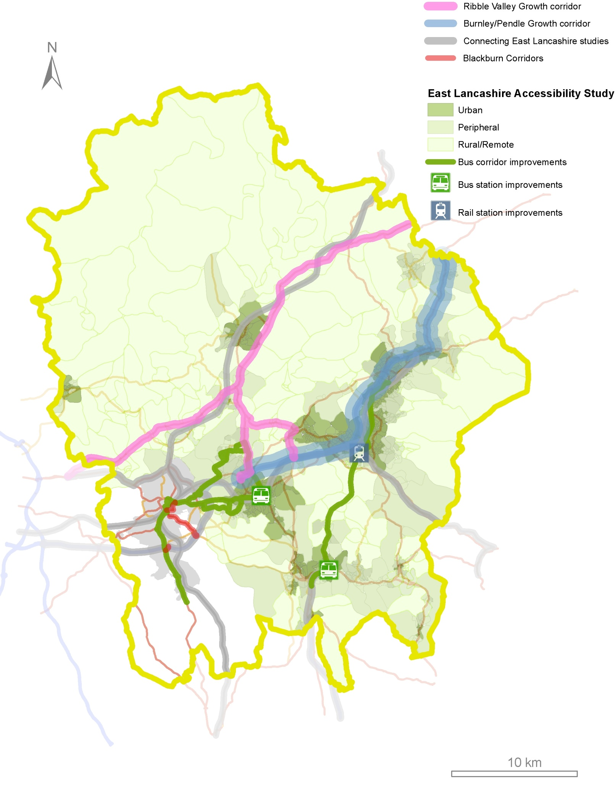
Figure 13: Travel in East Lancashire

Taking Our Vision Further –Local Travel

Making sure that everyone can get to services and opportunities. The issues:

- Limited cycling networks
- Limited interchange between public transport and cycling
- Neighbourhoods and the links between them need to be good enough standard to make travel easy for everyone.

Local travel and short journeys are a vital component of any transport network, as the DfT acknowledged in March 2013 when 'Door to Door - A strategy for improving sustainable transport integration' was published.

Cycling

Cycling in particular has the potential to offer options for the short journeys but also for longer journeys to work and education and for leisure.

In general, cycling is an option for journey times of less than 30 minutes. The geography and weather of East Lancashire may not make cycling such an obvious choice as in flatter, drier areas, but cycling is cheap and convenient. There is also the advantage that the facilities provided for commuters to cycle will be used by leisure cyclists looking to improve their health.

Although there is a lot of work being done to improve and extend cycling facilities, the cycling network in East Lancashire is far from complete and does not provide adequate links between housing, towns and employment. It also doesn't necessarily give good access to visitors.

Short journeys in the local community, to school, to the shops or just to enjoy being out and about, are key to local economies and to health and well-being. But beyond that, any journey involving public transport will involve local

travel, even if that local travel is simply walking to the bus stop.

Public transport is likely to become ever more important in the future and linking to it will be a key consideration in both urban and rural areas. Local travel will increasingly include getting to public transport hubs and that will mean providing options for cyclists to store a bike or take it with them for later in the journey.

Ensuring cycle facilities at train and bus stations are easily accessible and secure will encourage more people to use a mixture of bike, bus and train to complete their journeys. However, this will not happen unless cycle storage is secure, buses and trains connect well and cyclists and their cycles are catered for on trains and buses.

What we will do next:

For cycling to become a widespread choice for travel, particularly for commuting, we need to make sure that there is a good cycle network serving key centres and destinations in East Lancashire, that it is well maintained and well known.

The East Lancashire Strategic Cycle Network will build on work done under the Cycling in Lancashire Action Plan and the Cycle Pennine Lancashire initiatives. However, one of the first priorities will be to establish just what a 'good' cycle network looks like for all sorts of users.

Different cyclists have very different needs, from fit and confident enthusiasts happy to cycle anywhere, to the less fit and confident cyclists who want dedicated facilities and to know that routes are safe. Different journeys also have different requirements – commuters generally want a quick, convenient journey, whilst leisure riders are likely to be more interested in a more scenic route.

There is a lot of local knowledge that can inform the development of the network and there has already been substantial investment from a number of sources. Taking forward our ambition to have a coherent East Lancashire cycle network that can be used by all will therefore involve working with partners from both the public and private sectors.

The network will also provide some of the enhanced links to public transport that will be needed in the future. The East Lancashire Accessibility Study has already been mentioned. Interchange between cycling and public transport will form part of that study and so the output will inform the future development of the cycle network.

Possible links in this network have already been identified that would link communities to employment and would also offer potential for tourism and recreation:

- Rawtenstall to Rochdale - Strategic spinal route with connecting spurs providing commuter and leisure links.
- Baxenden to Haslingden - Missing section of National Cycle Network Route 6 (NCN 6), mostly along the former railway line.
- Blackburn to Chorley – surfacing of Leeds to Liverpool towpath
- Blackburn Wheel – a circular route linking employment and housing areas
- Southern section of NCN 6 from Haslingden/Helmshore to Ramsbottom and Greater Manchester along former railway line.
- Great Harwood to Burnley - former railway, missing central section
- Huncoat Greenway connecting Huncoat, Within Grove, Peel Park and Accrington – missing sections.
- Development of the NCN6 route to better serve Blackburn and the Lancashire Advanced Engineering and Manufacturing Enterprise Zone at Samlesbury

These proposals are in various stages of development and there is as yet no single funding strategy for them. However, this is far from an exhaustive list as the majority
of districts in East Lancashire have cycling strategies in place which identify further potential links both in a strategic cycle network and for more local travel.

Once the specifications of the cycle network have been established through consultation, including how it should be signed and maintained, the conversations can start as to the links to be included and how the network will be marketed to encourage its use.

Local links

The neighbourhoods of East Lancashire vary from the affluent in pretty rural villages to some of the most deprived in inner urban England. There are communities who are doing well and others that have effectively become stuck. In well-off areas, there are households that don't share the comparative wealth around them. Some of our towns and villages are remote from employment and services. And in rural areas, those living outside the villages can be even more isolated.

One thing all these communities have in common, though, is the need for good local links, the local footpaths and routes that facilitate those short journeys to school, to the shops or just to enjoy being out and about, that are key to local economies and to health and well-being.

These links are also the ones that make it easy to use other means of transport. If local travel is difficult, then making longer distance journeys becomes even more difficult as well. Local links are therefore vital to the economy and local businesses, as well as to our communities.
.

Local economies

Recent research has shown that many people in East Lancashire feel that there are not enough appropriate jobs that they can afford to get to.

This suggests firstly that we need to ensure that there are good, safe links in and out of communities that will mean that everyone can commute without the need to own a car. Since journey times are likely to remain relatively short, particularly from the most deprived areas, public transport, cycling and walking should be the modes of choice in the future.

It also suggests that we need to make local centres attractive so that local businesses can flourish and local employment can increase. The evidence shows that footfall increases in local shopping centres when people use sustainable modes which in turn become more popular as the local centres improve.

Local economic development in the rural area is likely to be tied to the visitor economy, but here too the public realm and attractive low carbon options will be key to growth.

Health and well-being

Mental and physical health is poor across many parts of East Lancashire. There are a number of causes of this, but many are linked to deprivation and isolation.

Road accidents, particularly involving young people are far more common in 'deprived' neighbourhoods. Air quality is also likely to be an issue and indeed there are a number of AQMAs (Air Quality Management Areas) in East Lancashire. Where crime or fear of crime is higher, the streets will be perceived as an unsafe place to be, particularly for the old and young. With an ageing population, this presents an ever more important issue.

If the public realm was a safer, nicer place to be, with less car traffic and more people out and about, then active travel modes (walking and cycling) would become more popular, giving more people the opportunity to enjoy their living environment, with benefits to both physical and mental health and well-being.

Increasing levels of physical exercise will not only help tackle obesity, but will help to reduce heart disease, strokes and type 2 diabetes.

Exercise is also good for mental well-being, as is green space. Access to the natural environment is a problem for many parts of East Lancashire, despite a Public Rights of Way network that most people could access if connections to it were better.

Sustainability

All plans, policies and schemes need to balance economic growth with the needs of the East Lancashire's people and the needs of the environment.

Perhaps the biggest challenge for the sustainability of travel and transport is to reduce our reliance on the car. This is not just an environmental issue though. For some, owning a car puts an enormous strain on the household budgets and not having a car can be a very real problem in rural areas and for those who need to travel longer distances from remote urban areas. And as the population ages, there will be more people who cannot drive even if they can afford to.

Sustainability will also bring economic benefits. By making East Lancashire a place where it is easy to get around without a car, the visitor economy will benefit. Not only is 'green tourism' becoming more popular, local attractions that are easy to reach will be used more by local people. And having fewer cars makes town and country more pleasant, a key consideration for the area's heritage townscapes.

It is not just new infrastructure that will be critical to this process. How we look after our highways and our public spaces will have a significant effect on the impression our 'public realm' portrays.

What we will do next:

Although we know in general terms what we need to do, much of the work of identifying where we need to enhance local links will fall out of other work streams in this masterplan and from the day to day contacts we have with our partners and our communities.

Some problems we can identify; we know where road safety and air quality are local issues. In other areas, we can only identify where problems may be occurring. The accessibility study will highlight where communities may not have adequate access to the wider public transport networks.

Other research can show where residents may be 'transport poor'. However, only the communities themselves can really know where new infrastructure or our doing things differently will provide the most benefit.

Work is already going on that will provide the starting point for providing high quality local links. For instance, we and our partners are already working to:

- Maintain our roads and footways
- Improve safety for all road users
- Improve air quality
- Improve public transport
- Make connections to green space

There are also opportunities presented by projects in the masterplan and by other initiatives that are underway.

We need to make sure that the maximum benefit is gained from public transport improvements such as Pennine Reach and Rawtenstall bus station. But we also need to make sure that we take full advantage of other schemes that change our highways network.

But improving local links should also involve looking beyond what we have done in the past. The current Townscape Heritage initiatives in Bacup and Accrington are examples of what can be achieved by bringing a new view to improving our towns.

The Townscape Heritage (TH) programme is a Heritage Lottery initiative for schemes which help communities improve the built historic environment of conservation areas in need of investment across the UK for the benefit of local residents, workers and visitors. Bids for funding for both the Bacup and Accrington TH initiatives have been successful in reaching the second stage of the bid process and are now waiting for final approval of the £1.5 million allocated by the Heritage Lottery Fund to each area.

In Bacup, a successful bid will see the physical appearance of the bid area improved and vacant floor space brought back into use. The Accrington Town Centre and Pals Centenary project aims to transform the declining historic retail and commercial gateway into the town centre, along Blackburn Road, culminating in a public realm scheme outside Accrington Town Hall and Market Hall to commemorate the Accrington Pals and the Battle of the Somme.

The Local Links programme will look to replicate partner working like this, involving the public and private sector, charities and communities in improving our county's neighbourhoods.

However, the best local links will be of no use if new opportunities for making longer distance journeys are not easily understood. The programme will have to address how changes to local travel are communicated in order to ensure that those most at need of access to employment and lifelong learning benefit from the changes made.

Next Steps

This masterplan represents the beginning of a programme of infrastructure delivery to serve East Lancashire over the next 10 years and beyond.

There is much to do and it will need the commitment and efforts of a variety of providers to see it through – Councils and Transport Authorities, Lancashire’s Local Enterprise Partnership, Highways Agency, Network Rail - and the support of private business and developers as well.

The first task was to make sure we have widespread agreement for the highway and transport improvements that are taken forward and delivered. Now that we have that agreement, then to stand the best chance of delivery, we must get work underway as soon as we can, so that we can take all opportunities to get funding for schemes that are ready to deliver. That will mean committing time and funding ‘upfront’ to working up these ideas and preparing the economic case for them.

Over the next 2 years we will need to:

- Progress with the studies and other evidence gathering, working with our partners to ensure that we can make the business case for the programme.
- Once we have that evidence, consult on and then programme the resulting actions.
- For currently funded schemes, finalise designs, begin to assemble land, and start works.
- For schemes less far advanced, carry out the detailed study work needed to progress to public consultation.
- Begin the preparation of major scheme business cases where appropriate.
- For proposals made in this masterplan, consult and work with communities, stakeholders and infrastructure providers to reach agreement on scheme specifics and secure funding for those proposals.

Delivery and funding of the masterplan will rely on a number of infrastructure providers and a variety of funding sources, and we will be working closely with these partners to make sure there is the guarantee of their support and assistance, with funding to follow.

Crucial to all this will be the support of residents and businesses. Too often attempts to deliver growth and new development have failed without the buy in and full support of the communities affected. We have the opportunity to make significant and long-term improvements, backed by substantial investment, to East Lancashire’s highways and transport system.

Securing Developer Contributions

The cost of delivering the package of measures identified in this masterplan, and those that will come out of the work we propose to do, cannot be borne entirely by public sector funding. We have shown that, in areas where we can come to rely on the development industry to contribute funding to new infrastructure, we can increase investor confidence and our ability to attract other sources of funding, and in turn improve the prospects of delivery, and delivering to earlier timescales.

Moving forward, investment in major new infrastructure will, increasingly, need to demonstrate an economic justification. In practice, this means a clear strategy that brings forward integrated proposals for new development and economic growth alongside the infrastructure to support it. In order to deliver on our proposals, it is vital that local authorities take every opportunity to coordinate their development planning strategies with future infrastructure investment, and pursue and pool together contributions from the development industry.

New procedures have been put in place for collecting and investing developer contributions. Whilst the Community

Infrastructure Levy (CIL) is yet to feature in East Lancashire, it is already proving to be a key mechanism in other parts of Lancashire to delivering major new infrastructure to stimulate and support major house building and business development.

Although market conditions are very different between the Central and East Lancashire, there are areas in East Lancashire that are, or would have the very real prospect to be, attractive areas for developers to build, new residents to live and businesses to locate to and bring jobs.

The speed and certainty with which we will be able to implement new infrastructure will be directly linked to developer contributions. For this reason it is important that local development frameworks are revisited to bring forward housing sites in locations that have the ability to generate CIL contributions.

Milestones

Project | Delivery Agency | Current Status | 2013/14 | 2014/15 | 2015/16 | 2016/17 |  | 2017/18 | 2018/19 | 2019/20 |  | 2020/21 | 2021/22
Manchester Road Railway Station Upgrade  Burnley | Network Rail | Under Construction | Project Completed
Todmorden West Curve Reinstatement | Network Rail | Committed | Project Completed
Pennine Reach  Darwen/Blackburn/Accrington | LCC/BwDBC | Committed | Start of Works:  Nov 13 |  |  | Project Completed
Clitheroe to Manchester Rail Corridor Improvements  (Blackburn to Bolton) | Network Rail | Programmed |  |  | Project Completed
Haslingden Road Corridor Improvements  Blackburn | BwDBC | Committed |  | Project Completed
Centenary Way Viaduct Major Maintenance Scheme, Burnley | LCC | Programmed |  |  | Project Completed
Rawtenstall Bus Station | LCC | Programmed |  | Project Completed
Nelson to Rawtenstall Bus Corridor Improvements | LCC | Programmed | Start of Works | Project Completed
A56 Colne to Foulridge Bypass | LCC | Pre-Programme |  | Traffic Study | Business Case Development and route protection |  |  | Planning Application |  | CPO/SRO |  | Start of Works | Road Open
Whinney Hill Link Road, Hyndburn | LCC | Pre-Programme |  |  |  | Scheme preparation |  | Planning Application | CPO/SRO | Start of Works |  | Road Open
M65 Junction 4 Improvements | Highways Agency | Pre-Programme |  | Project Completed
M65 Junction 5 Improvements | Highways Agency | Committed |  | Project Completed
East Lancashire Connectivity Study (ELCS) | LCC | Programmed | Start of Study | Study Completed
M65 Burnley / Pendle Growth Corridor Improvements (ELCS) | LCC | Pre-Programme | Route Management Strategy | Route Management Strategy Implementation
A59 Ribble Valley Growth Corridor Improvements (ELCS) | LCC | Pre-Programme |  | Route Management Strategy
Rawtenstall to Manchester Bus Corridor Improvements (ELCS) | Highways Agency | Pre-Programme | Route Management Strategy |  | Route Management Strategy Implementation: Delivery will require agreements with the Highways Agency and Transport for Greater Manchester and will be subject to securing a Growth Deal.
Cuerden / Whitebirk / Samlesbury Growth Triangle (ELCS) | LCC / BwDBC & Highways Agency | Pre-Programme | Part of East Lancashire Connectivity Study |  | Delivery will require agreement with the Highways Agency and will be subject to securing a Growth Deal.
East Lancashire Rail Network Improvements (ELCS) | Rail Industry | Pre-Programme | Part of East Lancashire Connectivity Study |  |  |  |  |  |  | Rail Industry Funding in Control Period 6.
Freckleton Street Link Road, Blackburn | BwDBC | Under Construction | Start of Works | Project Completed
Completion of the Blackburn Town Centre Orbital route | BwDBC | Pre-Programme |  |  |  |  |  |  | Start of Works | Project Completed
Darwen East Distributor Route | BwDBC | Pre-Programme |  |  |  |  | Start of Works |  | Project Completed
Fishmoor Link Road | BwDBC | Pre-Programme |  |  |  |  |  |  |  | Start of Works | Project Completed
East Lancashire Strategic Cycle Network | LCC/BwDBC | Pre-Programme | Start of Works | On going delivery of core elements, timescales subject to securing a growth deal

Funding
All figures £m and indicative

Project | 2013/2014 | 2014/2015 | 2015/2016 | 2016/2017 | 2017/2018 | 2018/2019 | 2019/2020 | 2020/2021 | 2021/2022 | 2022/2023 | Total | Comments
Manchester Road Railway Station Upgrade  Burnley | 2.1 |  |  |  |  |  |  |  |  |  | 2.1
Todmorden West Curve Reinstatement | 7.5 |  |  |  |  |  |  |  |  |  | 7.5
Pennine Reach  Darwen/Blackburn/Accrington | 10.8 | 20.6 | 8.3 | 0.2 |  |  |  |  |  |  | 39.9 | Full Approval Decision October 2013
Clitheroe to Manchester Rail Corridor Improvements  (Blackburn to Bolton) |  |  | 13.8 |  |  |  |  |  |  |  | 13.8 | Transport for Lancashire:  Programme Entry
Haslingden Road Corridor Improvements  Blackburn |  | 1.5 |  |  |  |  |  |  |  |  | 1.5 | Local Authority Pinch Point Programme
Centenary Way Viaduct Major Maintenance Scheme  Burnley |  |  | 3.2 |  |  |  |  |  |  |  | 3.2 | Transport for Lancashire:  Programme Entry
Rawtenstall Bus Station | 0.2 | 3.3 |  |  |  |  |  |  |  |  | 3.5 | Local Transport Plan Scheme
Nelson to Rawtenstall Bus Corridor Improvements | 0.1 | 0.5 |  |  |  |  |  |  |  |  | 0.6 | Local Transport Plan Scheme
A56 Colne to Foulridge Bypass |  | 0.3 | 0.7 | 0.5 | 0.5 | 1.5 | 1.5 | 20.0 | 20.0 | 1.0 | 46.0⁽¹⁾ | Transport for Lancashire:  Development Pool - delivery subject to inclusion in Growth Deal
Whinney Hill Link Road, Hyndburn |  |  |  | 0.3 | 0.4 | 0.4 | 4.6 | 9.2 | 0.4 |  | 15.3 | Delivery subject to securing developer funding
M65 Junction 4 Improvements |  | 2.0 |  |  |  |  |  |  |  |  | 2.0 | Transport for Lancashire:  Development Pool - delivery subject to HA approval through Pinch Point Programme
M65 Junction 5 Improvements |  | 1.4 |  |  |  |  |  |  |  |  | 1.4 | HA Pinch Point Programme
East Lancashire Connectivity Study (ELCS) | 0.1 | 0.2 |  |  |  |  |  |  |  |  | 0.3 | Local Transport Plan Project
M65 Burnley / Pendle Growth Corridor Improvements (ELCS) |  | 0.5 | 4.5 | 3.5 | 3.5 |  |  |  |  |  | 12.0 | Full delivery subject to inclusion in Growth Deal
A59 Ribble Valley Growth Corridor Improvements (ELCS) |  |  | 1.5 | 1.5 |  |  |  |  |  |  | 3.0 | Full delivery subject to inclusion in Growth Deal
Rawtenstall to Manchester Bus Corridor Improvements (ELCS) |  |  |  |  |  |  |  |  |  |  | tbc | Delivery subject to inclusion in Growth Deal
Cuerden / Whitebirk / Samlesbury Growth Triangle (ELCS) |  |  |  |  |  |  |  |  |  |  | tbc | Delivery subject to inclusion in Growth Deal
East Lancashire Rail Network Improvements (ELCS) |  |  |  |  |  |  |  |  |  |  | tbc | Rail Industry Funding in Control Period 6.
Freckleton Street Link Road, Blackburn | 5.5 | 5.5 |  |  |  |  |  |  |  |  | 11.0 | Assumed profile for 12 month construction period
Completion of the Blackburn Town Centre Orbital route |  |  |  |  |  | 5.0 | 5.0 |  |  |  | 10.0 | Delivery subject to inclusion in Growth Deal
Darwen East Distributor Route |  |  |  |  | 1.5 | 1.5 |  |  |  |  | 3.0 | Delivery subject to inclusion in Growth Deal
Fishmoor Link Road |  |  |  |  |  |  | 1.5 | 1.5 |  |  | 3.0 | Delivery subject to securing developer funding
East Lancashire Strategic Cycle Network |  | 0.5 | 2.5 | 3.0 | 3.0 | 3.0 | 3.0 | 3.0 |  |  | 18.0 | Full delivery subject to inclusion in Growth Deal
Total | 26.3 | 36.3 | 34.5 | 9.0 | 8.9 | 11.4 | 15.6 | 33.7 | 20.4 | 1.0 | 197.1
Highways Agency |  | 3.4 |  |  |  |  |  |  |  |  | 3.4
European Regional Development Funding | 1.15 |  |  |  |  |  |  |  |  |  | 1.15
Developer / S106 / CIL | 0.5 |  |  |  |  |  | 6.3 | 12.9 | 2.0 |  | 21.7
Local Major Transport Scheme (DfT/TfL) | 10.3 | 20.6 | 17.0 |  |  |  |  |  |  |  | 47.9
Regional Growth Fund | 7.6 |  |  |  |  |  |  |  |  |  | 7.6
Single Local Growth Fund |  |  | 7.25 | 7.0 | 3.0 | 8.0 | 6.3 | 17.8 | 16.0 |  | 65.4
Blackburn with Darwen Borough Council | 5.5 | 7.0* | 5.7 | 0.2 | 0.5 | 0.5 | 0.5 |  |  |  | 19.9 | *Includes £1.05m from Local Authority Pinch Point Programme in 2014/15
Burnley Borough Council | 0.6 |  |  |  |  |  |  |  |  |  | 0.6
Lancashire County Council | 0.62 | 5.3 | 6.6 | 3.8 | 2.4 | 2.9 | 2.5 | 3.0 | ? | 1.0 | 34.8
Total | 26.3 | 36.3 | 34.5 | 9.0 | 8.9 | 11.4 | 15.6 | 33.7 | 20.4 | 1.0 | 197.1

Appendix 1 – Scheme Delivery Timescales and Funding

Establishing approximate timescales and identifying the necessary funding along these timescales helps the transparency of the development process, facilitates cost sensitive approaches and sets clear expectations.

There are various resource intensive aspects in many development schemes that need to be considered before the works begin. These are mainly:

- Route protection
- Business case development for Major Schemes
- Scheme Identification
- Planning applications
The funding and timescale of various schemes in East Lancashire are discussed below.

Local Transport Authority Schemes

Pennine Reach (Darwen/Blackburn/Hyndburn)

This is a new high quality bus service designed to improve public transport in Blackburn, Darwen and Hyndburn along with new bus stations, innovative ticketing solutions and real time information service. The strategic route will improve accessibility within the region aiding growth and improving public transport within the region.

Time Table:

- Start of Works: November 2013
- Project Completed: 2016/17
Funding:
Approved capital build cost: £39.9m
Funding Streams:
Department for Transport: £31.9m
Lancashire County Council: £2.9m
Blackburn with Darwen Borough Council: £4.63m
Third Party: £0.47m

Rawtenstall Bus Station

Improvement to the existing bus station is necessary due to its dated and peripheral attributes. Rossendale Borough Council has committed to develop a new 8 stand design proposed by an architect.

Time Table:
- Start of Works: 2014/15
- Project Completed: 2014/15
Funding:
Estimated capital build cost: £3.5m
Funding Stream:
Lancashire County Council: £3.5m

Freckleton Street

The Freckleton Street to Montague Street Link Road will complete an important section of the Blackburn Town Centre Orbital Route and forms part of the wider masterplan for Blackburn town centre with the intention of helping to shape the physical environment of the area

Time Table:
- Start of Works: Underway
- Project Completed: 2014/15
Funding:
Estimated capital build cost: £11m
Funding Stream:
Blackburn with Darwen Borough Council: £11m

Haslingden Road Corridor Improvements, Blackburn

This scheme will widen Haslingden Road and will transform the mini roundabouts into signalised junctions. Improvements to current safety measures for cyclists and pedestrians will also be improved in the interest of promoting more sustainable modes of travel.

Time Table:
- Start of Works: 2014/2015
- Project completed: 2014/15
Funding:
Approved capital build cost: £1.5m
Funding Stream:
Local Authority Pinch Point Programme: £1.5m

Highways Agency

M65 Junction 4 Improvements

This scheme involves the full signalisation of the M65Jjunction 4 at Earcroft to support Blackburn with Darwen Council's Development Plan aspirations, ensuring that traffic can exit the M65 without excessive queuing. The Highways Agency has agreed in principle to fund the scheme.

Time Table:
- Project Completed: 2014/15
Funding:
Estimated capital build cost: £2m
Funding Stream:
Highways Agency Pinch Point Programme: £2m

M65 Junction 5 improvements

Works will be carried out to install traffic signals to all arms of the roundabout together with junction layout improvements to facilitate improved traffic flow. The works should help to reduce daily congestion, reduce journey times, improve safety and boost the economy

Time Table:
- Project Completed: 2014/15
Funding:
Estimated capital build cost: £1.4m
Funding Stream:
Highways Agency Pinch Point Programme: £1.4m

Transport for Lancashire

Clitheroe to Manchester Rail Corridor Improvements (Blackburn to Bolton)

The current track between Blackburn and Bolton is a single railway line. This limits the frequency of the busiest route serving Manchester and reduces the reliability. More double track railway will allow increased service frequency, particularly at peak hours, and improve the reliability.

Time Table:
- Start of Works: 2015/16
- Project completed: 2015/16
Funding:
Estimated capital build cost: £13.8m
Funding Streams:
Transport for Lancashire: £12.4m
Blackburn with Darwen Borough Council: £1.3m
Lancashire County Council: £0.1m

Centenary Way Viaduct Major Maintenance Scheme, Burnley

Centenary Viaduct is a seven span continuous bridge carrying the A682 principal road through the centre of Burnley. The works comprise replacement or renewal of a number of bridge related features, and will allow the current abnormal loads restriction to be lifted.

Time Table:
- Start of Works: 2015/16
- Project completed: 2015/16
Funding:
Estimated capital cost: £3.2m
Funding Streams:
Transport for Lancashire: £2.8m
Lancashire County Council: £0.4m

Other Schemes

A56 Colne to Foulridge Bypass

The A6068, as it passes through the North Valley area of Colne, carries traffic of around 25,000 vehicles per day including over 1,300 heavy goods vehicles. This causes severe problems, with congestion and delays throughout much of the day. In the peak hours, the congestion is among the worst in Lancashire. There is also the question of where economic growth is to be accommodated within Pendle, which will also have an impact on future traffic in the area.

We will collect the evidence that will allow us to draw up detailed design proposals for all possible options, including what could ultimately be done along the North Valley to increase capacity in the absence of a bypass as well as detailed consideration of all possible routes for an A56 Colne to Foulridge bypass. Before any further decisions are taken on the most appropriate solution both to Colne's congestion problems and to supporting future development, there will be a full public consultation at which the detailed work will be presented alongside the viable options that have emerged.

Time Table:

- Detailed traffic studies, environmental work and options design leading to public consultation on viable alternatives: 2014/15 to 2016/17.
For chosen option:
- Business Case Development: 2016/17 to 2017/18
- Planning Application if required: 2018/19
- Compulsory Purchase Orders (CPO)/(SRO) procedures if required: 2019/20
- Start of Works: 2020/21
- Project completed: 2022/23
Funding:
Estimated capital build cost (bypass): £46m
Funding Streams:
Single Local Growth Fund £32m (subject to Growth Deal)
Lancashire County Council: £10m
CIL/S106 developer funding: £4.0m

Whinny Hill Link Road, Hyndburn

This scheme comprises a new distributor road to serve the Huncoat Strategic Employment Site and housing development on the former Huncoat Colliery. It will also improve the highway network serving the Whinney Hill landfill site and remove traffic from roads fronted by residential properties.

Time Table:
- Scheme Preparation: 2016/17
- Planning Application: 2017/18
- CPO/SRO procedures: 2018/19
- Start of works: 2019/20
- Road Open: 2020/21
Funding:
Estimated capital build cost: £15.3m
Funding Stream:
CIL/S106 developer funding: £15.3

Completion of the Blackburn Town Centre Orbital route

This scheme will complete the Blackburn Town Centre orbital route between Copy Nook and the Towns Moor retail park and comprises improvements to the highway and a new bridge over the Leeds and Liverpool Canal in Audley, Blackburn, improvements to the Towns Moor Gyratory and widening of Montague Street.

Time Table:
- Start of Works: 2018/19
- Project Completed: 2019/20
Funding:
Estimated capital cost: £10m
Funding Streams:
Single Local Growth Fund: £9m (subject to Growth Deal)
Blackburn with Darwen Borough Council: £1m

Darwen East Distributor Route

This scheme delivers a new link road on the eastern side of Darwen which will unlock land to enable the future development of new housing and improve access to local employment opportunities planned through the Council’s emerging Local Development Framework. The scheme also provides a local traffic alternative to the already busy A666 and enables better access to M65 Junction 4.

Time Table:
- Start of Works: 2017/18
- Project Completed: 2018/19
Funding:
Estimated capital cost: £3m
Funding Streams:
Single Local Growth Fund: £2.5m (subject to Growth Deal)
Blackburn with Darwen Borough Council: £0.5m

Fishmoor Link Road, Blackburn with Darwen

The Fishmoor Link Road scheme delivers a new link road which will facilitate future development of housing and employment in the Fishmoor area of Blackburn with Darwen. It also relieves one of the borough’s busiest and congested junctions at the Blackamoor Road and Roman Road junction, which is classified as an Air Quality Management Area. In addition, the scheme will also improve access to local businesses at Walker Park and Roman Road industrial estates from M65 Junctions 4 and 5.

Time Table:
- Start of Works: 2019/20
- Project Completed: 2020/21
Funding:
Estimated capital cost: £3m
Funding Streams:
Developer funding: £2m
Blackburn with Darwen Borough Council: £1m

Appendix 2 – A56 Colne to Foulridge Bypass

Map showing the currently protected route for the southern section of the A56 Villages Bypass scheme and the three southern options identified in the M65 to Yorkshire Corridor study.

We will now undertake the next stage of the work that will give us the evidence to draw up detailed design proposals for all the southern options. These options will include what could ultimately be done along the North Valley to increase capacity in the absence of a bypass, as well as detailed consideration of all possible routes for an A56 Colne to Foulridge bypass. Once this work has been completed we will be able to consult on our final proposals.

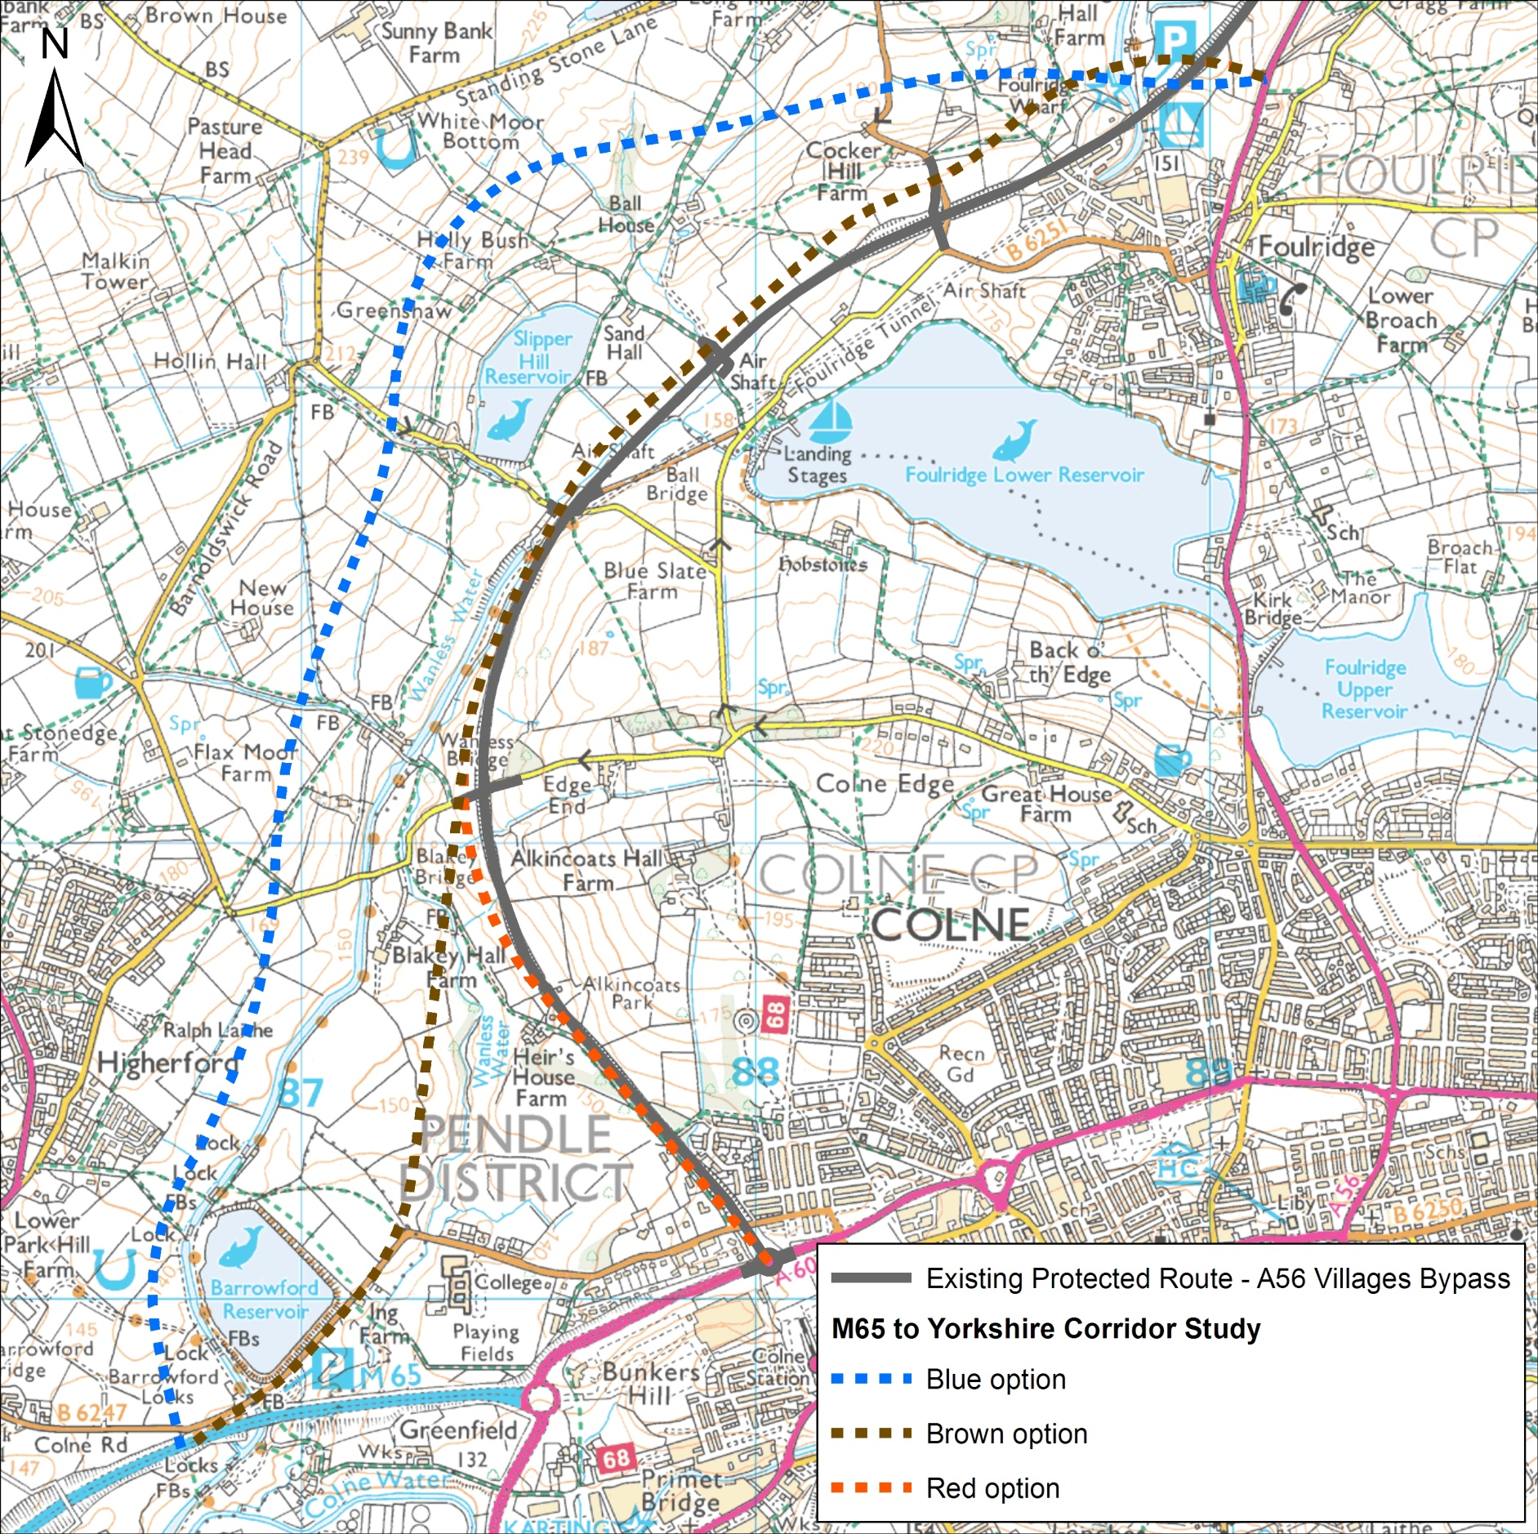

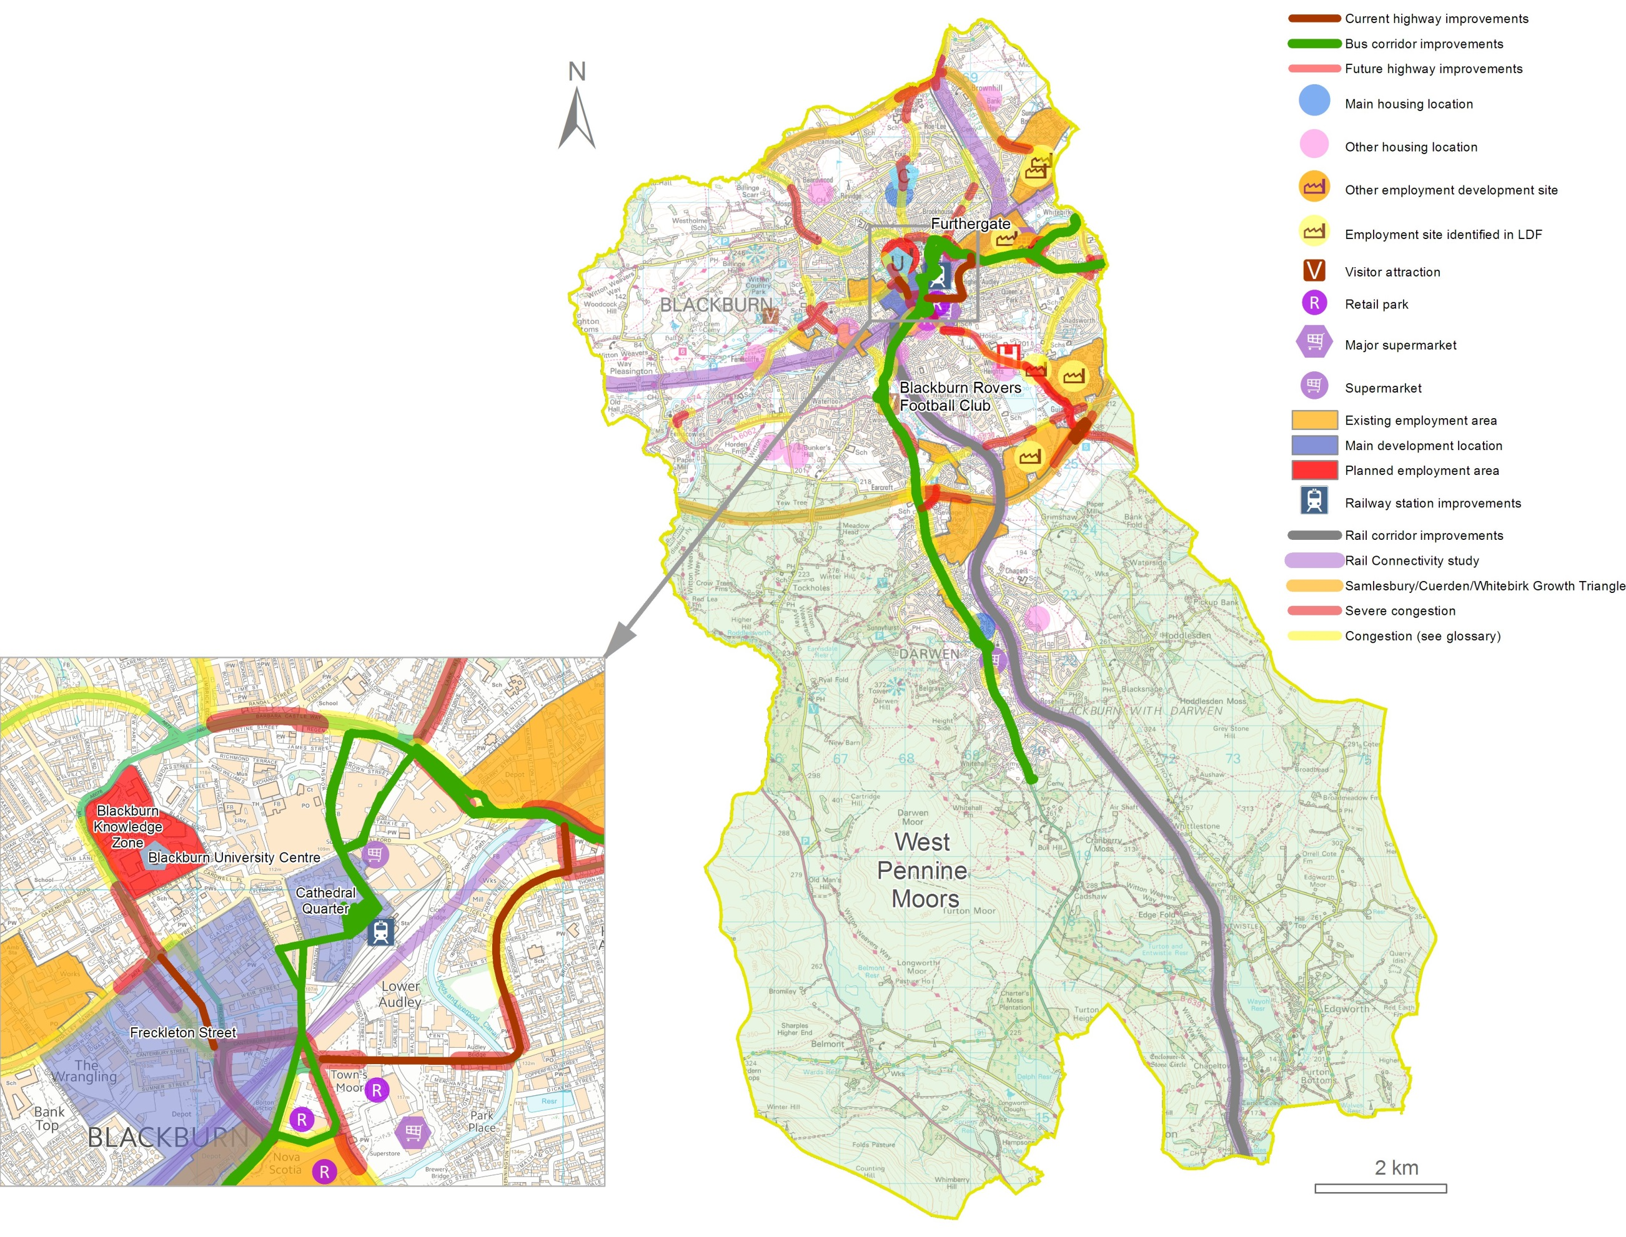
Appendix 3 Blackburn with Darwen

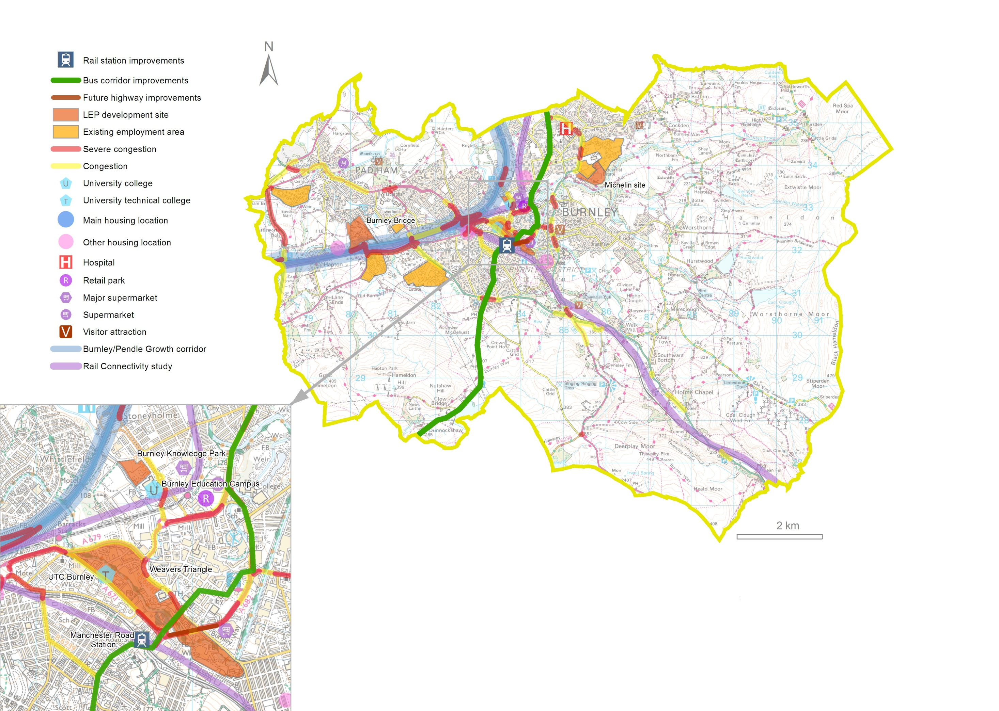
Appendix 4 District Maps

Burnley

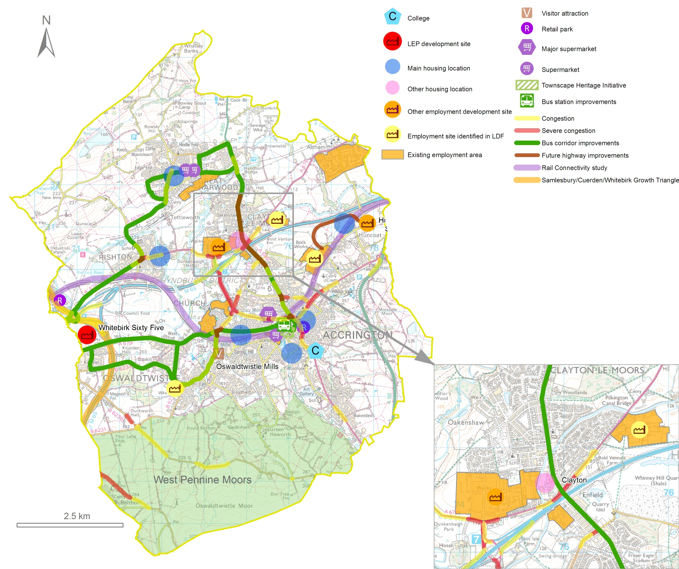

Hyndburn
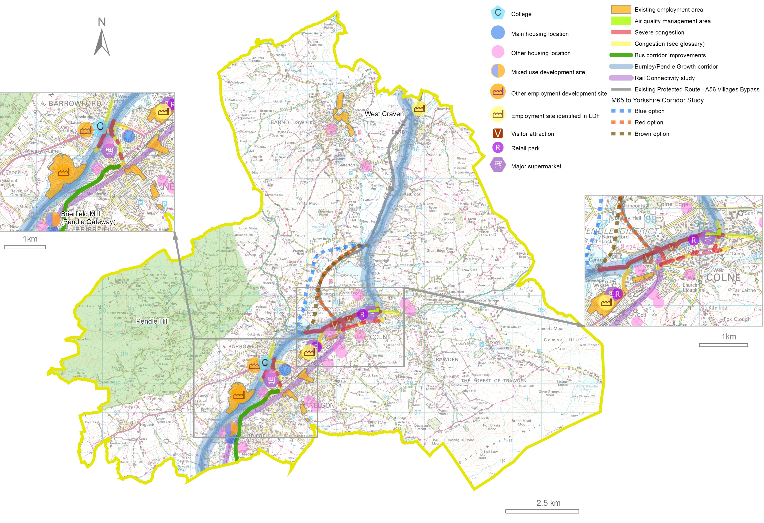

Pendle
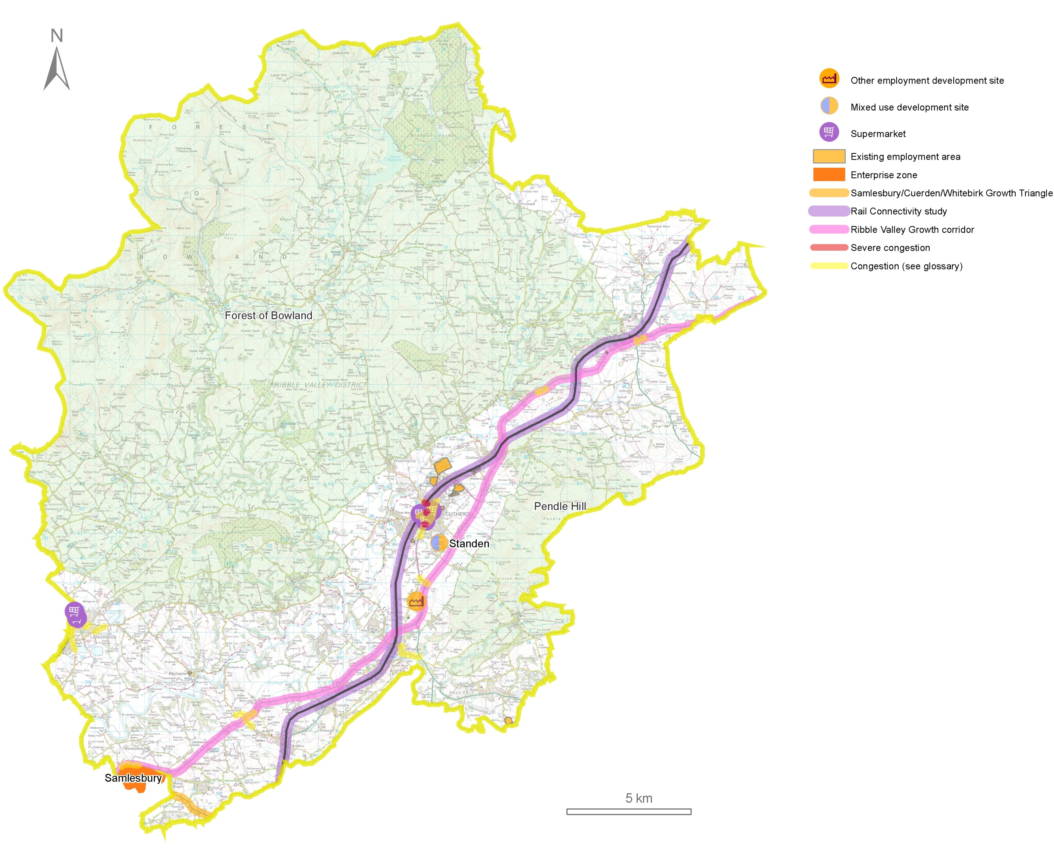

Ribble Valley

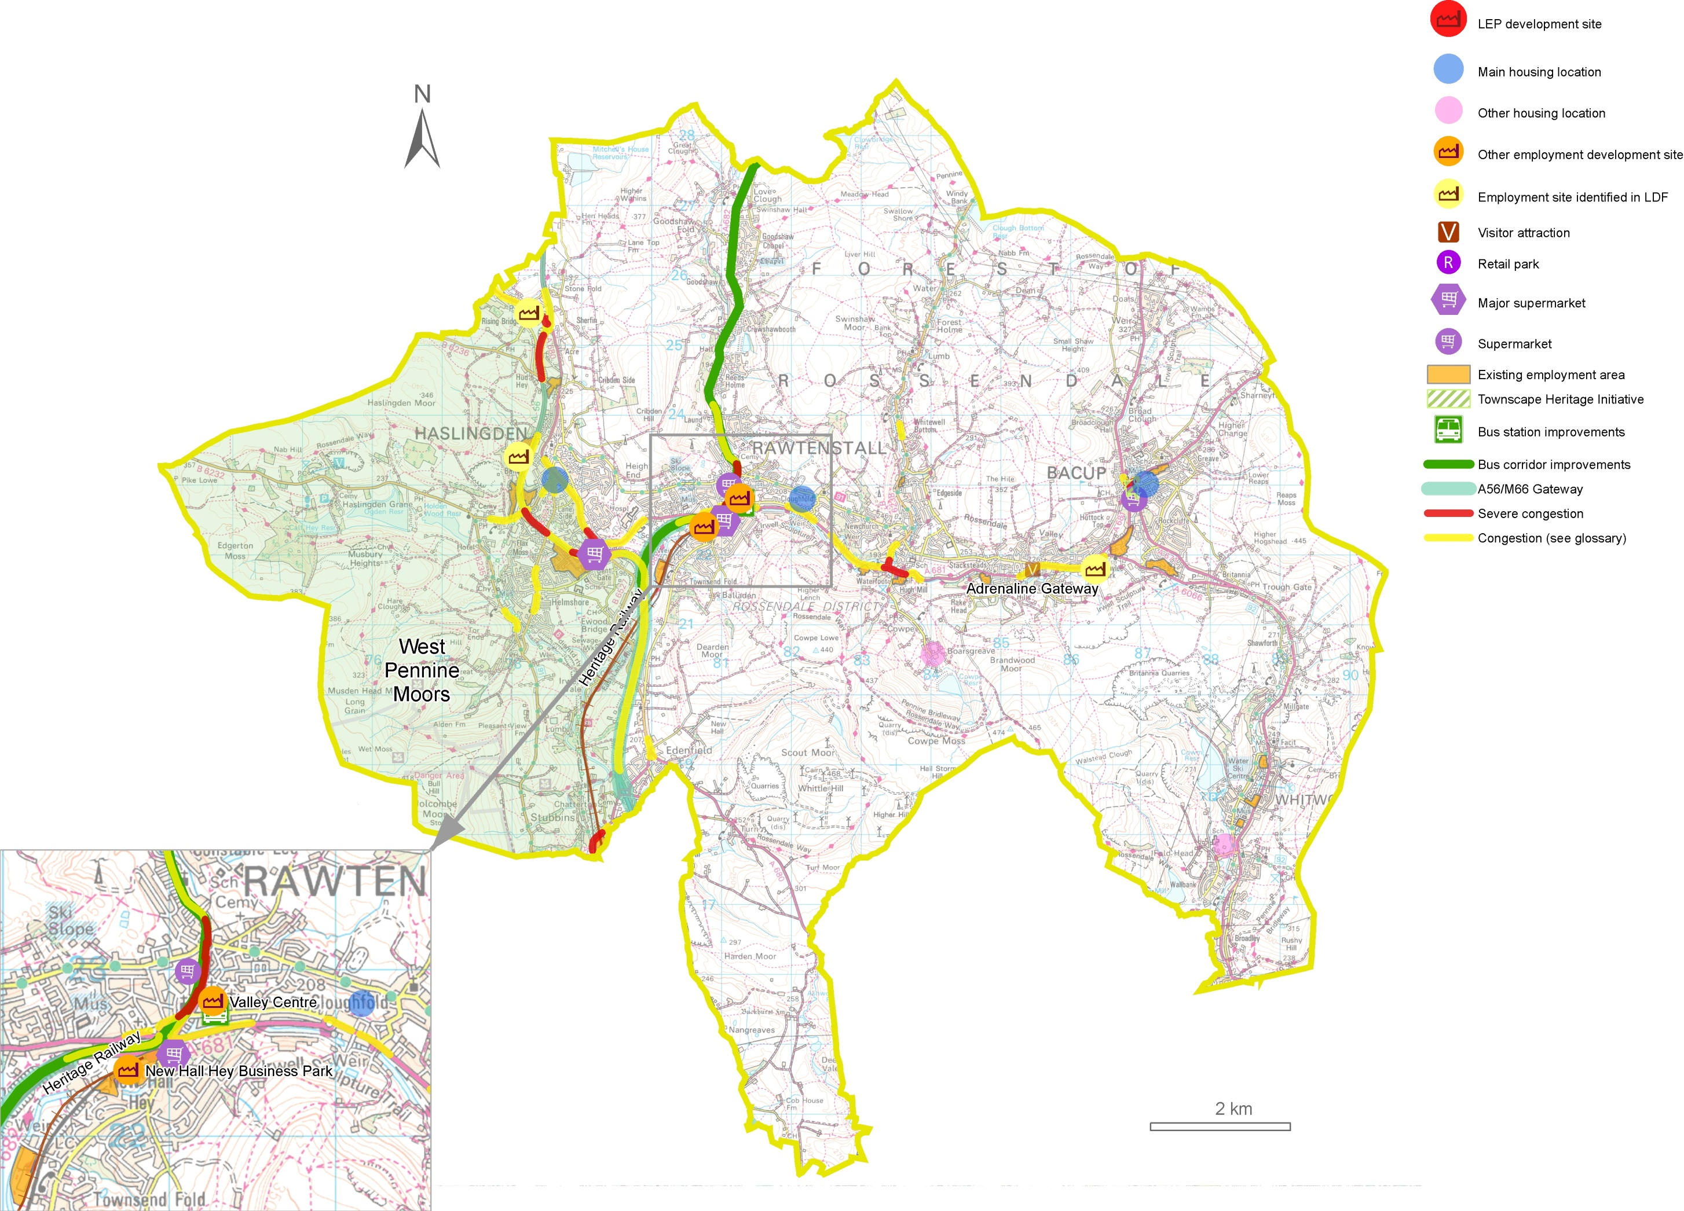
Rossendale
Appendix 5 Glossary

Air Quality ~ the condition of the air around us. Pollution is often a cause of poor air quality. Carbon Emissions ~ carbon dioxide (CO2) and carbon monoxide (CO) produced by vehicles and industrial processes.

Core Strategy ~ the key compulsory local development document specified in United Kingdom planning law. It sets out the vision, objectives, strategy and policies that will manage development and use of land in an area. Every other local development document is built on the principles set out in the core strategy, regarding the development and use of land in a local planning authority’s area.

Compulsory Purchase Orders (CPO) ~ compulsory purchase orders allow certain bodies to buy land or property even where a land owner does not want to sell it. A CPO is a last resort and only used where taking the land is necessary and it is in the public interest.

Congestion – a condition on road networks that occurs as use increases that is characterised by slower speeds, longer journey times and increased queuing. The maps in this masterplan use the following definitions based on average speed during peak hours:

Road type/Speed limit | Severe congestion | congestion
Urban 30mph & 40 mph | < 10mph | 10 – 20 mph
50mph & 60 mph | < 20 mph | 20 – 30 mph
Dual carriageway and motorway 70 mph | < 40 mph | 40-50 mph

Economic Development ~ long term actions to improve the standard of living and economic health of an area. Actions can involve many areas including education, infrastructure, competitiveness, environmental sustainability, social inclusion and health.

Green Belt ~ an area of open countryside or farmland between urban areas, where development is restricted to limit urban growth and prevent separate urban areas joining together over time.

High Speed Rail ~ High Speed 2 (HS2) will be the UK’s new high speed rail network, built initially between London and Birmingham. Phase 2 of HS2 will extend the route to Manchester and Leeds.

Highway Authority ~ an organisation legally responsible for looking after the highway network (roads, footways and cycle ways) in an area and which has certain legal powers as a result. In Lancashire, the County Council is the highways authority for most roads in the county.

Infrastructure ~ the basic facilities needed for society to function, such as roads, railways, communications systems, electricity, gas and water supplies, and public buildings including schools.

Integrated Transport (IT) Block ~ Government capital funding provided to County and Unitary Councils for support for small-scale transport improvement schemes.

Lancashire Advanced Engineering and Manufacturing Enterprise Zone ~ the Enterprise Zone is made up of the two BAE Systems sites at Samlesbury and Warton. The Lancashire Economic Partnership (LEP) worked with BAE Systems to launch the Zone in April 2012, and it is intended to become a world class location for advanced engineering and manufacturing.

Lancashire Enterprise Partnership (LEP) ~ a public/private sector partnership which provides leadership for the county’s economy and therefore has an important role in directing local economic development activity for job creation and growth.

Local Development Framework (LDF) ~ a set of documents setting out the policies and plans which will shape how an area develops and which make up the local plan for a local planning authority’s area.

Local Sustainable Travel Fund ~ a government fund to support measures to encourage economic growth and reduce carbon emissions.

Local Transport Plan ~ a statutory document that sets out how the County Council will provide sustainable and accessible transport capable of supporting the county’s economic growth over the next few years and beyond.

Sustainable ~ in this masterplan, sustainable means something that “meets the needs of the present without compromising the ability of future generations to meet their own needs”. Making plans, policies and schemes sustainable means balancing environmental, social and economic issues.

Nature Conservation Value ~ areas of the natural environment with valuable habitats or plant or animal species to be protected and enhanced that need to be considered by a planning authority when they are preparing their local plan and making decisions on planning applications.

Park and Ride ~ a system for reducing urban traffic congestion in which drivers leave their cars in parking areas on the outskirts of a town or city and travel to the city centre on public transport. Most park and ride is bus based; rail based sites are usually called ‘Parkways’.

Pinch Point Programme Funding ~ part of the Government’s growth scheme providing funding to tackle specific places on the national main road network where traffic congestion is at its worst.

Rolling Stock ~ the carriages and wagons that make up a train. The quality and capacity (the number of people or quantity of goods that can be carried) of rolling stock affects the level of service on a route.

Side Roads Order (SRO) ~ a legal order that allows a highway authority to make alterations to roads or other highways affected by a major road scheme including closing or diverting roads or private accesses affected by it.

Spatial Planning ~ how the public sector influences the distribution of people and activities in an area. It includes land use planning, urban planning, transport planning and environmental planning. Other related areas are also important, including economic development and community development. Spatial planning takes place on local, regional, national and international levels.

